A road trip to the US

i WOULD LIKE TO VISIT…



This video presents the 10 MUST visit cities in the US : <https://www.youtube.com/watch?v=46SYtrSe-X4>

**Watch it and complete the chart:**

|  |  |  |
| --- | --- | --- |
| Cities | State | Interest |
| 10- |  |  |
| 9- |  |  |
| 8- |  |  |
| 7- |  |  |
| 6- |  |  |
| 5- |  |  |
| 4- |  |  |
| 3- |  |  |
| 2- |  |  |
| 1-New York City | New York |  |

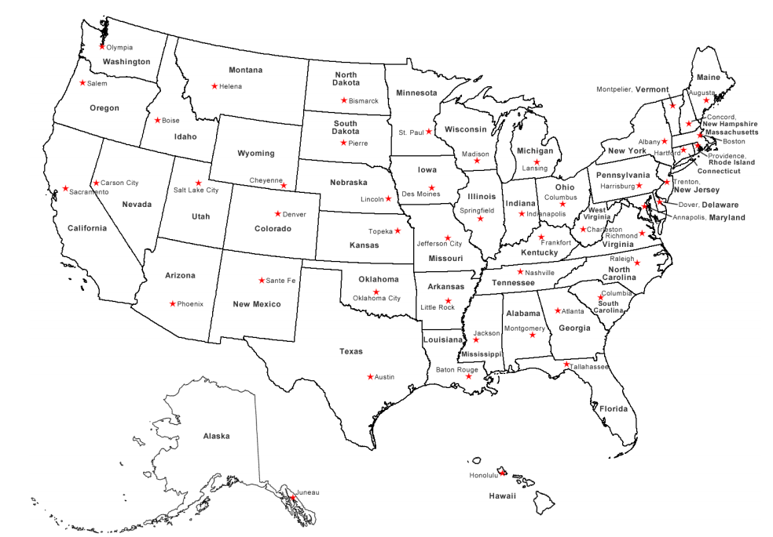**Highlight OR add them on the map:**

**After New York, where would you like to go? Why?**

**I would like to go to _ _ _ _ _ _ _ _ _ in _ _ _ _ _ _ because there is/are _ _ _ _ _ _ _ _ _ _ _ _ _ _ _ _ _ _ _ _ _ _ _ …**