* 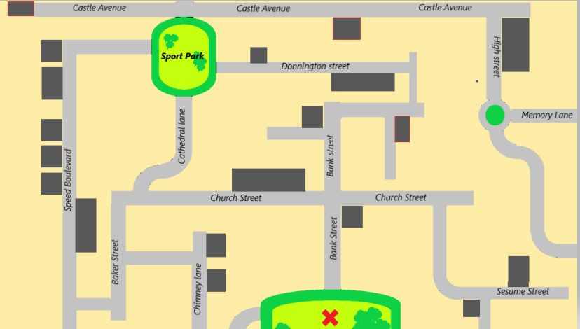Listen and retrace the itinerary on the map.
* Listen and retrace the itinerary on the map.
* Listen and retrace the itinerary on the map.
* Listen and retrace the itinerary on the map.