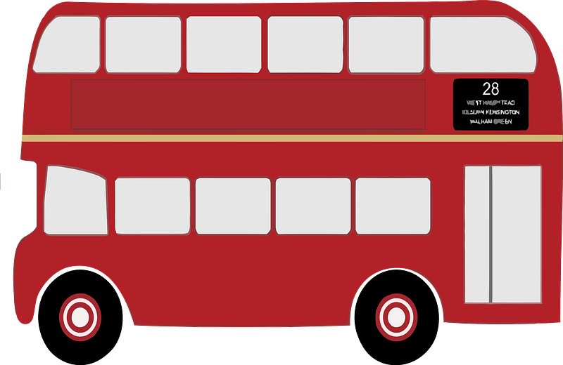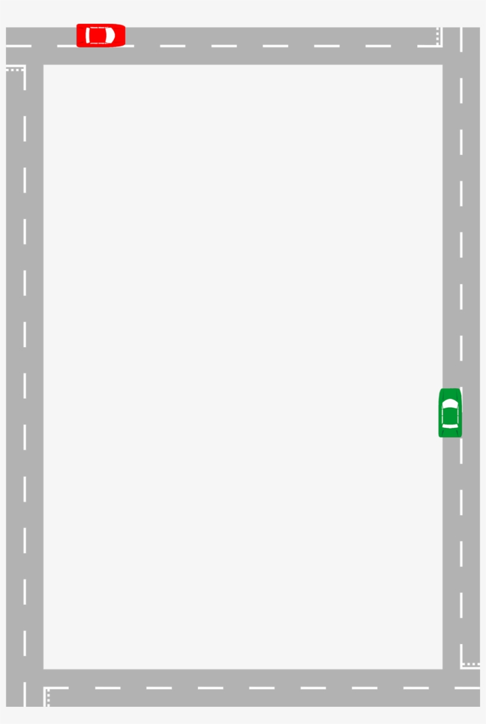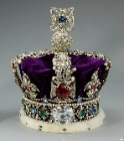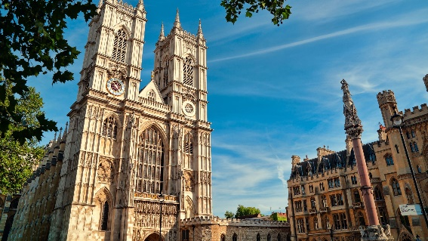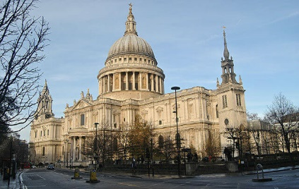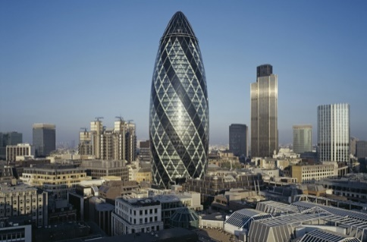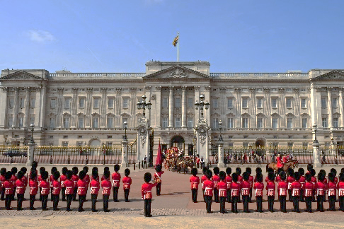

It includes the House of Lords and the House and the House of Commons. They debate and vote on new laws.

The clock tower is very famous!

It is a very famous symbol of London. It crosses the Thames.

It is a very animated place in London. Take a photo of Nelson’s column! He defeated Napoleon at the Battle of Trafalgar (1805)

To mark the Millenium, an enormous wheel (135m high) was built. For a magical view over London, buy a ticket!

**The Tower of London**

It is a very important place for Anglican people. You can recognize its beautiful dome.

**The Gherkin**

**Hyde Park**

**Buckingham Palace**

**Westminster Abbey**