**Directions**

1. 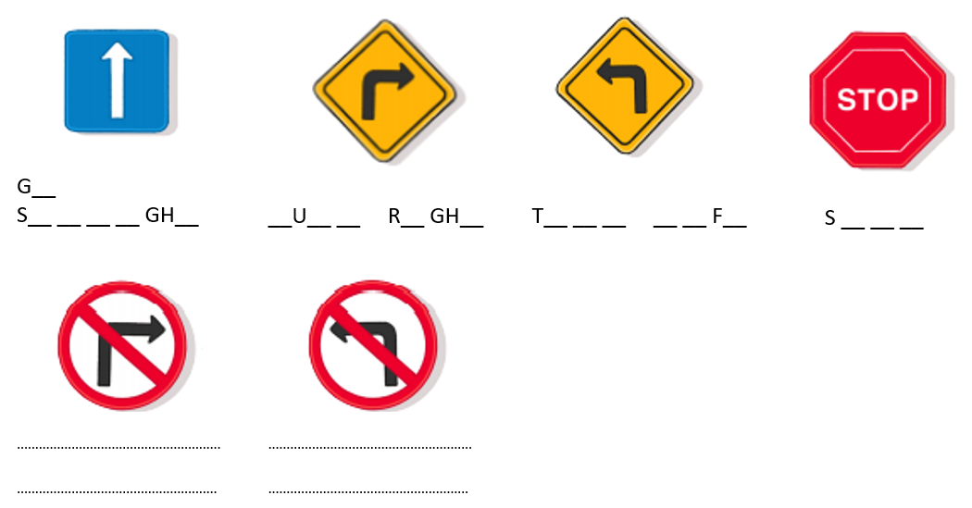Listen and complete the instructions.

**__O**

**A__ __** R **__ __ S**



**Directions**

1. ****Listen and complete the instructions.

**__O**

**A__ __** R **__ __ S**

