A road trip to the US

PLANNING MY TRIP

What DO YOU NEED before leaving?

1. **I need _ _ _ _ _ _ _ _ _ _ .**

* In the US we need _ _ _ _ _ _ _ _ _ .

1$ = 0.83€

* How much are…

100$ = _ _ _ _ 2000$ = _ _ _ _

1500$ = _ _ _ _ 10000$= _ _ _ _

* Prepare your budget here:

In your opinion, how much do you need to go to the US?

|  |  |  |  |  |
| --- | --- | --- | --- | --- |
| Transport | Accommodation | Food | Activities | Gifts |
|  |  |  |  |  |

**I need _ _ _ _ _ _ _ _ _ _ _ to have a nice trip!**



1. **I need _ _ _ _ _ _ _ _ _ with _ _ _ _ _ _ _.**

I

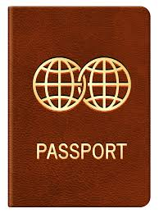

1. **I need official documents.**

* I need _ _ _ _ _ _ _ _ _ _ _ _ _
* I _ _ _ _ _ _ _ _ _ _ _ _ _ _
* 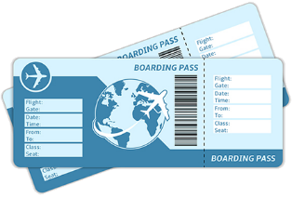I _ _ _ _ _ _ _ _ _ _ _ _ _ _