**3 Important Steps That Can Give You Best Dental Treatment**

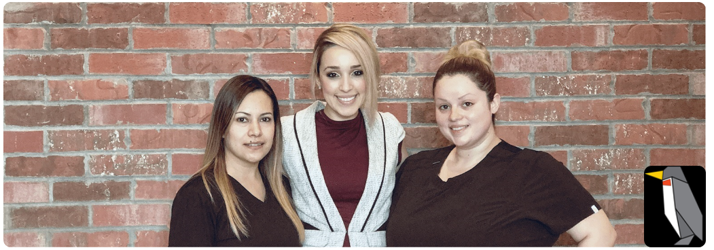

Like some other type of treatment, orthodontic or dental treatment must have well-talented specialists that can serve and help patients with their requirements. There are 3 different things that one mist remember in case they wants a [**Walk in Dentist Office Near Me**](https://emergencydentistinhouston.com/emergency-dentist-near-me/) that will be capable to do the wonderful job possible all through the treatment:

The very first tip is that you must recognize what to search for a dentist – It must be done even earlier than an urgent situation occurs; there are some different things that you must remember when it comes to searching the best **Walk in Dentist Office**, such as professional qualifications, location, cost, personal comfort and urgent care. It is crucial to select a **walk in dentist office** that would be situated close to your location or place. Throughout this, it would be simpler to go to the [**Emergency Laser Dentistry**](https://emergencydentistinhouston.com/emergency-laser-dentistry/) clinic as well as to plan a reliable visit with your dentist.

It is even crucial to think about the treatment cost; try to request first in case there are different forms of payment which are accepted by the **Laser Gum Treatment Dentist** clinic - plans, credit cards, debit cards etc. Insurance must even be measured thus you would be able to recognize if you can utilize the insurance that you have. It is even useful in case you will guesstimate the costs of routine procedures thus you would be able to have a clear idea in case you can save some good money.

Next would be about the association between the dentist and the patient - it is crucial as you will be discussing with the **Laser Gum Treatment Houston** orthodontist frequently. It is very important to have a happy relationship with your professional dentist thus it would be simple for you to ask questions about your treatments. It wouldn’t be tough for a patient to express and tell whatever that he/she experiences regarding something that concerns this dentist cure.

If talking about professional qualifications then these are one more important factor to consider - you must recognize the training and the guidance of this clinic. It is remarkable to ask different type of things first regarding the guidelines or policies when it comes to different parts of orthodontic cure - it is to confirm the safety of patient.

Once it comes to urgent situations, one must always keep in mind that a dentist has to be easy to accessible and reach at any specific time. We not know when an emergency will happen so it is good to have a number with the dentist.

Another important tip, is about how to search a dentist throughout inquiring some people you know. It is useful in case you will ask some opinions from some friends or family members as they would be able to give you details regarding their dentists or anyone they know. You may even ask your earlier dentist or also a doctor as they can know someone that they may suggested to you.