Sequence 1: “Black lives matter” 3e LCE
THE TRIANGULAR TRADE

The Atlantic slave trade has been called the triangular trade because it had three stages that form the shape of a triangle when viewed on a map.
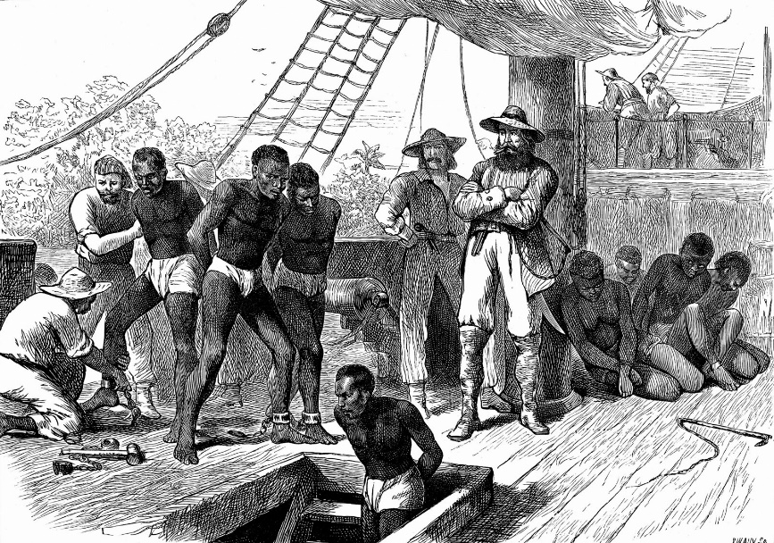

The first stage began in Europe, where manufactured goods such as metals, cloth, guns, and spirits (=alcohol) were loaded onto ships bound for ports on the African coast. There, the goods were exchanged for slaves. Many slaves were taken from the region bordering the Gulf of Guinea; in fact, a section of the African coast became known as the Slave Coast. The Atlantic slave trade changed the nature of African slavery. The Europeans mostly demanded adult males to work in the New World colonies. Thus, African chiefs began selling males into the international slave trade. Most slaves were captured in raids on neighboring African peoples / tribes, though others became slaves because of criminal convictions or failure to pay debts. African chiefs transported the captives to the coast and sold them to European ship captains.

The second stage of the triangular trade was the shipment of slaves across the Atlantic Ocean, usually to Brazil or to an island in the Caribbean Sea. This trip, known as the Middle Passage, took a few weeks to several months. The Middle Passage was suffocating and dangerous for African slaves. On the slave ships, men and women were separated, kept naked, crammed close together, and the men were chained for long periods. Many slaves did not survive the voyage. The almost continuous dangers faced by the captives included epidemic diseases and attacks by pirates, in addition to physical, sexual, and psychological abuse at the hands of their slave dealers.
The peak of the Atlantic slave trade seems to have been reached in the 1780s, when on average some 78,000 slaves were brought to the Americas each year. These slaves were transported in the ships of British merchants but also French and Portuguese slave traders.

After arriving in Brazil or the Caribbean, the slaves were sold at auction and were taken throughout the New World. They were put to work on plantations. The shipment to Europe of plantation crops and products made from them was the third stage of the triangular trade. Among the most valuable exports to Europe were sugar, tobacco, cotton, and rum.

Adapted from https://kids.britannica.com/students/article/Atlantic-slave-trade/602896

Manufactured goods = manufactured products.
Neighboring = living next to them.
Naked = with no clothes on.

