Sequence 1: “Black lives matter” - 3e LCE
Written comprehension
Read the text and do the activities. Do not hesitate to talk with your partners to check your answers:
- Read the text and complete the document:
- Number the different stages of the triangular trade.
- Place Europe / Africa / North America / South America.
- Place the Slave Coast.
- Place the Middle Passage.
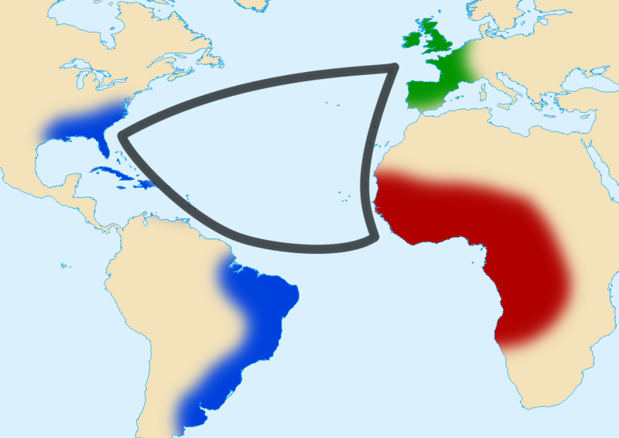

- Read the first paragraph and do the activities:
- What did Europeans have in their ships? Tick the correct answers.
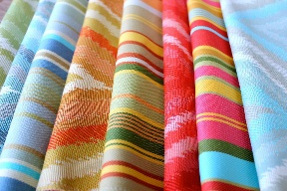 | 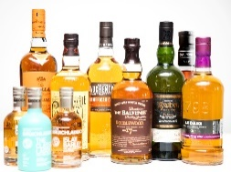 | 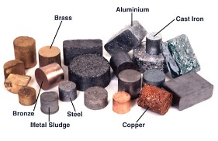 |  | 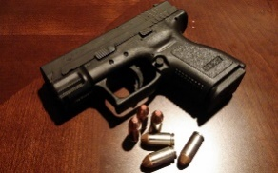

- Pick out three different ways to be enslaved / to become a slave.
____________________________________________________________________________________________________________________________________________________________________________________________________________________________________________________________________

- Read the second paragraph and do the activities:
- The difficulty of the journey across the Atlantic Ocean is mentioned. Underline all the terms or expressions referring to it in the text and classify them in the grid.

Terms / expressions referring to the general atmosphere on slave ships. | Terms / expressions referring to the conditions of living of slaves on ships.

- Name the three main European slave trading nations:
__________________________________________________________________________________________________________________________________

- Read the third paragraph and do the activities:
- Associate the vocabulary from the text to its definition:

Sold at auction • |  | • Name given to a farm where slaves worked.
Plantation • |  | • A cultivated plant that is grown on a large scale.
Crop • |  | • Sell an object (or a slave) to the person who gives the biggest sum of money.

- What type of raw materials (= matières premières) did Europeans value the most? Pick out 4 of them.
__________________________________________________________________________________________________________________________________

