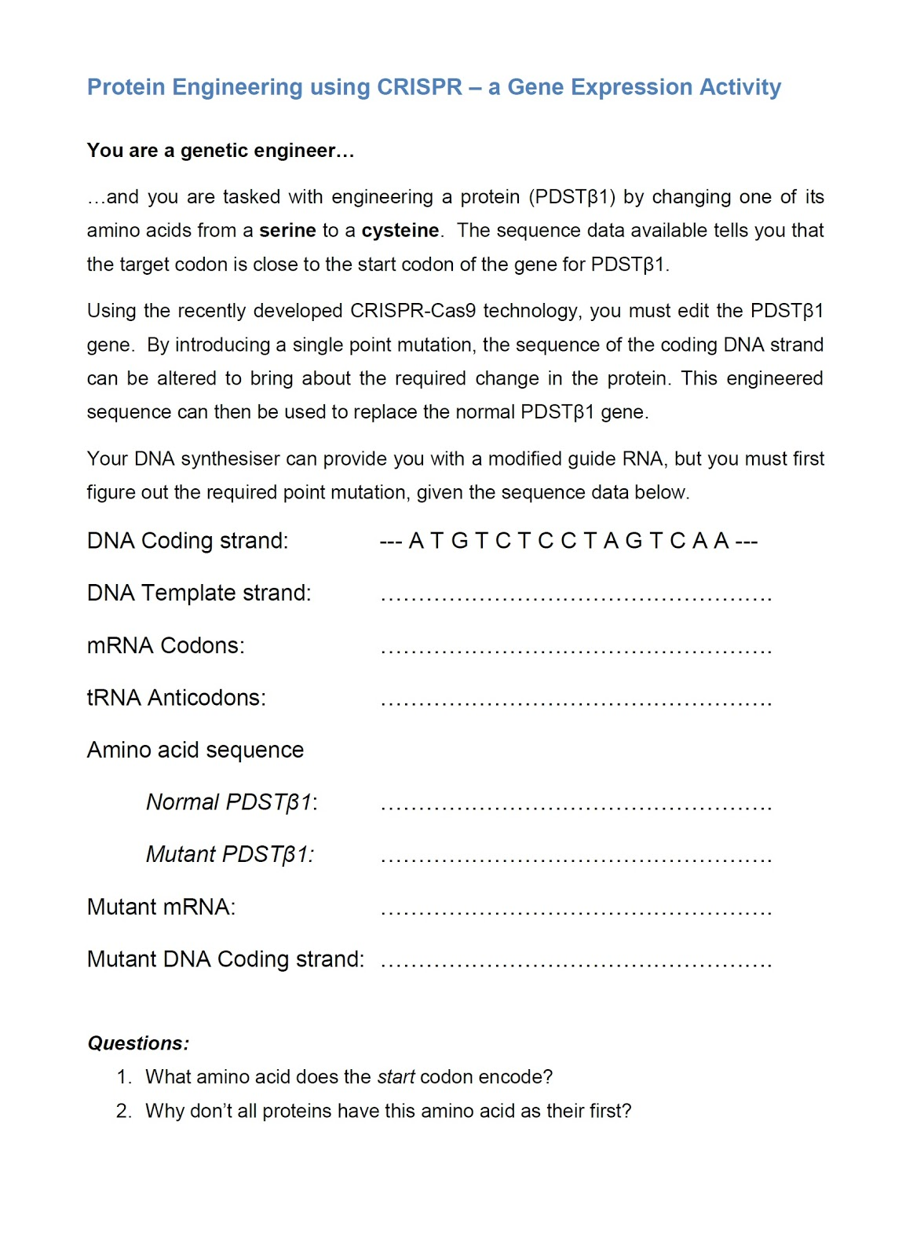

--- T A C A G A G G A T C A G T T ---
A U G - U C U- C C U- A G U - C A A
U A C - A G A - G G A - U C A - G U U

Met – Ser – Pro – Ser – Gln
Met – Cys- Pro – Ser – Gln
AUG – UGU – CCU- AGU – CAA
--- A T G T G T C C T A G T C A A ---

Methionine
Because this amino acid, although it’s the one that starts the synthesis of the protein, is sometimes removed at the end of the synthesis.

