1. A) What are your **go to** ways to cure a cold?

B) Can you provide an example of **hogwash**?

C) What is a **gut feeling**? Do you usually listen to your gut feeling?

D) What could be described as **funky**?

E) What kind of behaviour would **throw you off** on a first date?

1. What are these cold?

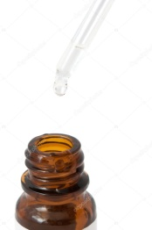 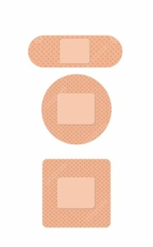 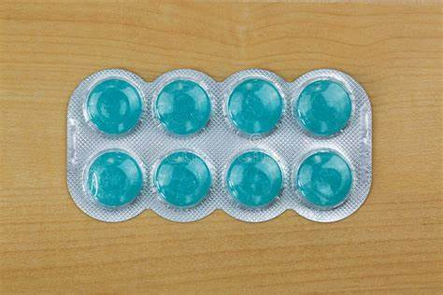

­­­­­--________________ __________________ ­­­­­­­­______________________

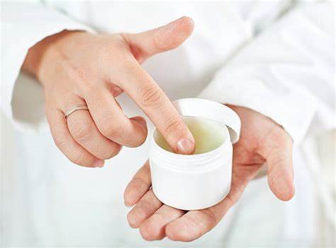 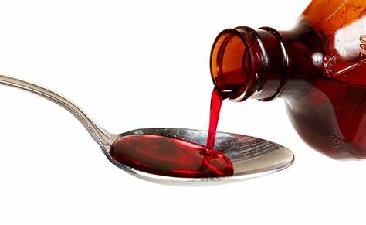 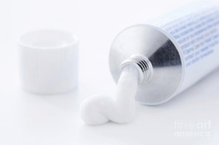

­­­­_______________ ­­­­______________________ ­­­­­­­­­________________

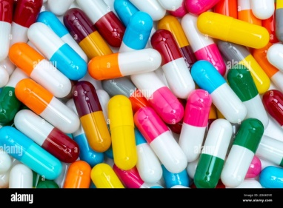 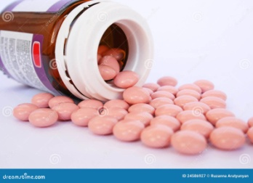

_____________________ ­­­_____________________

1. A) Which things or people are **overblown** in contemporary media?

B) What is **ancient wisdom**? Do you believe in it?

C) Would you **give** alternative medicine **a go**?

D) What are you **intrigued** with?

E) What does it mean to be **having a moment**?

1. Conversation questions
2. What types of alternative medicine do you know of?
3. Do you think that alternative medicine is effective?
4. Are there any categories of alternative medicine that you think could be classified as hogwash?
5. Have you ever tried alternative medicine? Would you try it? Which practice seems the most effective to you?
6. Do you like eating mushrooms?
7. Some people **claim** that food can be medicine. What do you think of it?
8. How likely are you to believe something related to health without scientific evidence?
9. What do you do to relax after a stressful day?
10. What are some beliefs based on ancient wisdom that you know of?
11. Task: Do a little research and find some natural/herbal remedies and describe how and why they are used OR find some remedies based on ancient wisdom used in the past that seem bizarre to the contemporary population.