Ahmed Mechri middle school-Rogassa
Full-name: ............................................................. School year : 2020-2021
Class: : 4 MS....... Duration : 45 minutes
First term English Test
Group: .........
TEXT: Maqam Eshaheed
"The Martyr's Memorial" located in Algiers , it was designed by "Bachir Yelles". This impressive monument symbolizes the Algerian war for independence.
It is one of the most attractive landmarks in Algiers. The monument was opened in February 1986 on the 20th anniversary of Algeria's Independence by the President Chadli Bendjedid. It is formed in the shape of three palm leaves , each representing a stage of Algiers' struggle. This historical landmark reaches a height of 92 meters above the three supporting fins. it has an Islamic-style tower. Underground , It includes a crypt, an amphitheater and the National Mujahid Museum.
Adapted by: the teacher
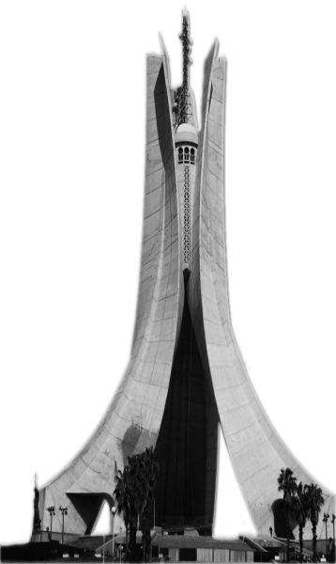

Part one (14pts): A) Reading comprehension (7pts)
Task one: Read the text and fill in the table below (3pts):
Landmark | Location | Designer | Date of opening | Height | Symbol of
………………  ......................................... | …………  ................ | …………..  ................... | …………………  ............................ | ………  ............ | …………..  .....................
Task two: Read the text again and answer the questions (2pts):
- Who opened Maqam Eshaheed? .........................................................................
- Does it include an Amphitheatre? ........................................................................
Task three: Find in the text synonym and opposite of the following words (2pts):
Attractive = …………. Closed ≠ ………………….
B) Mastery of language (7pts)

Task one: Supply punctuation and capitalization where necessary (2pts):
there are many landmarks in algiers such as the casbah
........................................................................................................................

Task two: Rewrite the sentences into Passive voice (3pts):
- Bologhine Ibn Ziri built the Casbah →. .................................................................
- A lot of tourists visited the Casbah. →. .................................................................
- They sold craft products . →. ...........................................................................
Task three: Classify the following words in the right box (2pts):

Shape – Height – Style – Stage
/ai/ like | 1-.........................................................................2-........................................................................
/ei/ Name | 1-.........................................................................2-........................................................................

Part Two (6pts): Integrated Situation
Your English teacher asked you to write an article about a famous landmark. You have chosen “the ancient Casbah”

Use the information in the chart below and write your article (6 to 8 lines).
Landmark | Location | Date of construction | The founder | Listed by UNESCO | The former name
Casbah | Algiers | 16th Century | Bologhine Ibn Ziri | Since 1992 | Icosium (Roman)

..............................................................................................................................................................................................
..............................................................................................................................................................................................
..............................................................................................................................................................................................
.............................................................................................................................................................................................
..............................................................................................................................................................................................
..............................................................................................................................................................................................
..............................................................................................................................................................................................
..............................................................................................................................................................................................
..............................................................................................................................................................................................
..............................................................................................................................................................................................
..............................................................................................................................................................................................
..............................................................................................................................................................................................

The best of luck Your teacher: Mr. Benguemmar Nacer

