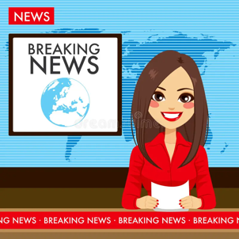**What happened in the world during summer 2025?**

**Match these headlines to the pictures below**

1) In June and July 2025→ Students in **Australia** and the **UK** organized nationwide protests against rising university fees and student loan reforms. Many high school students joined the movement, demanding affordable education and using the hashtag **#NoDebtFuture** on social media.

**2) July 4th** → A **lightning strike** ignited the **Dragon Bravo Fire** on the North Rim of **Grand Canyon National Park**, Arizona. Over the next month it expanded into a **megafire**, consuming more than **116,000 acres**(about 47,000 ha).

3) Netflix kicked off its summer slate with several standout new and returningseries.  June saw the release of *Squid Game Season 3*, which became Netflix’s biggest TV launch ever with over 60.1 million views in just three days. As August unfolds, Netflix’s *Wednesday – Season 2, Part 1*dropped on August 6, reuniting Jenna Ortega with a star-studded cast including Lady Gaga.

4) In early July 2025 → Central Texas’s Hill Country was struck by one of the deadliest flash floods in U.S. history. On **July 4**, remnants of **Tropical Storm Barry**, combined with Pacific moisture, unleashed over **20 inches (≈ 50 cm)** of rain in just a few hours. At least **135 people lost their lives**, including dozens of children and staff at **Camp Mystic**, a girls’ summer camp swept away in the floodwaters.

5) July 8th→President **E. Macron** and First Lady **B. Macron** were officially invited by **King Charles III** to the UK for a **state visit from 8 to 10 July 2025**, staying at **Windsor Castle**. It marked the **first state visit by a French president since 2008**, and the **first by an EU head of state since Brexit.** The French President met with **Prime Minister Keir Starmer** and opposition leaders at **Downing Street** on 9 July. They focused on migration (especially small-boat crossings), defence collaboration, trade, and investment.

6) **July 13th** → At **MetLife Stadium** in New Jersey, **President Donald Trump** appeared alongside FIFA president to present the **FIFA Club World Cup trophy** following **Chelsea FC’s 3‑0 victory over Paris Saint‑Germain**. Despite receiving a chorus of boos when he appeared on the jumbotron and entered the pitch, Trump remained unshaken—delivering the trophy to Chelsea captain, and later handing out runner‑up medals. He notably stayed on stage during Chelsea’s celebration.

7) August 12th → Taylor Swift officially unveiled her 12th studio album, titled The Life of a Showgirl. The announcement came at exactly **12:12 a.m. ET** during a playful reveal on the New Heights podcast hosted by her boyfriend Travis Kelce. Swift dramatically revealed the title from a mint-green briefcase marked “T.S.,” while her website immediately updated with a blurred orange and green album image and pre-order options though the official release date remains unconfirmed.

8) August 15th → Donald Trump and Vladimir Putin met in  **Alaska**, for the first U.S.–Russia summit in over a decade. The talks focused mainly on the **war in Ukraine**, but no ceasefire or peace deal was reached. Putin repeated his long-standing demands, while Trump insisted discussions were “productive” despite the lack of results.

9) August 14th to 17th → The first **World Humanoid Robot Games** took place in Beijing gathering over 500 robots from 16 countries. Robots competed in sports like football, boxing, and sprinting, as well as dance, martial arts, and service tasks.  
The Games showcased both the progress and challenges of humanoid robotics, aiming to inspire innovation and collaboration worldwide.

10) August 22nd →2025 Women’s Rugby World Cup officially began at Sunderland’s Stadium of Light. The host nation England’s Red Roses kicked off the event with a commanding match against the USA, winning 69-7.

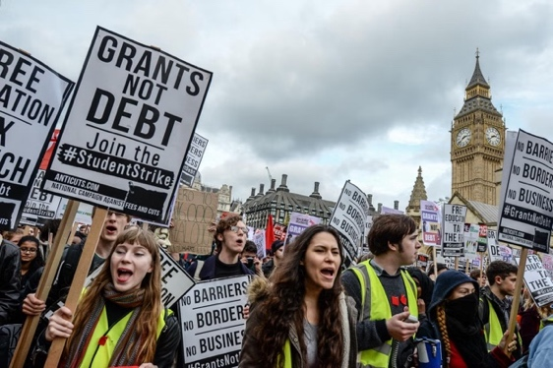

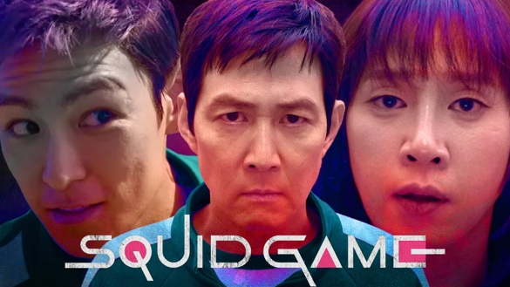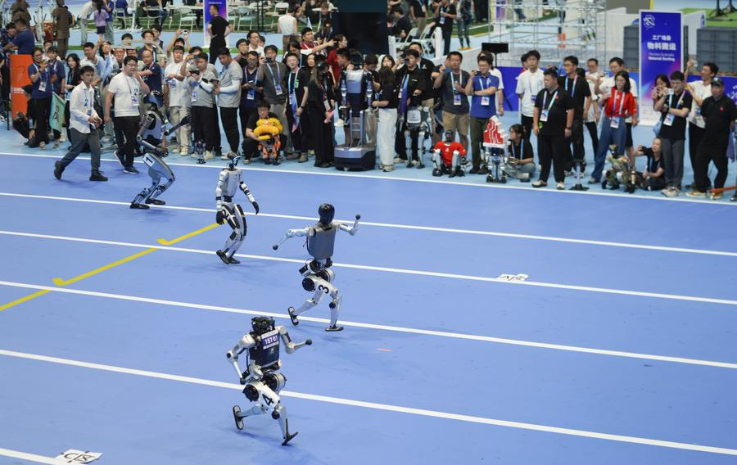

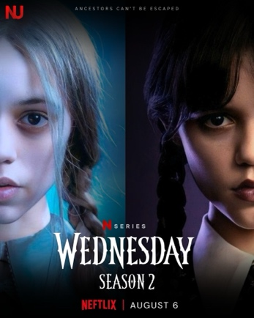

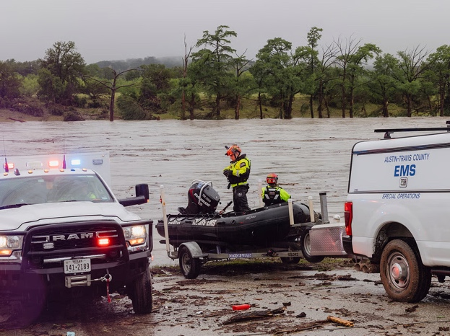

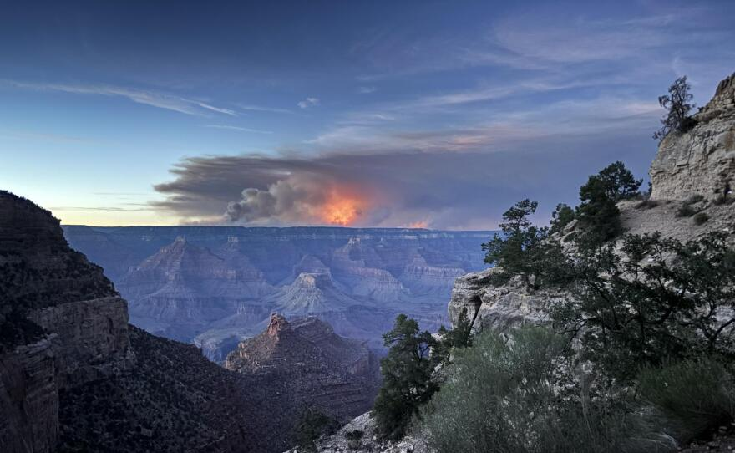

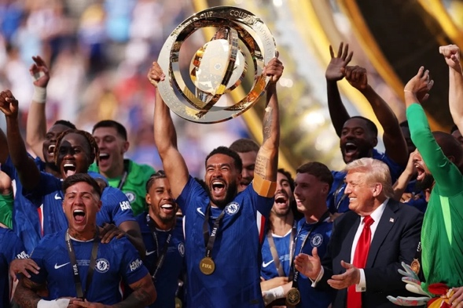

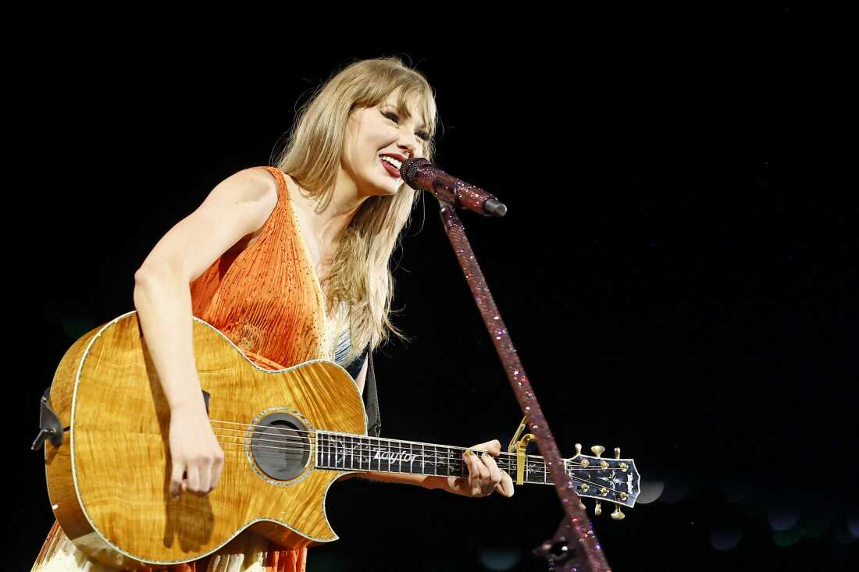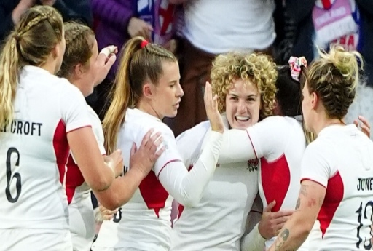

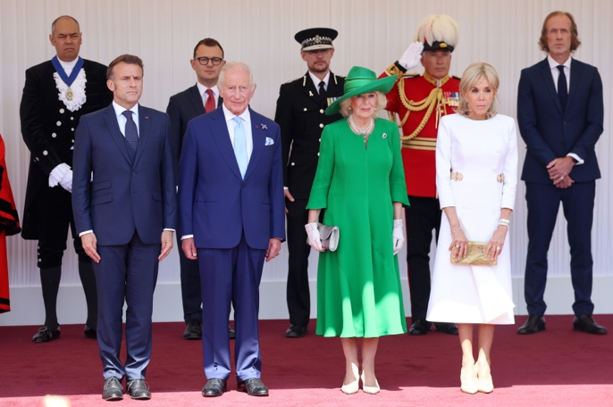

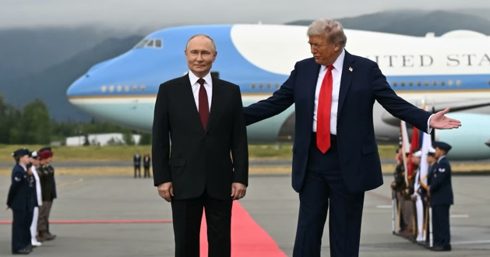

* **What’s the English for?**

exiger→ humidité/hydratation →

déclencher/provoquer→ une inondation→

remarquable/exceptionnel → balayer/éradiquer→

lancement→ une huée →

prestigieux/constellé d’étoiles→ vice-champion→

apparaître/déplier→ donner le coup d’envoi→

* **Look at all the verbs ending in –ED (preterite) in the first five paragraphs (there are 10 of them). Classify them according to the pronunciation of the ending.**

|  |  |  |
| --- | --- | --- |
| [d] as in *opened* | [id] as in *invented* | [t] as in *walked* |
|  |  |  |

* **Find the words corresponding to the phonetic transcriptions in the headlines above.**

/ˈdɛt/→ /ˈstɑːrstʌdɪd/→

/ˈsəʊʃəl/→ /ˈleɪtər/→

/ɪgˈnaɪt/→ /ˈwɪm*ɪ*n/→

/rɪˈliːs/→ / ˈɪmɪdʒ/→

**Finally, it’s your turn to write about an international or personal event**

_________________________________________________________________________________________________________________________________________________________________________________________________________________________________________________________________________________________________________________________________________________________________________________________________________________________________________________________________________________________________________________________