Topic : Australia and the Environment : Man and Nature
AXE 1: Man and Nature
KEY QUESTION: How do Australians interact with their environment, and what does this reveal about their relationship with nature in the context of climate change?

LESSON 2
Aborignal perspective :
Nature as a spiritual being

Key question: How does the Aboriginal spiritual vision of nature shape humans’ relationship with the land?

Activity 1 :

Observe the title “ The Rainbow Serpent” and the illustration.
- Present and describe the document below.
- What do you expect the text to be about ?
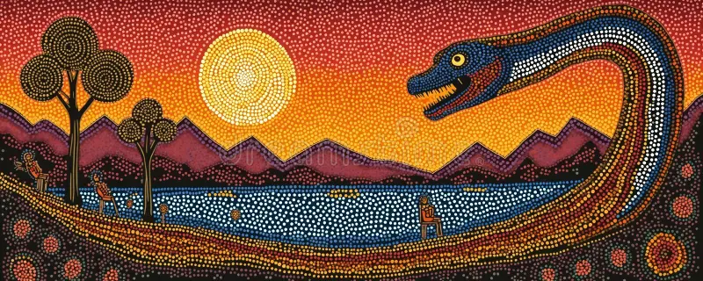
Aboriginal dot art vector painting. The Rainbow Serpent, dreamtime story.

Activity 2 : Reading (Aboriginal Dreamtime Story – adapted version, level B1+)

« Long ago, before there were trees, rivers or animals, the Earth was flat, dry and silent. Nothing moved and nothing lived on the land. Deep under the ground, the Rainbow Serpent was sleeping in a long and peaceful slumber.
One day, she woke up and slowly began to travel across the land. As she moved, her long body shaped the ground. She created hills, valleys and deep lines in the earth. These lines later became rivers and lakes.
Then the Rainbow Serpent called the frogs to come out of the ground. The frogs had been sleeping for a very long time, and their bellies were full of water. When they laughed, the water came out and filled the deep lines in the land. Soon, rivers and lakes appeared everywhere.
After that, grass, trees and flowers began to grow. The land became green and alive. Many animals woke up: kangaroos, birds, reptiles and insects. They started to walk, fly and swim across the new world.
The Rainbow Serpent then made laws for all living beings. She asked the animals and the humans to respect the land and to live in harmony with nature. Those who obeyed the laws were rewarded and became humans. They received a totem, a special animal that protected them and guided them.
But some creatures did not obey the laws. They were punished and turned into stones, hills and mountains. In this way, the Rainbow Serpent shaped the landscapes of Australia.
The humans lived on the land and took care of it. The Rainbow Serpent told them that the land would always belong to them if they respected it and protected it. But if they forgot the laws, the land could be taken away from them.
Today, when people see a rainbow in the sky after the rain, they remember the Rainbow Serpent. She is a symbol of life, water and creation, and she reminds humans that nature is sacred and must be respected. »
This story is based on a traditional Aboriginal Dreamtime story

Useful vocabulary
- slumber: long sleep • shaped: formed
- obey / disobey: follow / not follow rules •sacred: holy, very important
- punished / rewarded: given a bad or good result
- totem: a spiritual animal that protects a group

1- Present the document : type of document? The main character?
The main topic of the text? ☐ the creation of the Earth
☐ a conflict between tribes
☐ a journey across Australia

…………………………………………………………………………………………………………
………………………………………………………………………………………………………...

2- a) What was the Earth like at the beginning?
…………………………………………………………………………………………………………

b) What natural elements did the Rainbow Serpent create? (two examples)
…………………………………………………………………………………………………………

c) How were rivers and lakes formed?
…………………………………………………………………………………………………………

3- Put the following events in the right order:
❑ The animals woke up
❑ The frogs released the water
❑ The Rainbow Serpent travelled across the land
❑ The laws were created

4- What laws did the Rainbow Serpent make?
…………………………………………………………………………………………………………

5- What happened to those who obeyed the laws? What happened to those who disobeyed the laws?

…………………………………………………………………………………………………………

…………………………………………………………………………………………………………

6- What does the Rainbow Serpent symbolise in Aboriginal culture ?
…………………………………………………………………………………………………………

8- Why is nature presented as sacred?
…………………………………………………………………………………………………………

9- What lesson does this story teach about humans’ relationship with the land?
…………………………………………………………………………………………………………

Activity 3 : Video Aboriginal Culture and Dreamtime

GLOBAL COMPREHENSION
- What is the main topic of the video?
☐ Aboriginal food traditions
☐ Aboriginal history at school
☐ Aboriginal beliefs about creation and nature
- What is the general message of the video?
☐ Nature is dangerous
☐ Nature is a spiritual and sacred element
☐ Nature is only a resource for humans
- Who are the main characters in the stories mentioned?
☐ Modern scientists
☐ Aboriginal ancestors and spirits
☐ European settlers

MAN AND NATURE

A. Nature as a spiritual being
- According to the video, what is the Dreamtime?
→ ………………………………………………………………………………………….
- What role do the ancestral spirits play in the creation of the land?
→ ………………………………………………………………………………………….
- Name two natural elements created by the ancestral beings.
→ ………………………………………………………………………………………….

B. Humans and the land
- How do Aboriginal people see the land?
☐ as private property
☐ as a living and spiritual entity
☐ as an economic resource
- What relationship should humans have with nature, according to the video?
→ They should ……………………………………………………………………….
- According to the video, how do Aboriginal people behave towards the land and nature? Describe their relation with nature.
………………………………………………………………………………………………………
………………………………………………………………………………………………………
………………………………………………………………………………………………………
………………………………………………………………………………………………………
10- Complete the sentence:
For Aboriginal people, humans are not the owners of the land, but its……………..

C. Interpretation
- Why can we say that nature is “alive” in Aboriginal culture?
→ …………………………………………………………………………………………...
→ …………………………………………………………………………………………...
- In what way is this vision different from a Western vision of nature?
→ …………………………………………………………………………………………...
→ …………………………………………………………………………………………...

Use the documents : the video and the story “The Rainbow Serpent” to answer in about 8–10 lines.
“How do Aboriginal stories and beliefs show that nature is a spiritual being and not just a resource for humans?”
Write 8–10 lines or prepare a 1-minute oral answer.
………………………………………………………………………………………………………
………………………………………………………………………………………………………
………………………………………………………………………………………………………
………………………………………………………………………………………………………
………………………………………………………………………………………………………
………………………………………………………………………………………………………
………………………………………………………………………………………………………
………………………………………………………………………………………………………
………………………………………………………………………………………………………
………………………………………………………………………………………………………

Activity 3 : Video “Uluru: Australia’s sacred mountain”

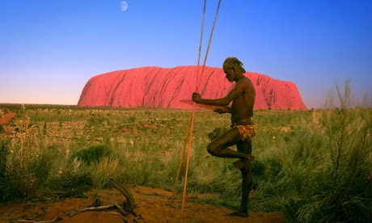
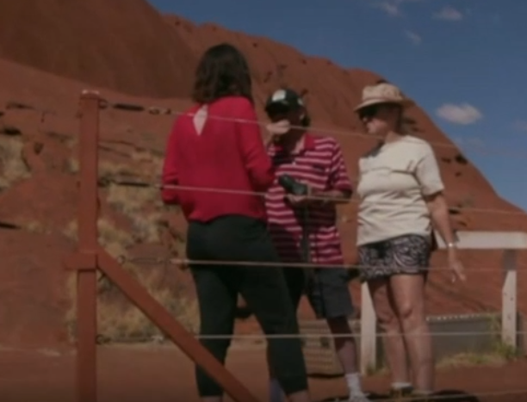

1- Look at both photos and discuss their similarities and differences.
………………………………………………………………………………………………………
………………………………………………………………………………………………………
2- Judging from the title and the photos, guess what the video is about.
………………………………………………………………………………………………………
………………………………………………………………………………………………………
3- Now watch the video and take notes about :
- what Uluru is.………………………………………………………………………………………………………
………………………………………………………………………………………………………
- the tourists : where they come from and why.
………………………………………………………………………………………………………
………………………………………………………………………………………………………
- the Aboriginal people and why they do not want tourists to come.
………………………………………………………………………………………………………
………………………………………………………………………………………………………
4- Describe what Uluru means to Aboriginal people.
………………………………………………………………………………………………………
………………………………………………………………………………………………………
……………………………………………………………………………………………………...

