**🎶 Vocabulary Activities – Irish Music & Instruments**

**🎨 Activity 1 – Match the picture with the name**

**Instructions:**

a) Read the following text about the traditional Irish inustruments :

“Traditional Irish Instruments: A Brief Guide” (adapted)

Traditional Irish music has a long history and is known for its distinctive instruments. The bodhrán, a type of drum, provides the rhythm. The tin whistle, a simple wind instrument, produces a sweet and high-pitched sound. The uilleann pipes, similar to bagpipes, are played with the elbows and create a haunting melody. The fiddle, which looks like a violin, plays fast and energetic tunes. The Celtic harp is one of the oldest symbols of Ireland and adds elegance to traditional songs.

Today, these instruments are often heard during festivals, family gatherings, and even in pubs. They are not only tools for making music — they are symbols of Irish identity and tradition.

→ Activité proposée : associer instruments et fonctions, repérage du présent simple, lexique culturel.

b) Match each picture with the name of the instrument. Paste or draw the image next to the correct label.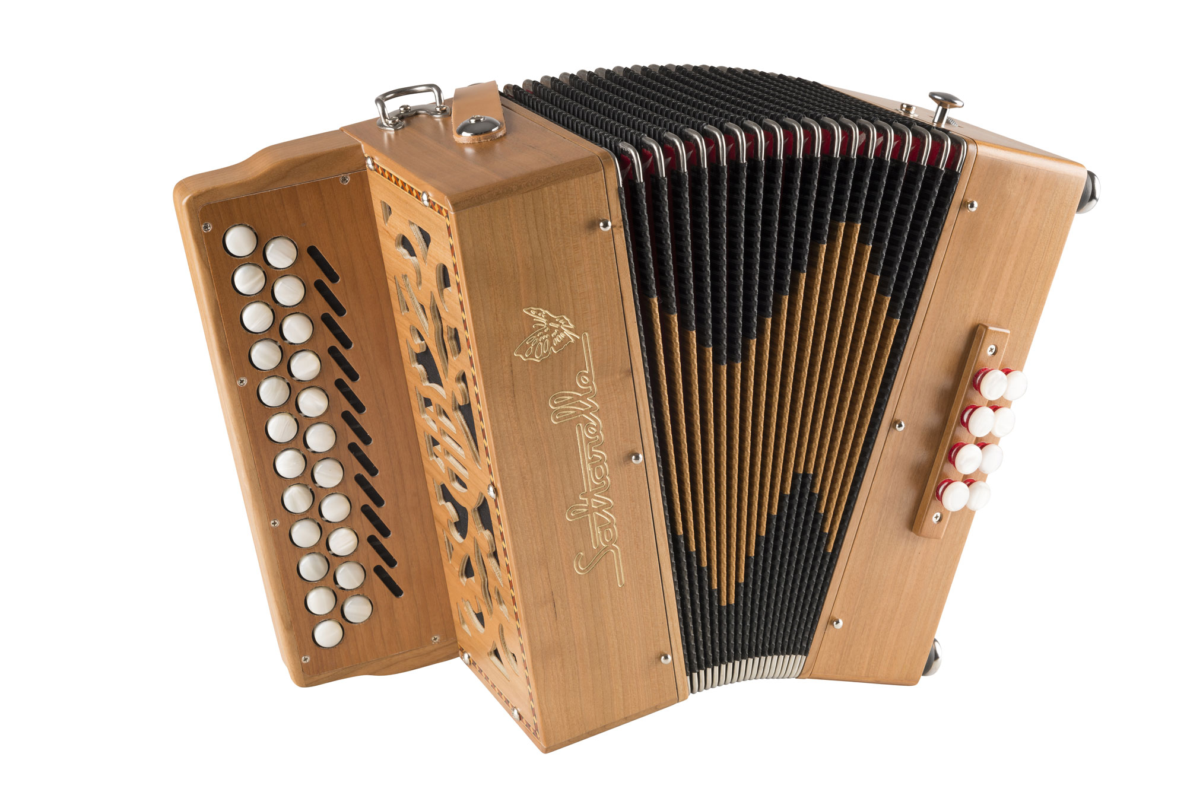  
Write the number of the image next to the correct name.

1. 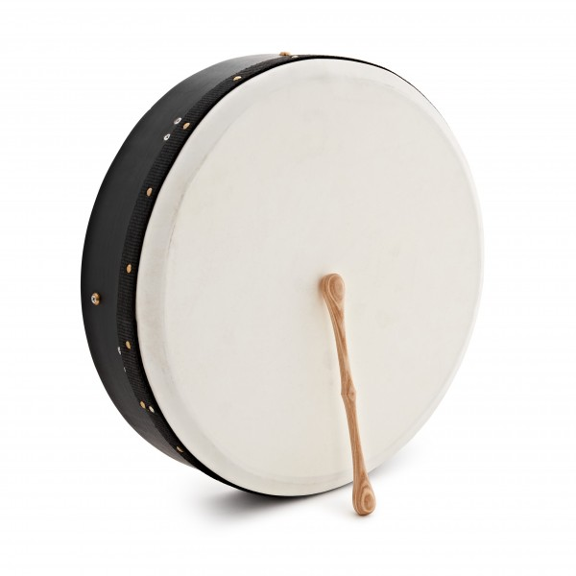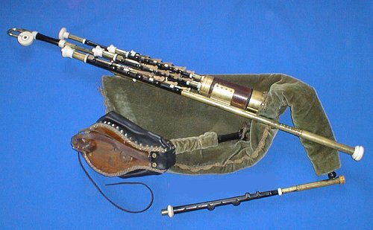Fiddle
2. Bodhrán
3. Tin Whistle
4. Uilleann Pipes
5. Irish Harp
6. 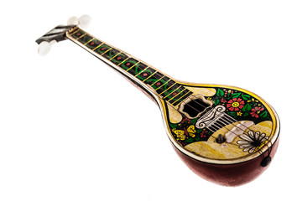Banjo
7. 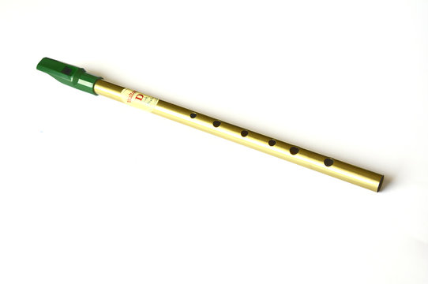Accordion
8. Concertina
9. 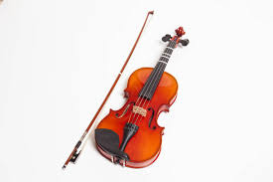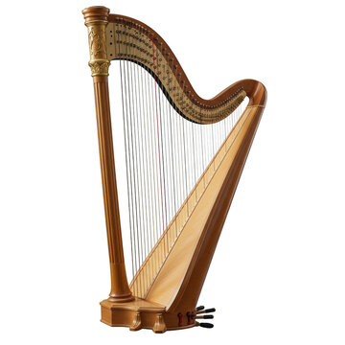Bouzouki

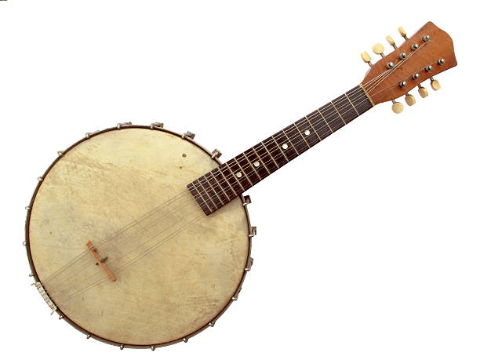

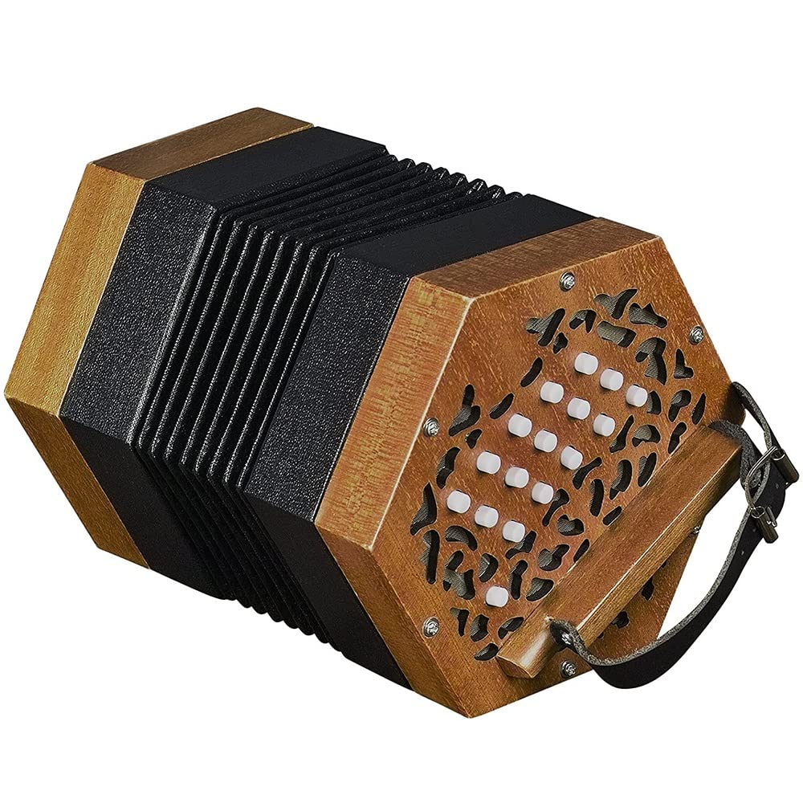

**🔍 Activity 2 – Word Search**

**Instructions:** Find the following 8 words hidden in the grid. Circle them.

**Words to find:**  
banjo – fiddle – harp – bodhrán – whistle – pipes – flute – bouzouki

B O D H R A N Q P I P E S

A K W T M F L U T E U H Y

N W H I S T L E I R D D M

J Z V D X H B Z O M G A A

O R R D E I J D B A C R D

U L K F I D D L E I T I I

K Y O O Q B I R M I H S T

O C B A N J O P R C I H I

U B O U Z O U K I L M A O

I D B G U W V O D H E F N

**✍️ Activity 3 – Complete the sentences**

**Instructions:** Use the words from the box to complete each sentence.

**Word bank:**  
fiddle – rhythm – lyrics – perform – chorus – tune – traditional – band

1. U2 is a very famous _________.
2. The _________ of this song is so catchy!
3. Many Irish people love to _________ music in pubs.
4. The _________ repeats several times in the song.
5. Irish dancers need to follow the _________ very precisely.
6. I love the _________ of this ballad.
7. The _________ is a key instrument in Irish folk music.
8. “Danny Boy” is a very _________ Irish song.

**💬 Activity 4 – Odd One Out**

**Instructions:** In each group of four words, find the one that does not belong and explain why.

1. Bodhrán – Fiddle – Violin – **Pizza**
2. Chorus – Lyrics – Tune – **Football**
3. Tin Whistle – Banjo – Accordion – **Calculator**
4. Perform – Sing – Dance – **Write**

**🗣️ Bonus Activity – Interview a Classmate (Oral)**

**Instructions:** Work in pairs. Ask your partner the following questions. Then, tell the class what you learned.

* What’s your favorite musical instrument?
* Do you know any Irish instruments?
* Do you play any instrument?
* What kind of music do you like?
* Have you ever heard Irish traditional music?