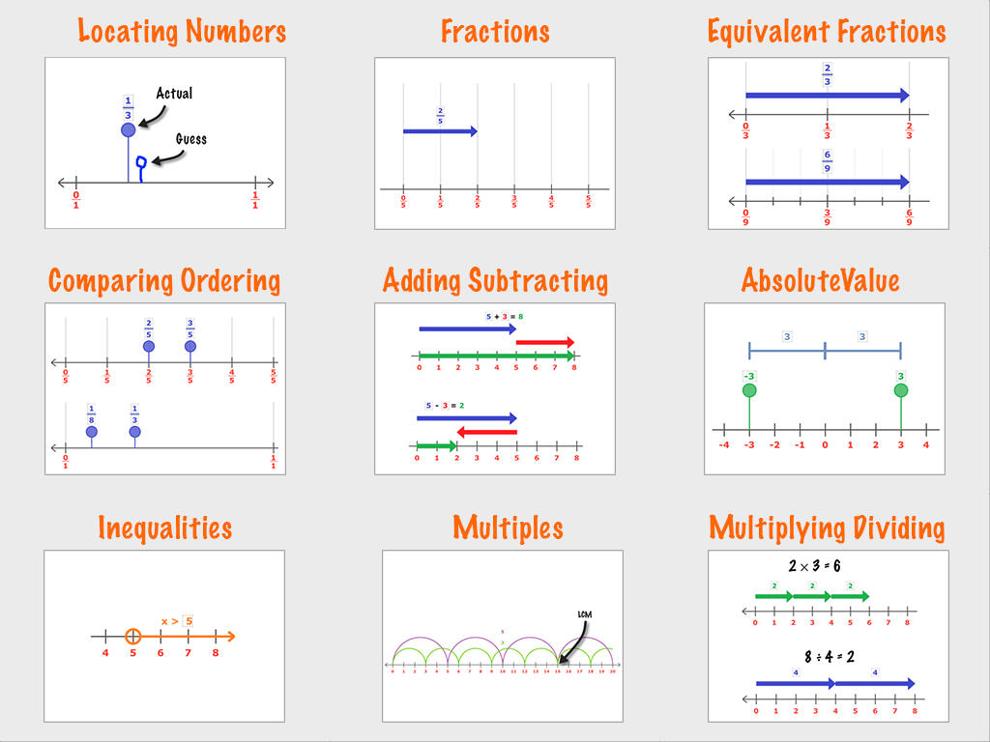

Get curious and explore as many of these topics as possible today using number lines !