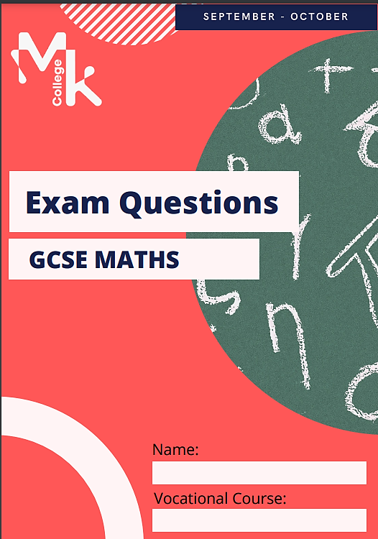
TARGET BOOKLET
GCSE MATHS
2022-23

Contents

Targets…………………………………………………………Page 3

Introduction to Number…………………………………..…Pages 4-10

Fractions …..………………………………………………….Pages 11-18

Percent..………………………………………………………..Pages 19-25

Ratios……………………………….…………………………..Pages 26-32

Scale and Maps………………………………………….........Pages 33-38

Introduction to Algebra …………………………….………..Pages 39-48

Substitution……………………………………………….……Pages 49-55

Linear equations and inequalities………………….………Pages 56-62

Circle ………………………………….………………….……..Pages 63-68

All Questions are from AQA past papers and topic tests

Source | Target | Completion (Y/N)

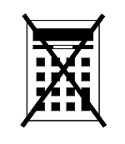
Number

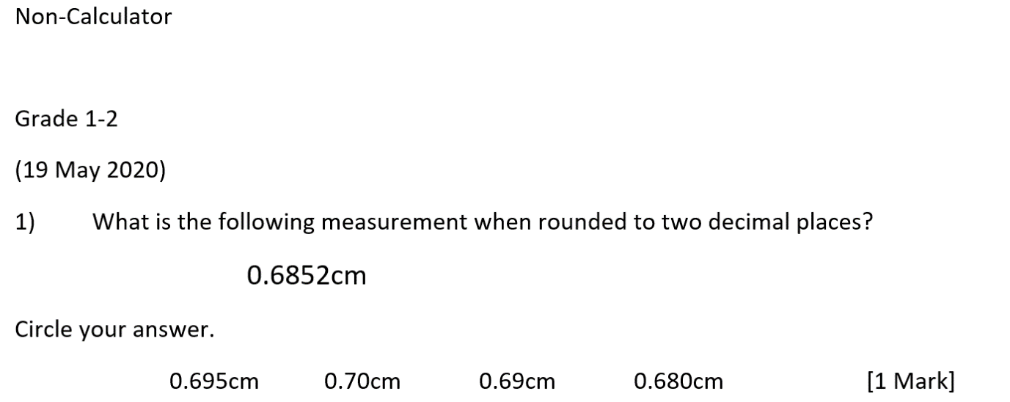

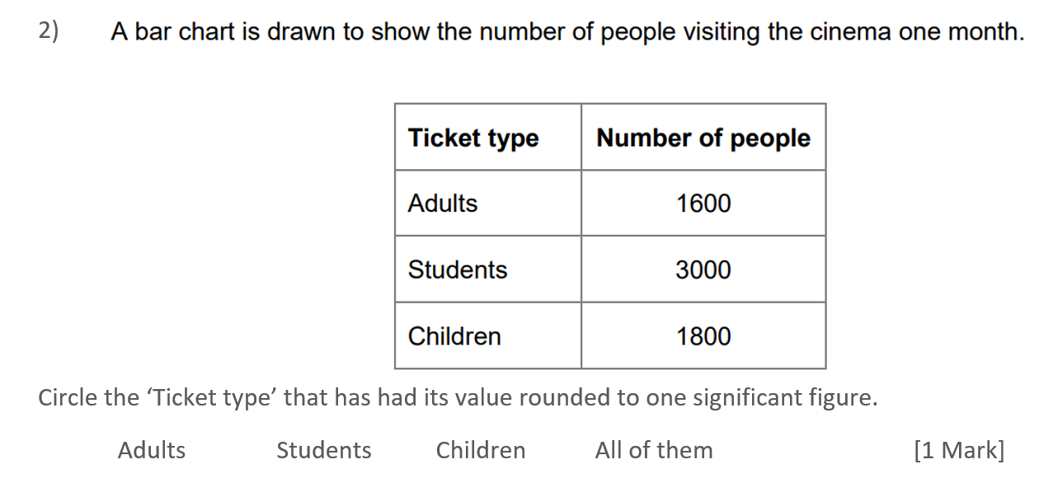

(19 May 2020)

Grade 3
(21 May 2019)
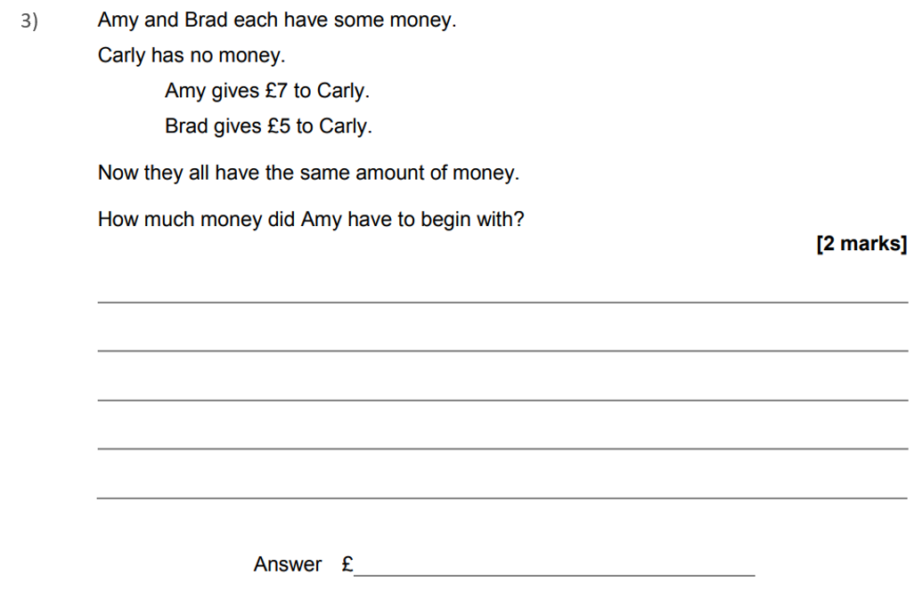

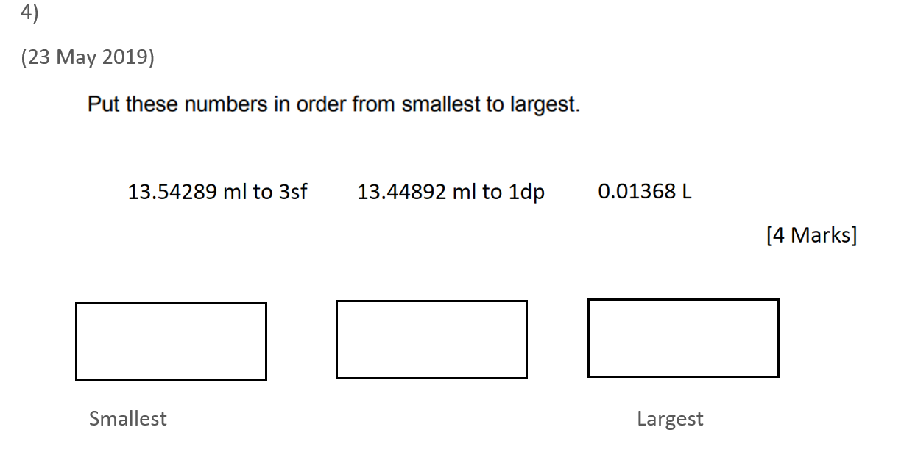

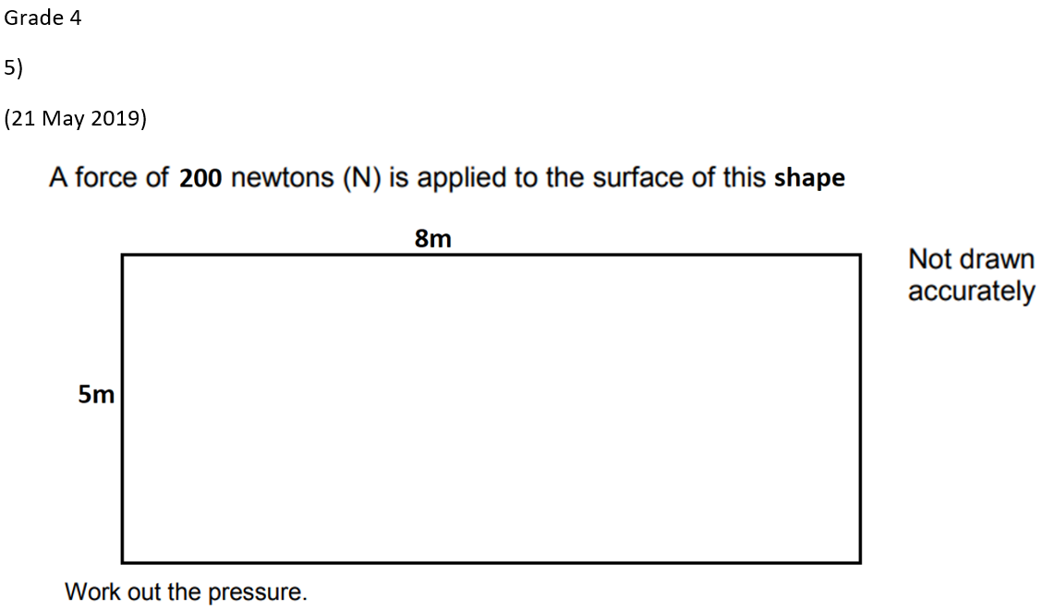

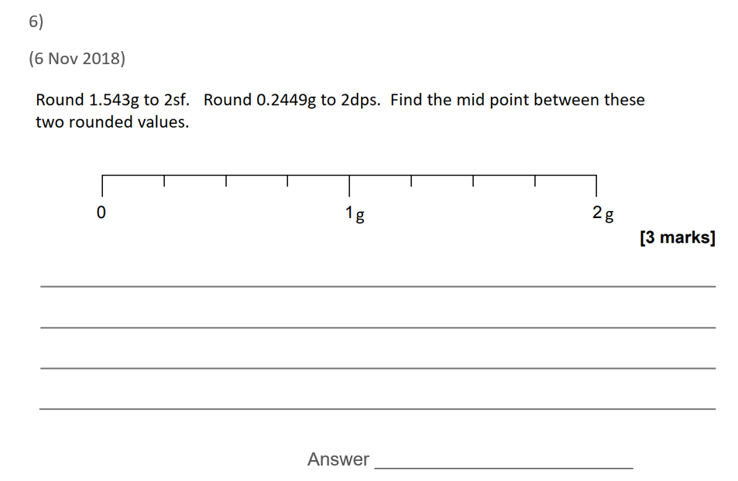

Number

Calculator

Grade 1-2

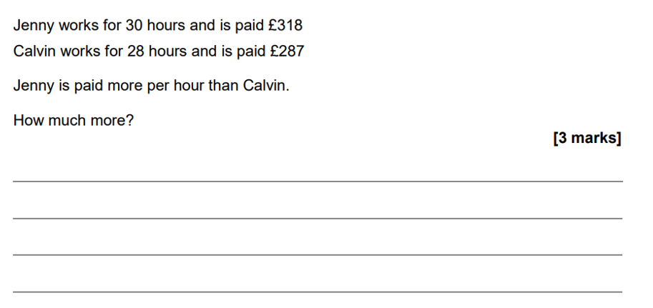
(4 June 2020)

Answer __________________________

(8 June 2020) 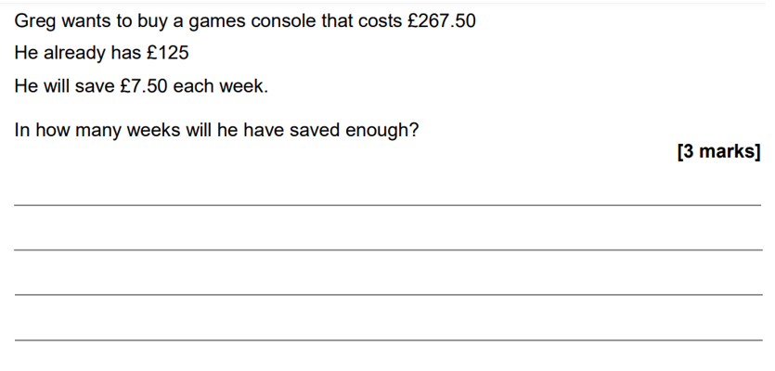
Answer __________________________

Grade 3

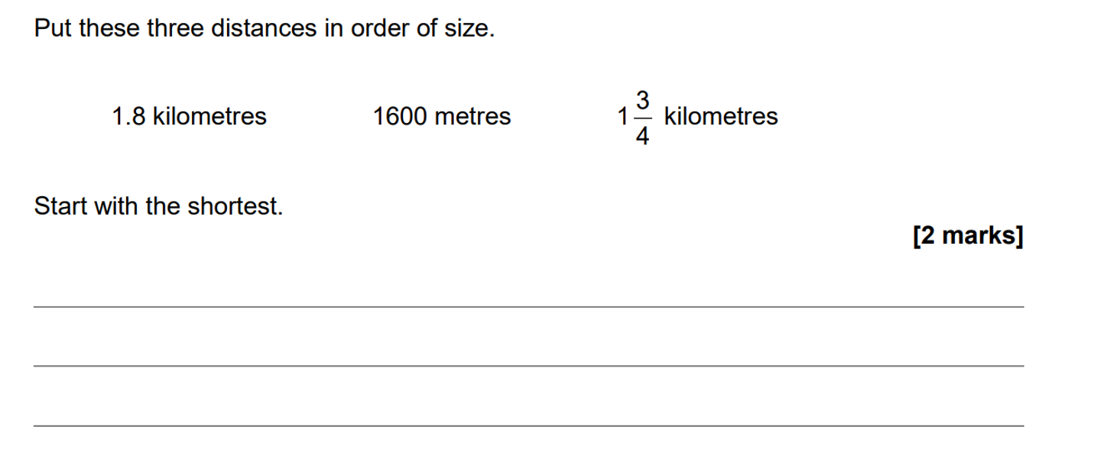
(8 June 2020)

(8 June 2020)
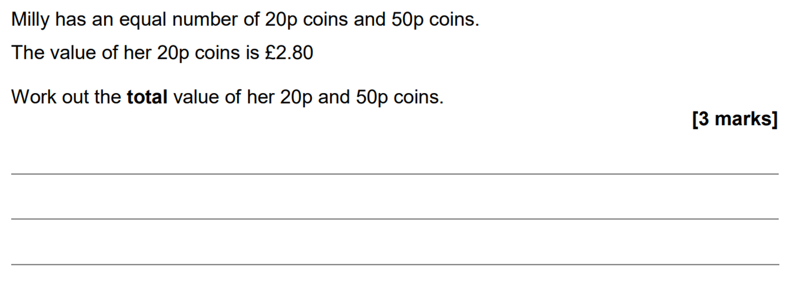

Grade 4

(8 June 2020)
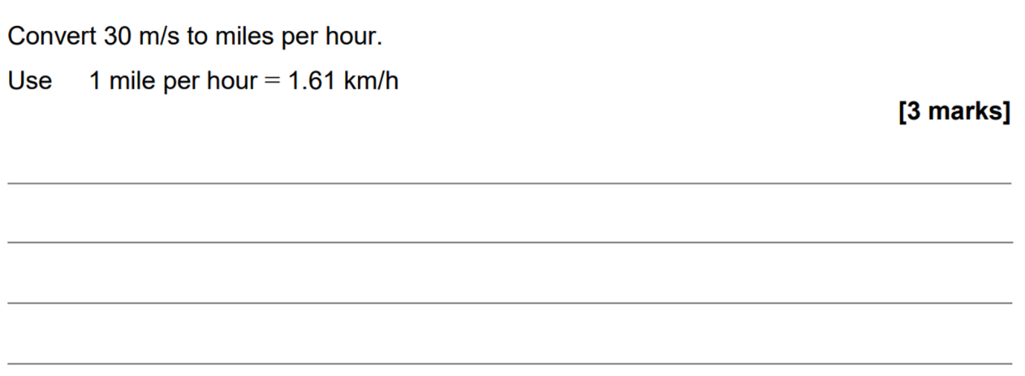

(11 June 2019)
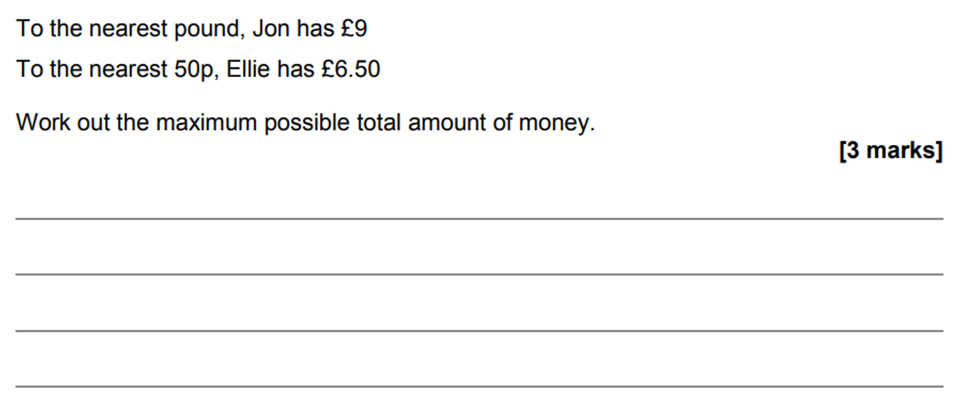
Answer £ _______________________

QR Links for Learning Resources and Extra Practice

Notes

___________________________________________________________________

___________________________________________________________________

___________________________________________________________________

___________________________________________________________________

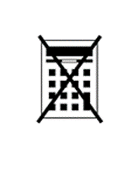
Fractions

Non-Calculator

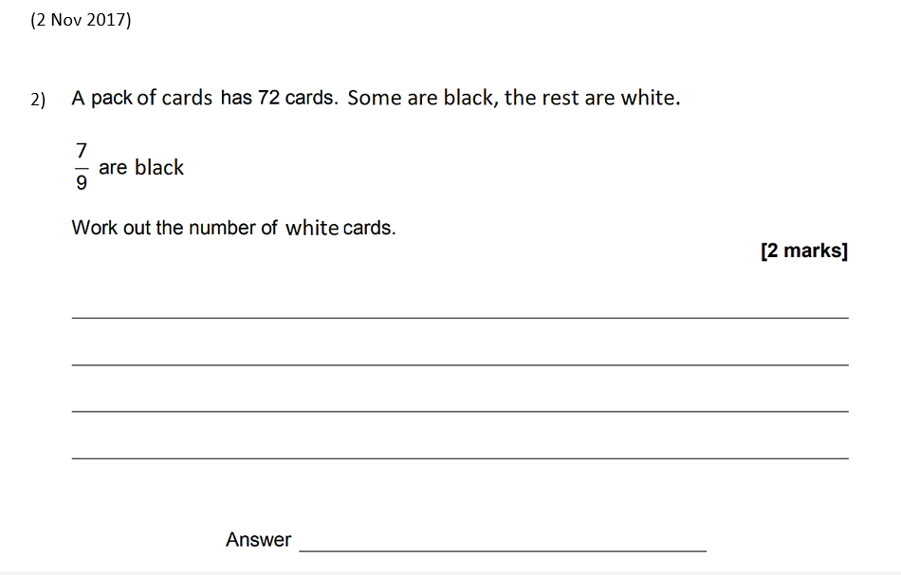
Grade 1-2

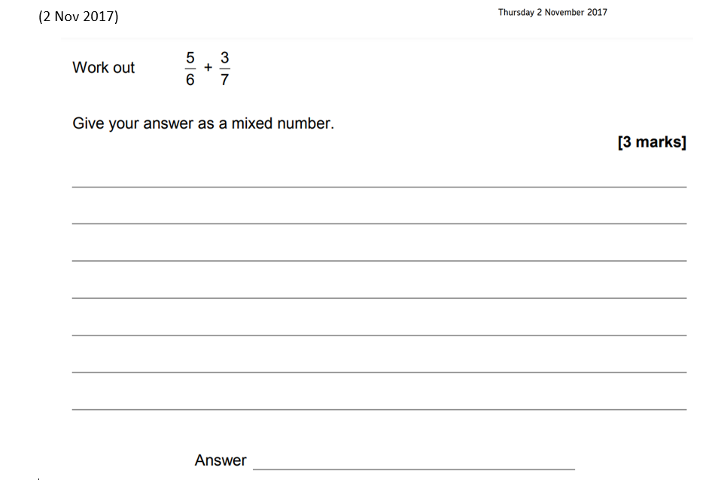
Grade 3

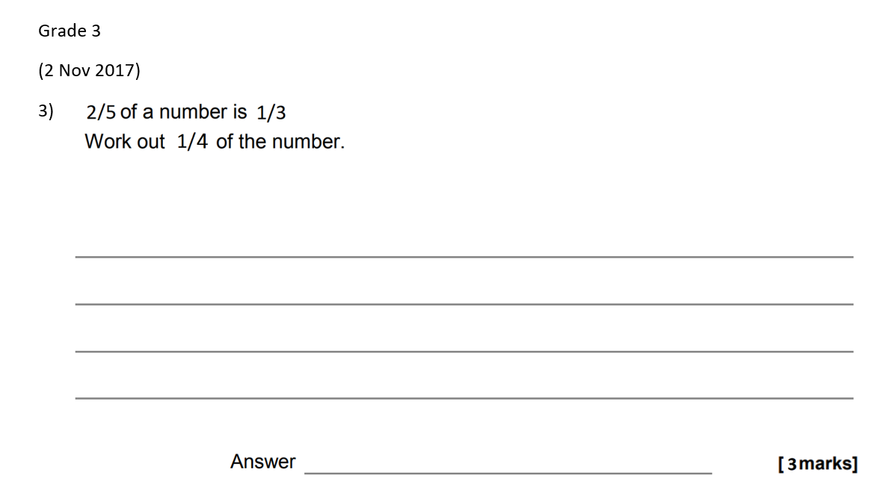

Fractions

Calculator

Grade 1-2
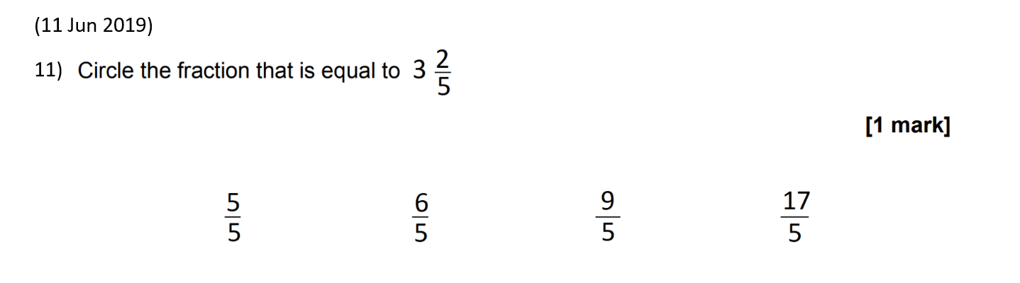

(20 May 2022 predicted)
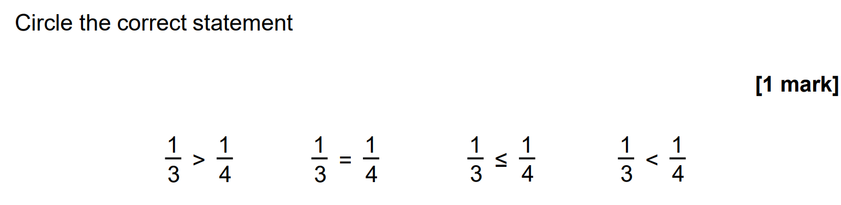

Grade 3
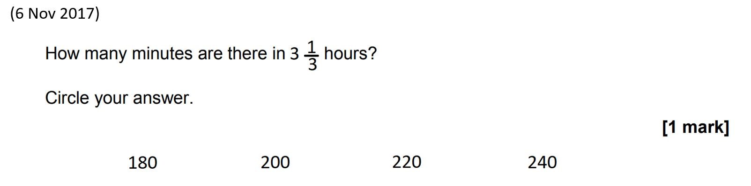

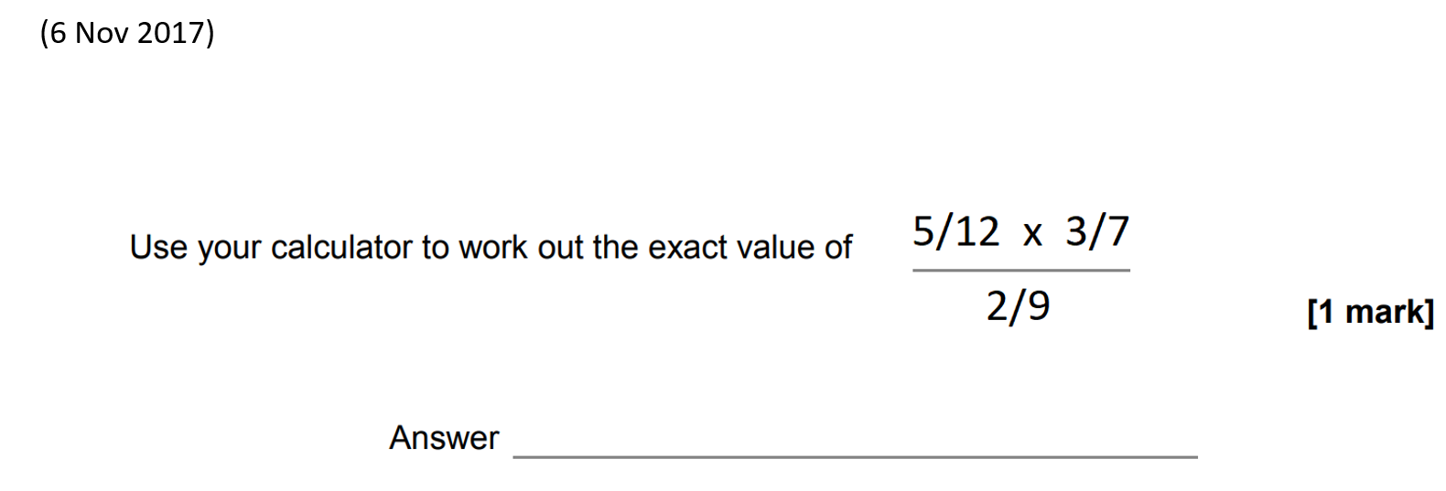

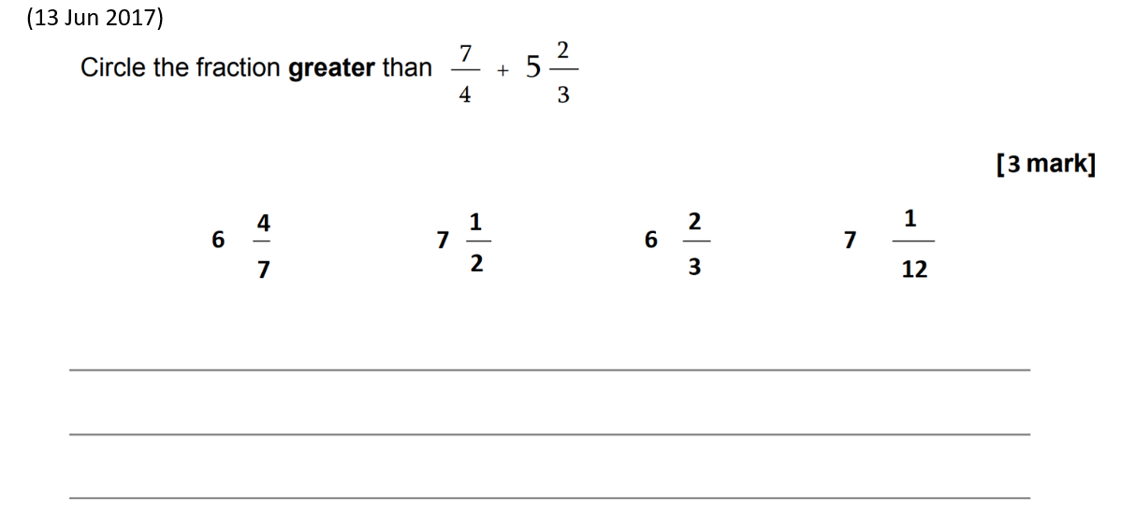

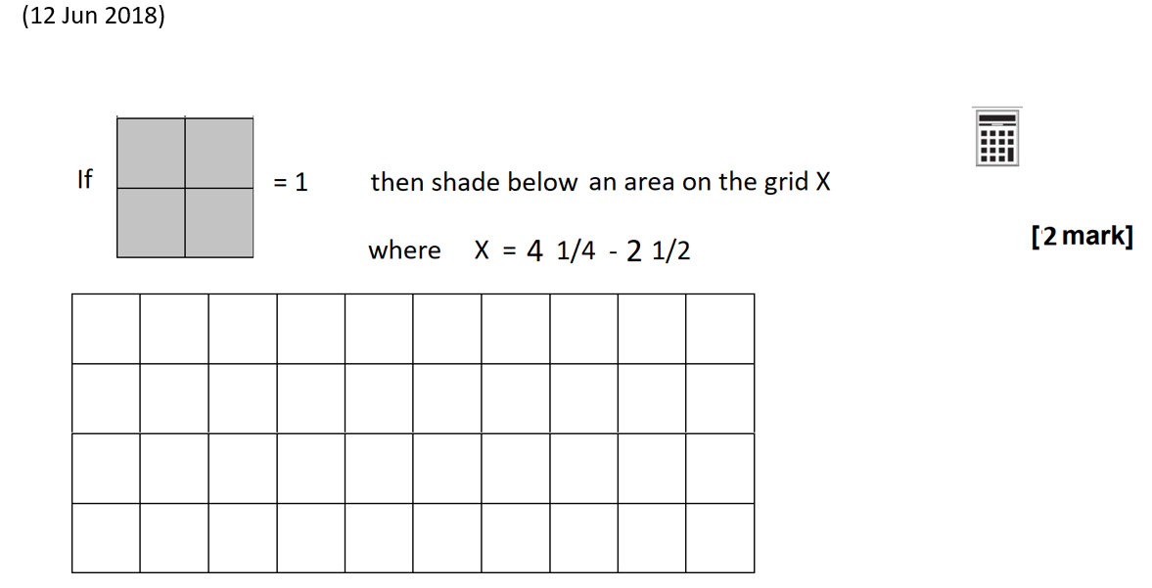
Grade 4

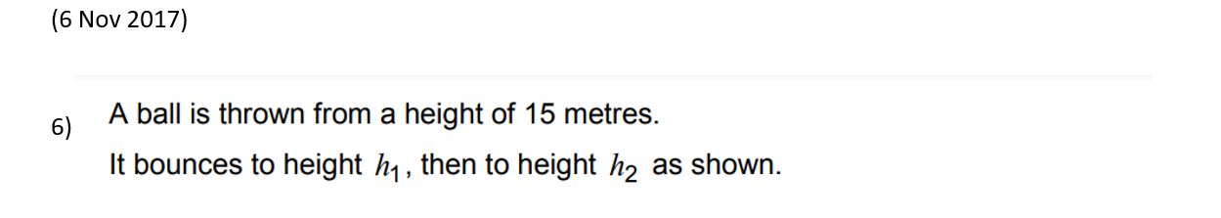
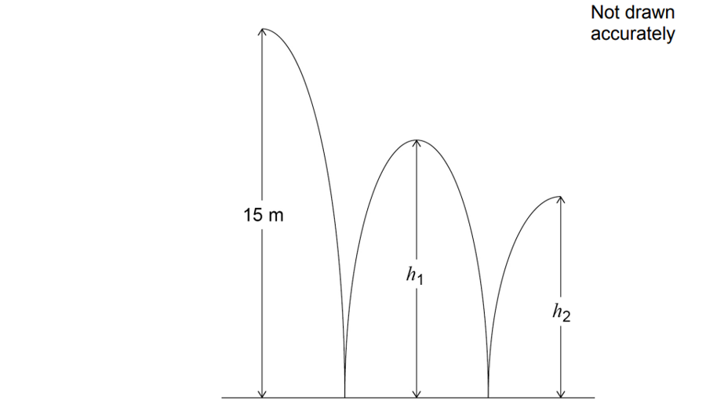
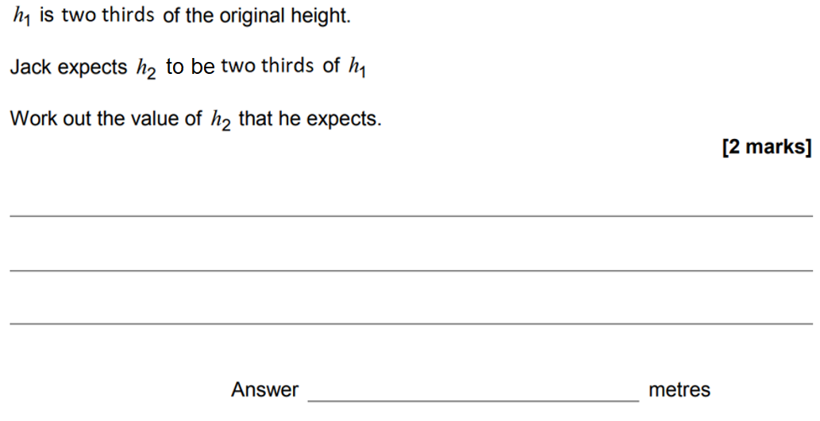

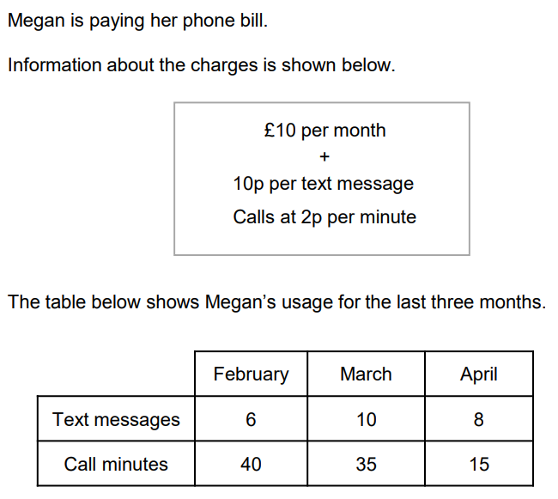
(20 May 2022 predicted)

Find Megan’s greatest phone bill as a fraction of her lowest, writing your answer as a top heavy fraction in its simplest terms.
____________________________________________________________________________________________________________________________________________________________________________________________________________________________________________________________________________

QR Links for Learning Resources and Extra Practice
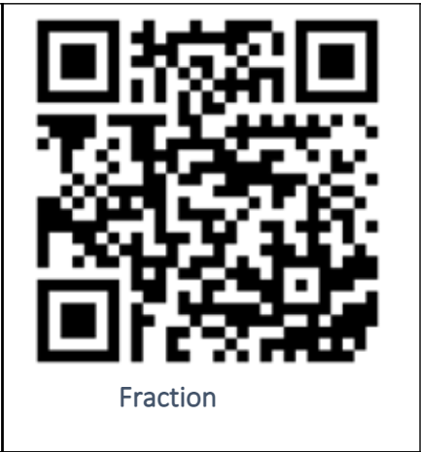

Notes

___________________________________________________________________

___________________________________________________________________

___________________________________________________________________

___________________________________________________________________

Percent

Non-Calculator

Grade 1-2

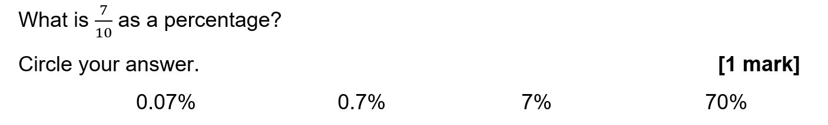

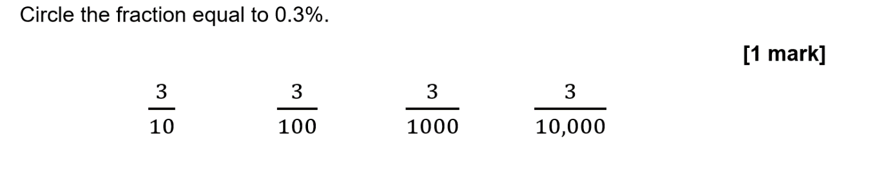

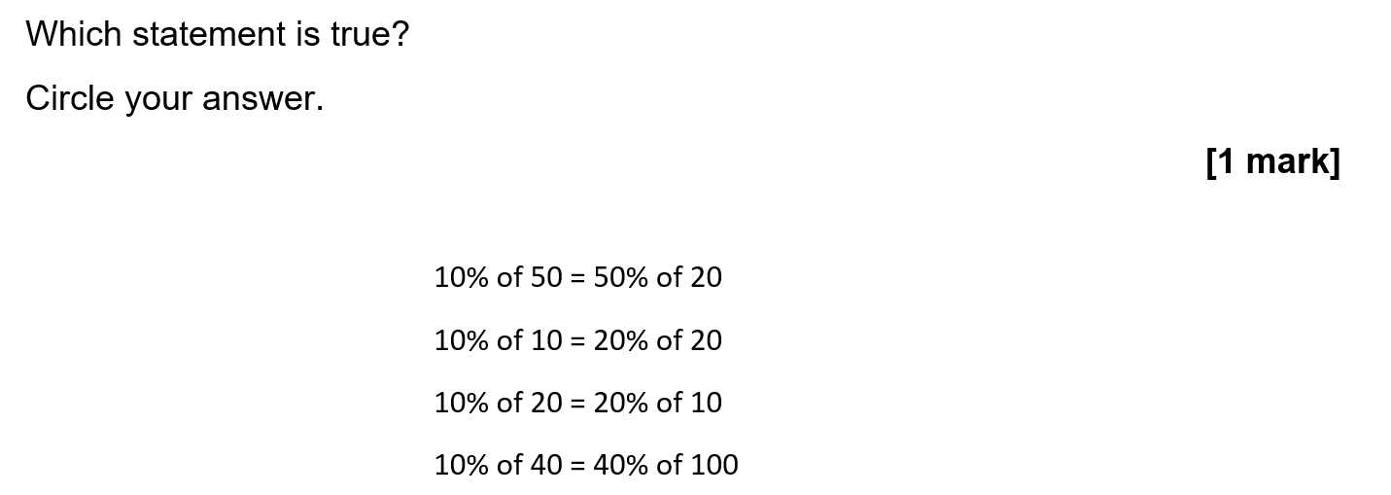

Grade 3

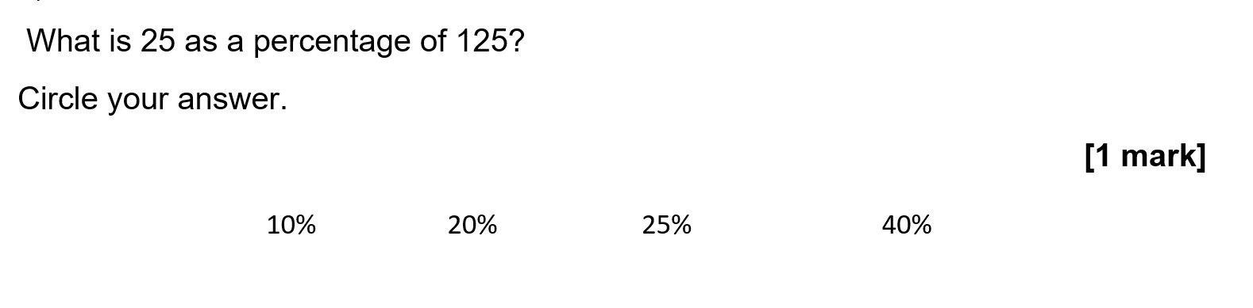

Grade 4

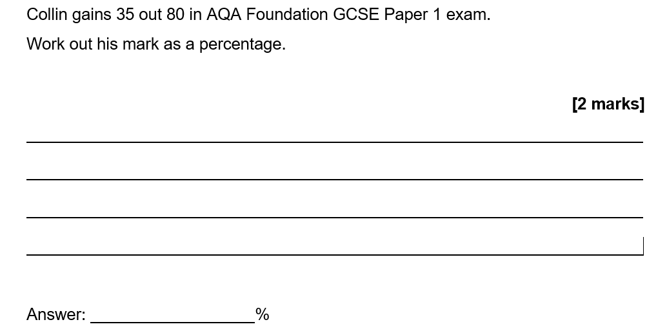

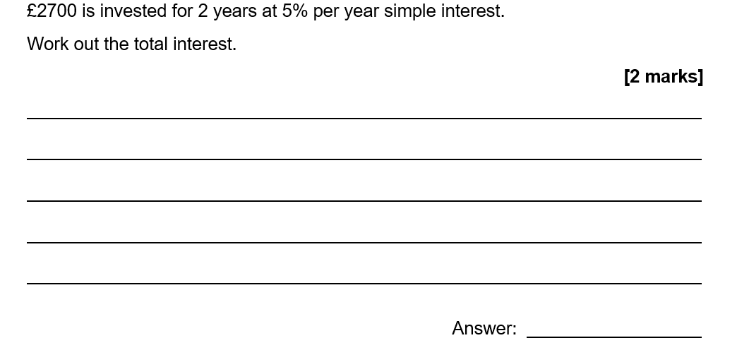

Percent

Calculator

Grade 3

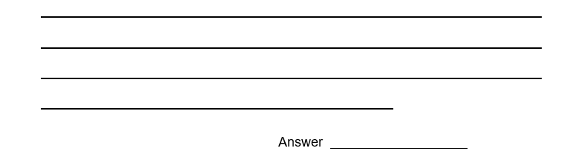
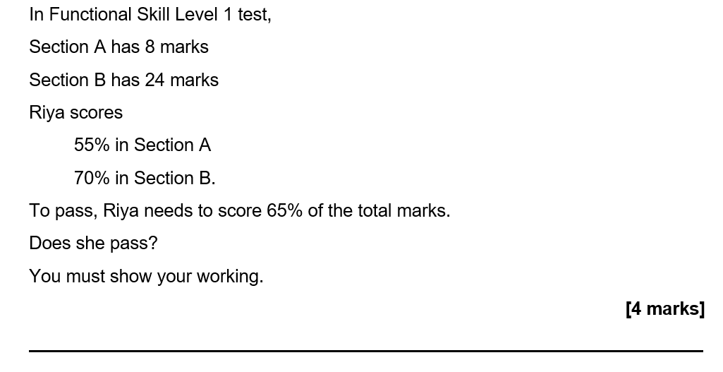

Grade 4

(Calculator)
An adult ticket for a museum is £16:00
A child ticket costs 70% of the price of an adult ticket.
Mrs Jenkins and her three children go to the museum.
Mrs Jenkins has a voucher that reduces the total entry cost by 10%
Mrs Jenkins pays with three £20 notes.
Work out how much change Mrs Jenkins will receive.
[4 marks]

Answer £

Ellen works for a company that sells cars.
Her monthly pay is
- a salary of £1470
- 28% of the total profit the company makes from her sales
- a £250 bonus if she sells at least 15 cars.
The table shows information about the cars she sold last year.
Total Cost  to the company | Total income  for the company | Number of months when  she sold at least 15 cars
£464 500 | £538 000 | 3

Was Ellen’s total pay for the year more than £40 000?
You must show your working.
[6 marks]

Answer £

QR Links for Learning Resources and Extra Practice

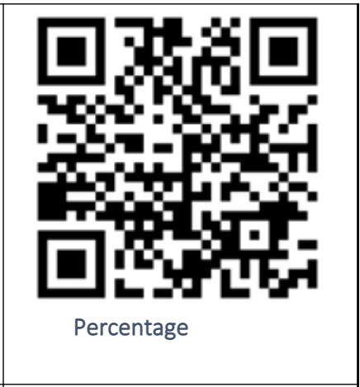

Notes

___________________________________________________________________

___________________________________________________________________

___________________________________________________________________

_____________________________________________________________

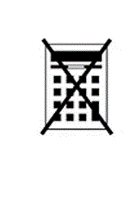
Ratios

Non-Calculator

Grade 1-2
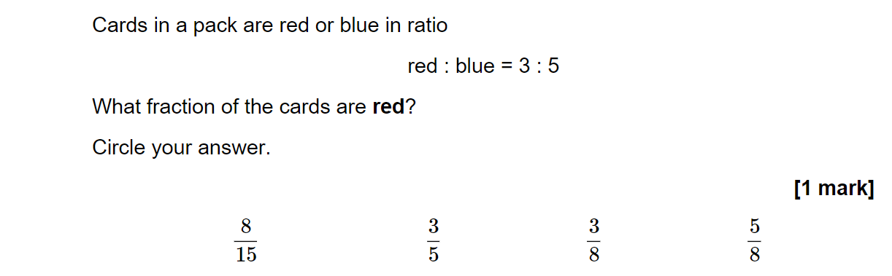

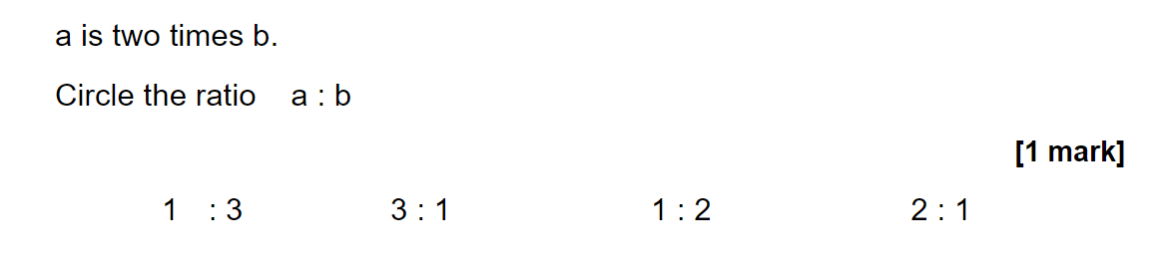

Grade 3
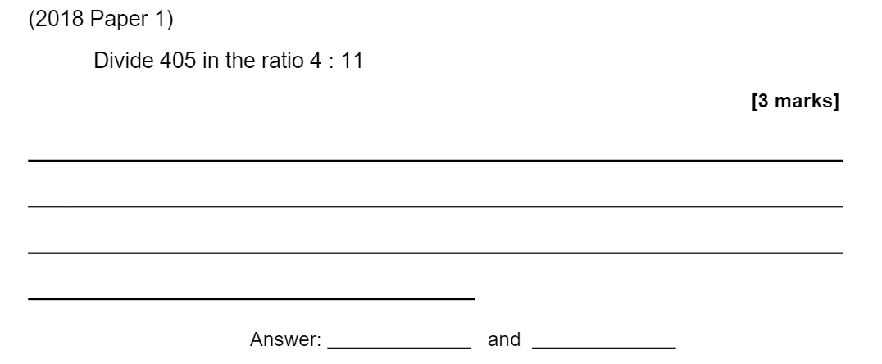

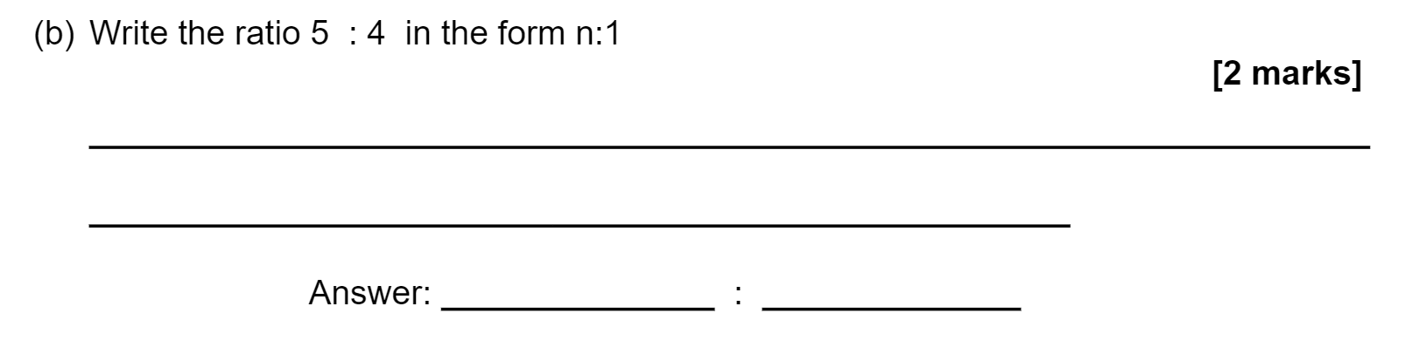

Grade 4
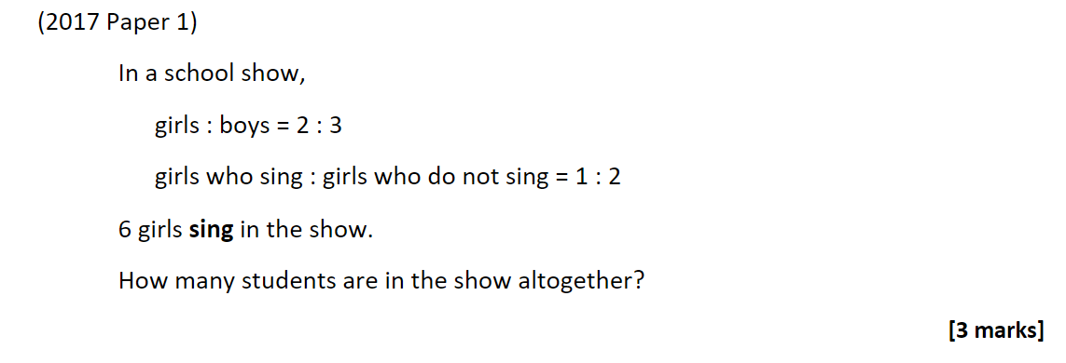

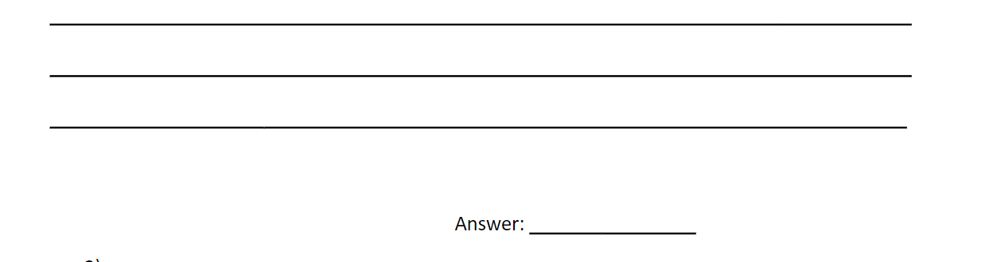

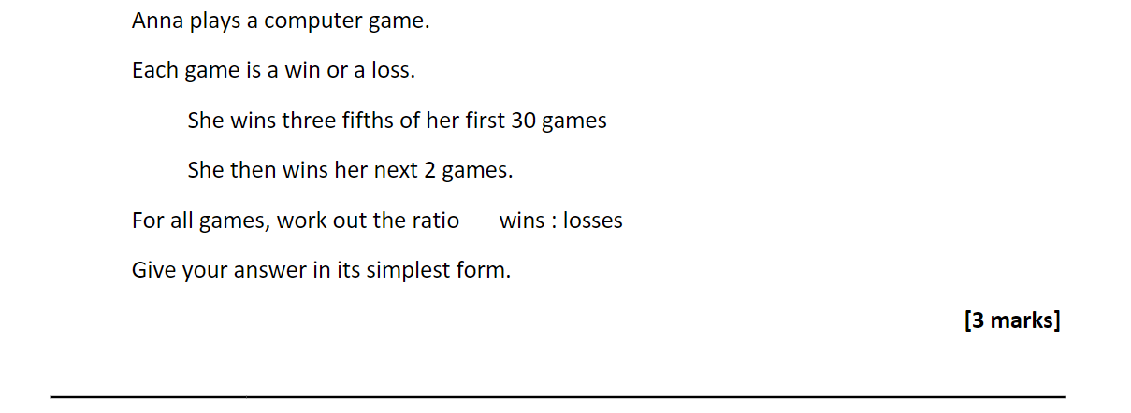

Ratios

Calculator

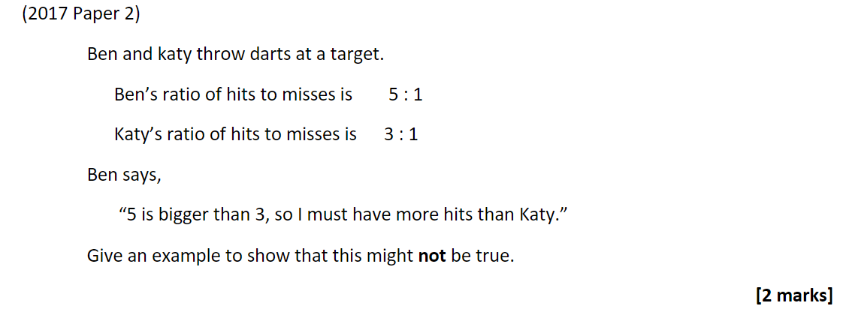
Grade 3

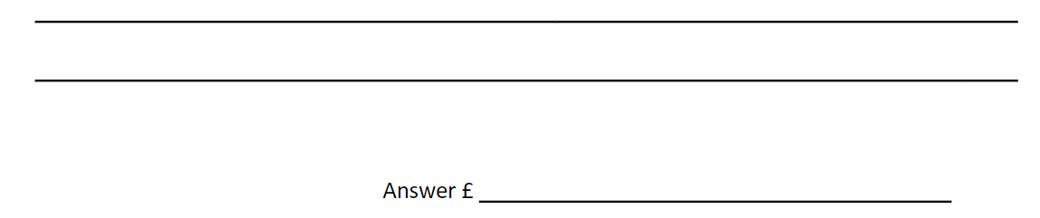

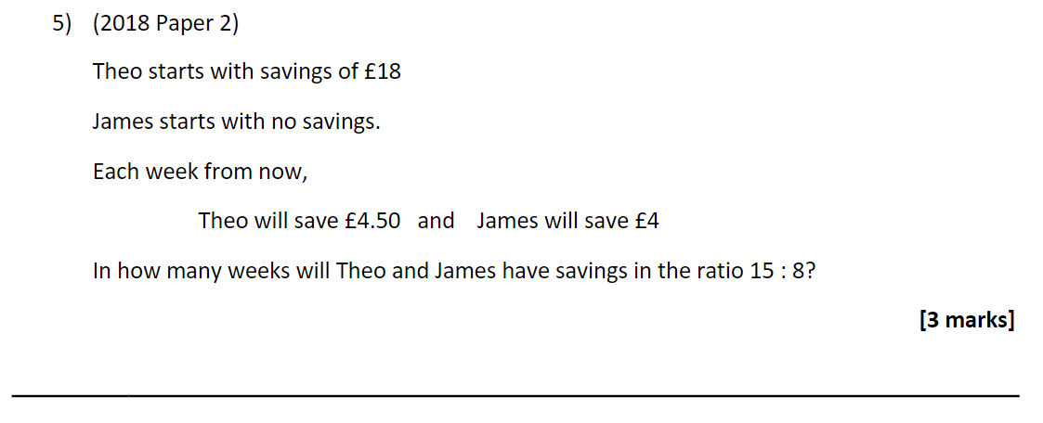

Grade 4
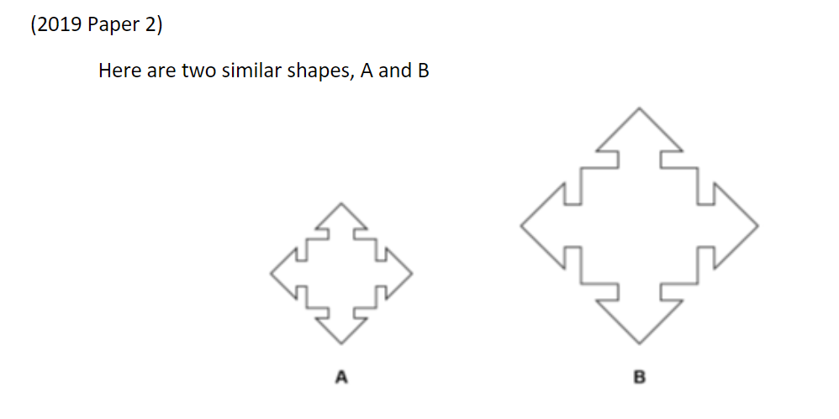
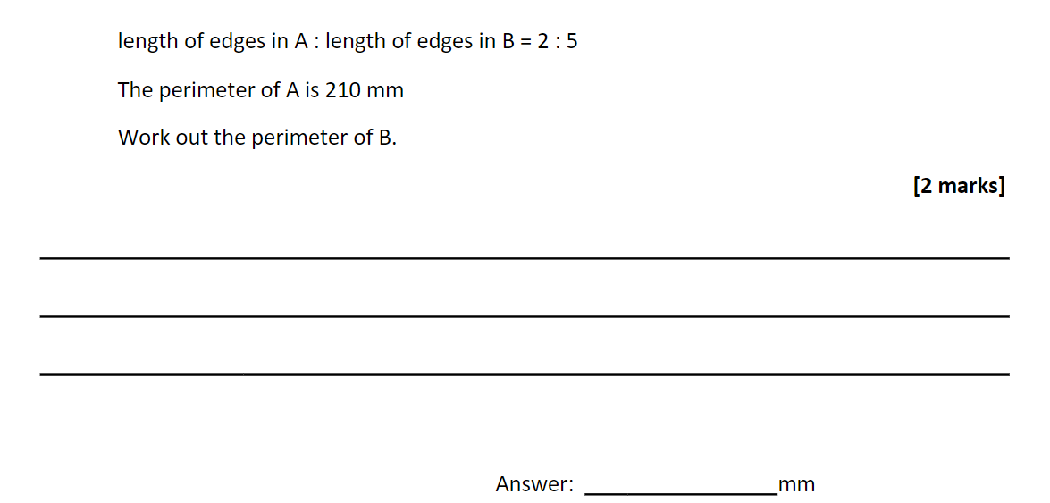

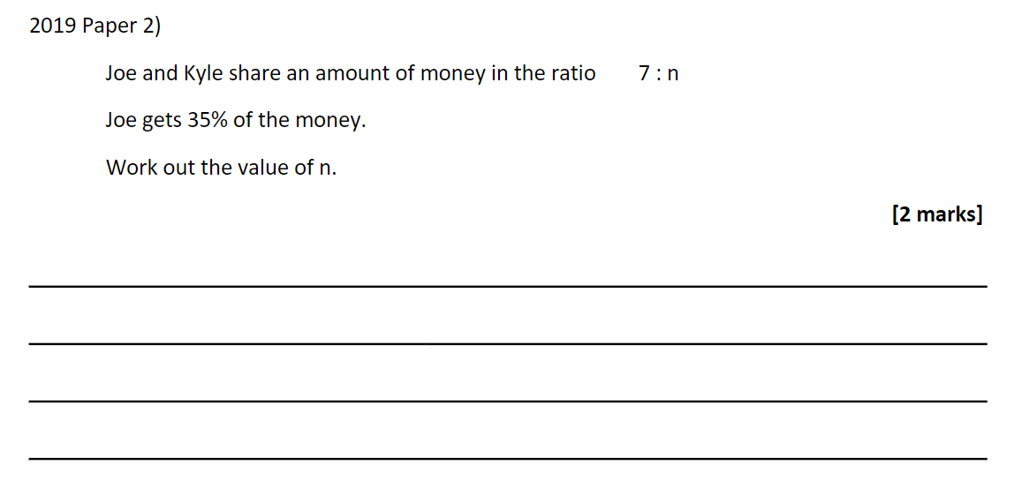

QR Links for Learning Resources and Extra Practice

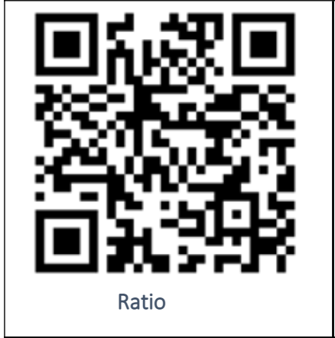

Notes

___________________________________________________________________

___________________________________________________________________

___________________________________________________________________

___________________________________________________________________

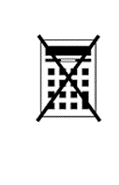
Scales and Maps

Non-Calculator

Grade 3
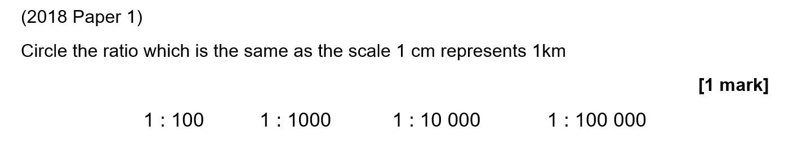

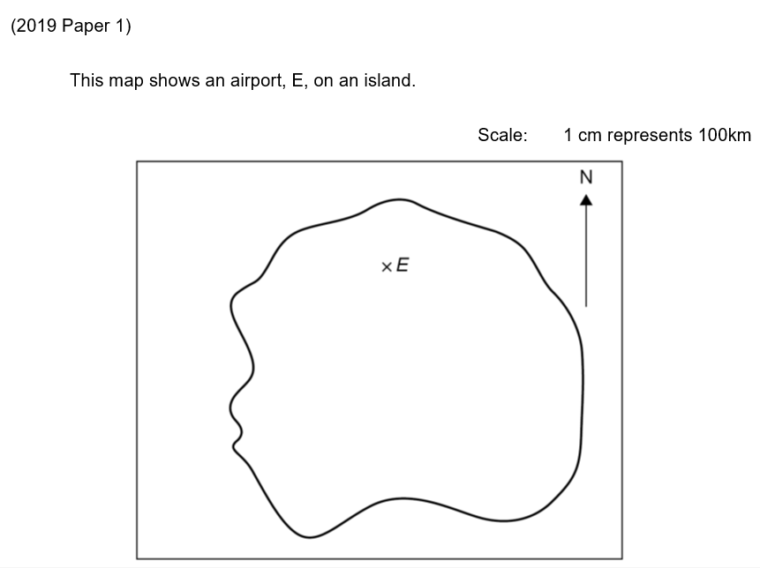

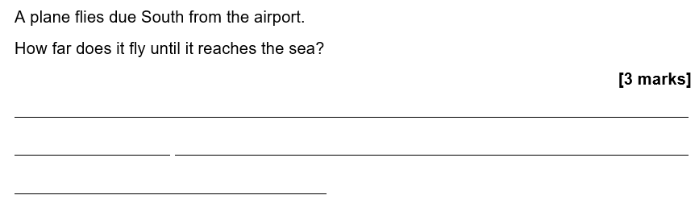

Grade 4

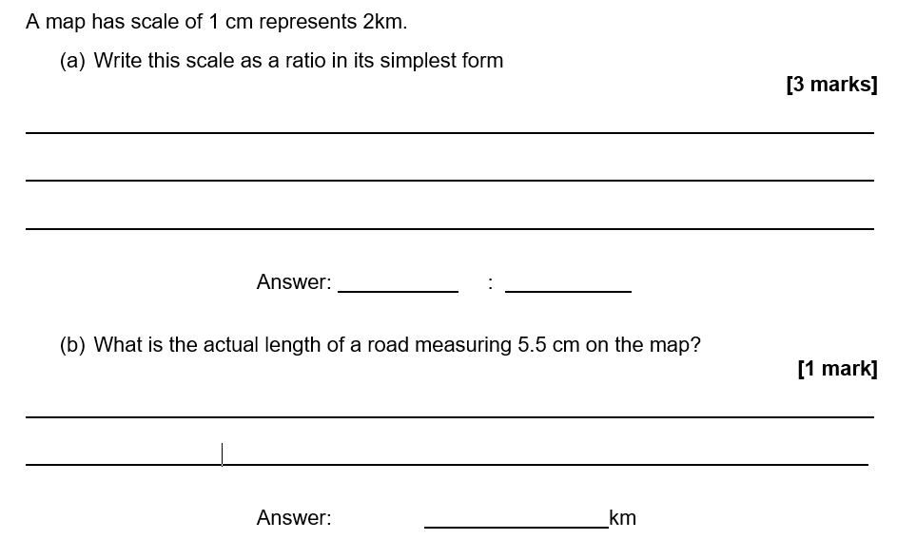
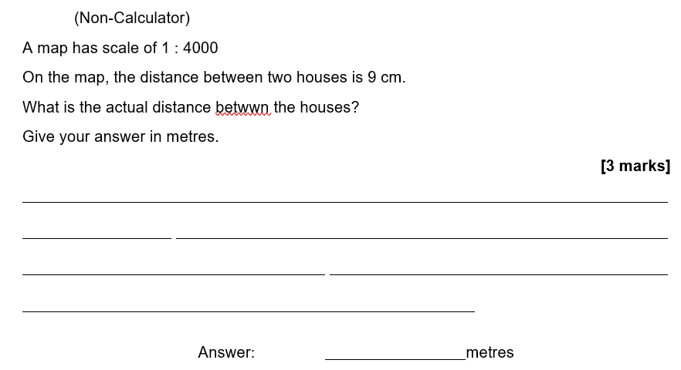

Scales and Maps

Calculator

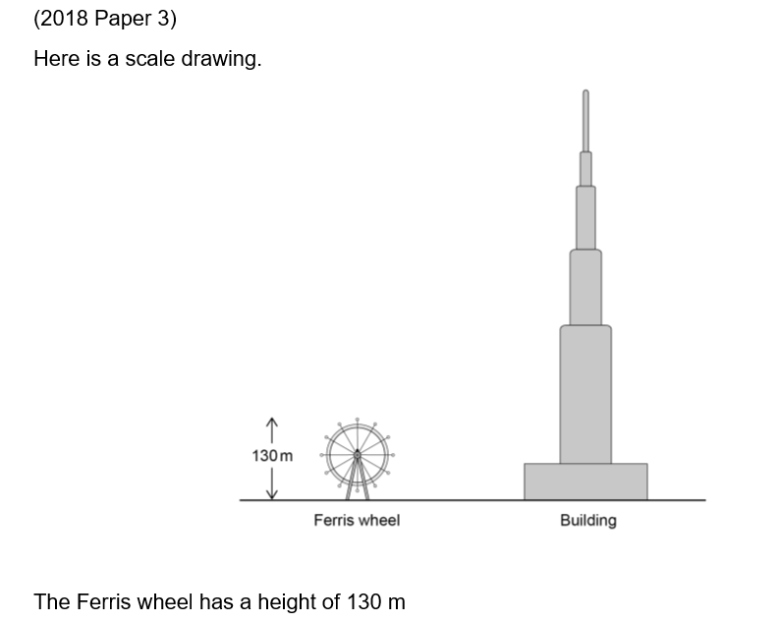
Grade 3

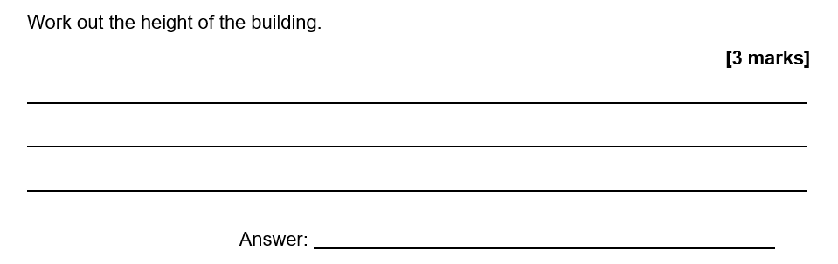

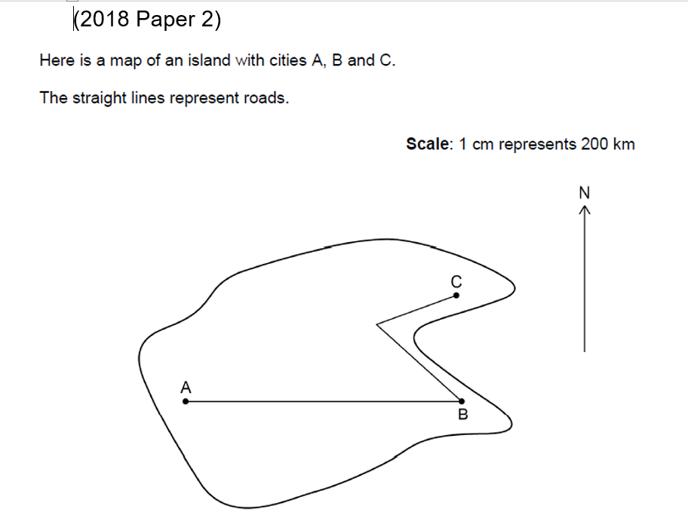
Grade 4

a) A is due west of B
Write down the bearing of A from B. [1 mark[

_________________________________________________________________________________________________________________________________________________________________________________________________________

b) Umar drives from A to B on the route shown.
Kaz drives fro B to C on the route shown.
Use the map to work out how much further Umar drives than Kaz.
You must show your working. [5 marks]

_________________________________________________________________________________________________________________________________________________________________________________________________________
___________________________________________________________________
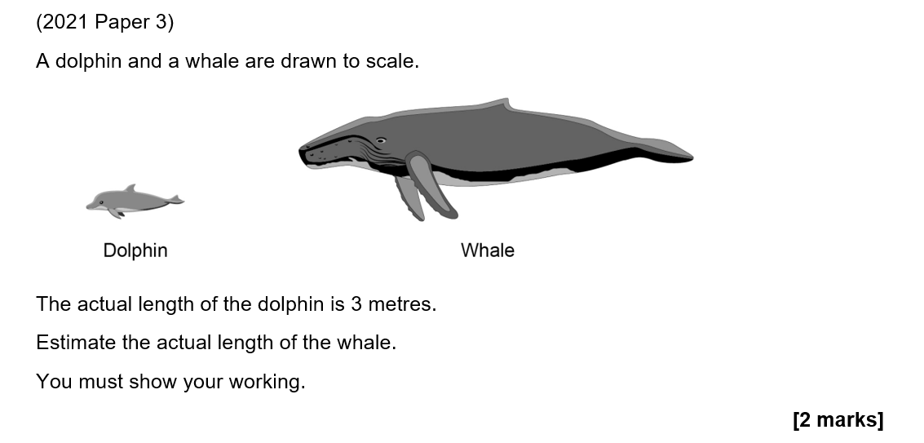

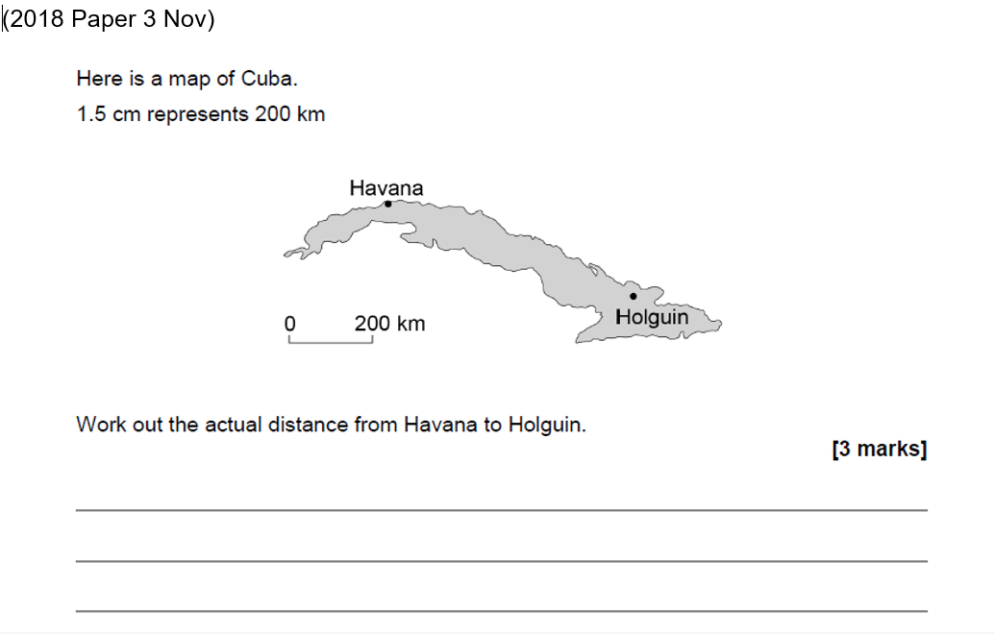

QR Links for Learning Resources and Extra Practice

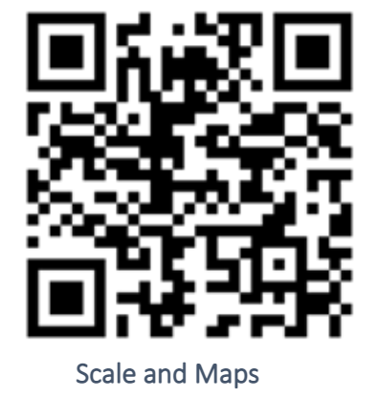

Notes

___________________________________________________________________

___________________________________________________________________

___________________________________________________________________

___________________________________________________________________

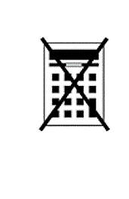
Introduction to Algebra

Non-Calculator

Grade 1-2
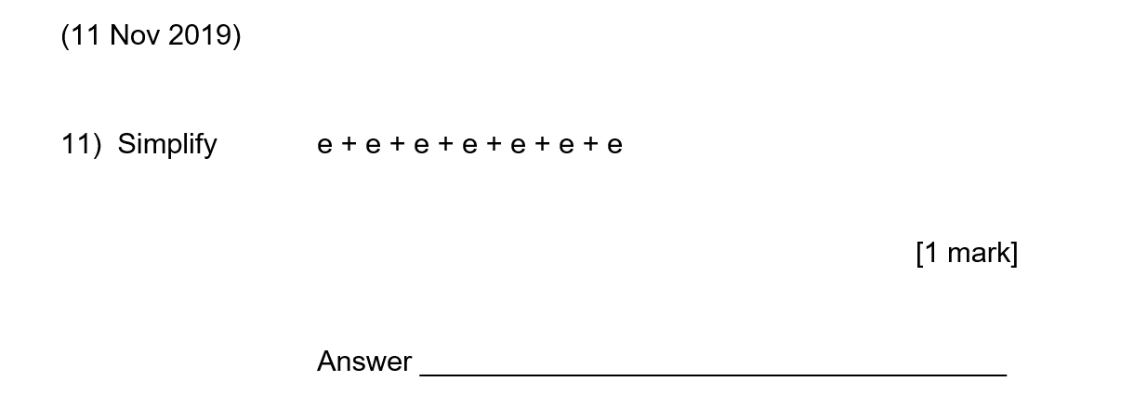

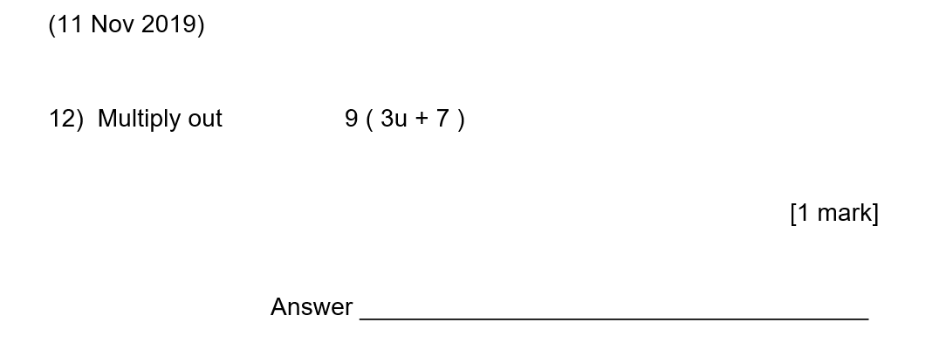

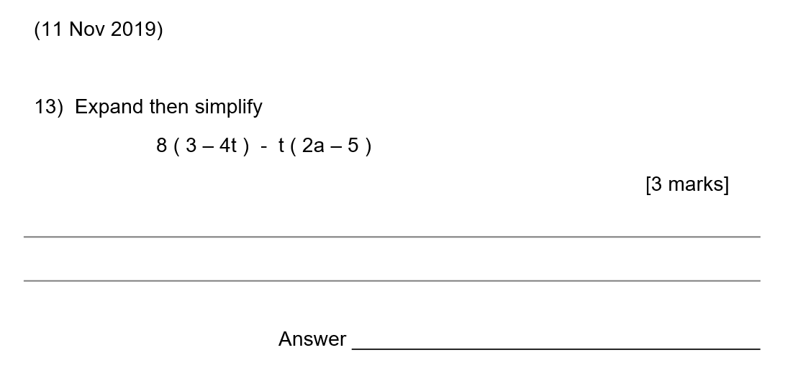
Grade 3

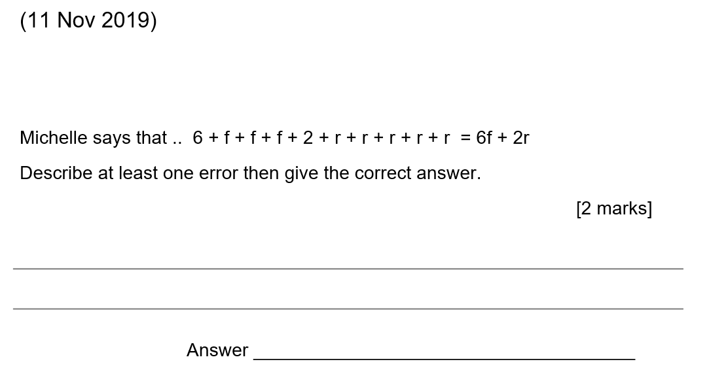

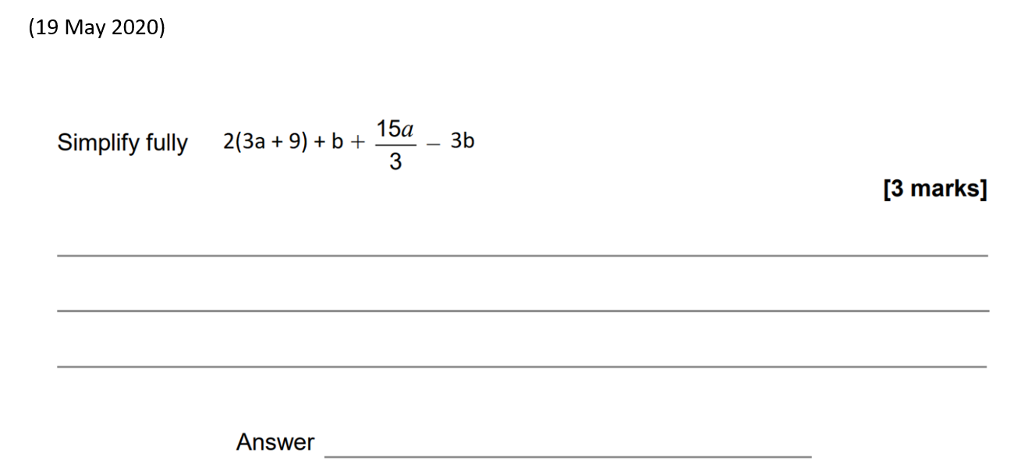
Grade 4

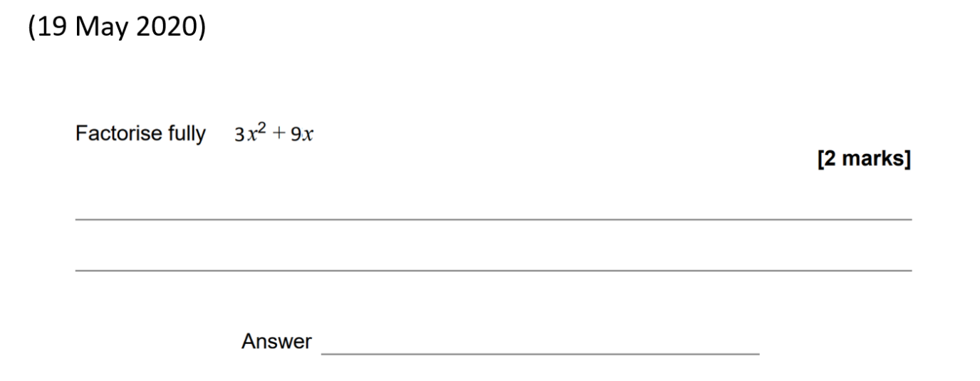

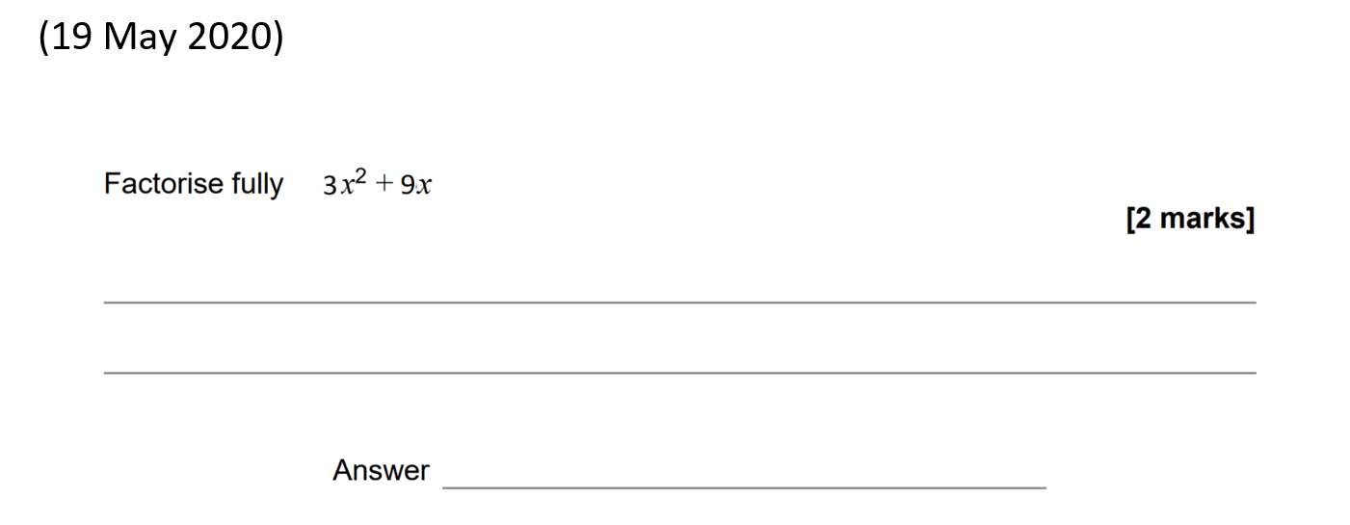

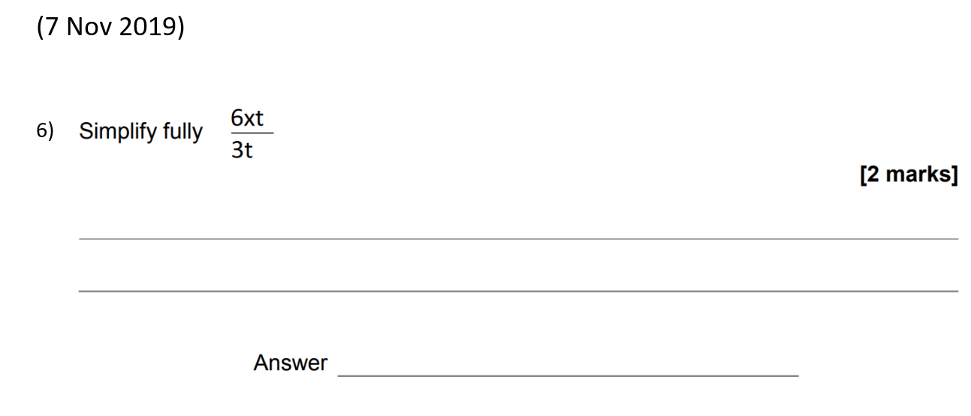

Grade 5

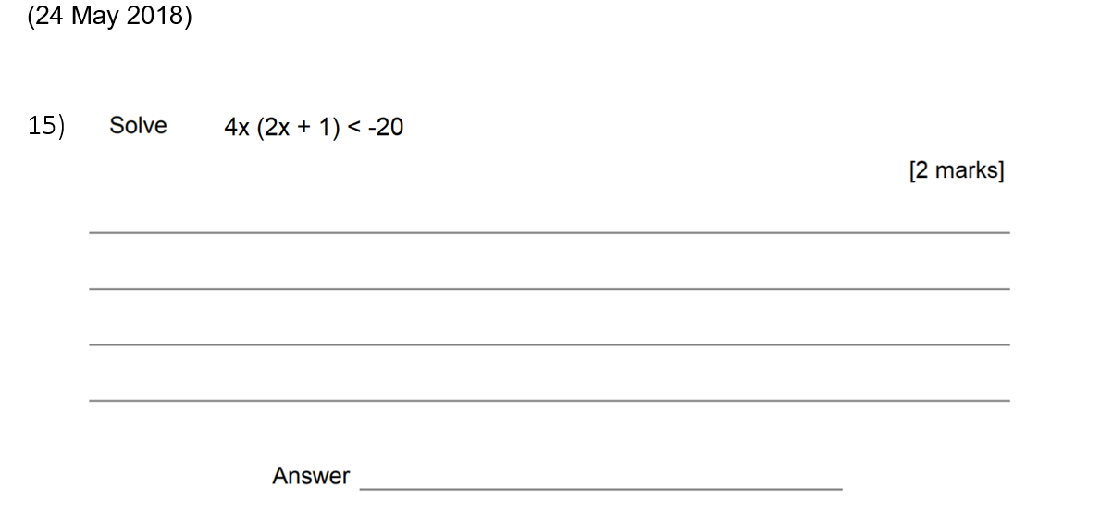

Introduction to Algebra

Calculator

Grade 3

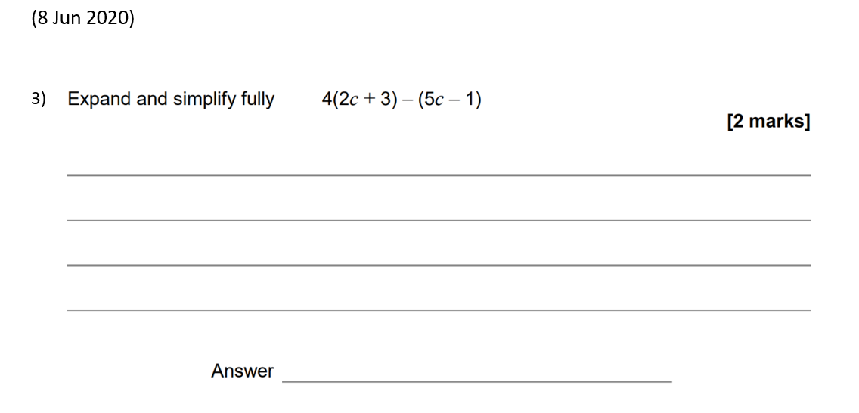

Grade 4
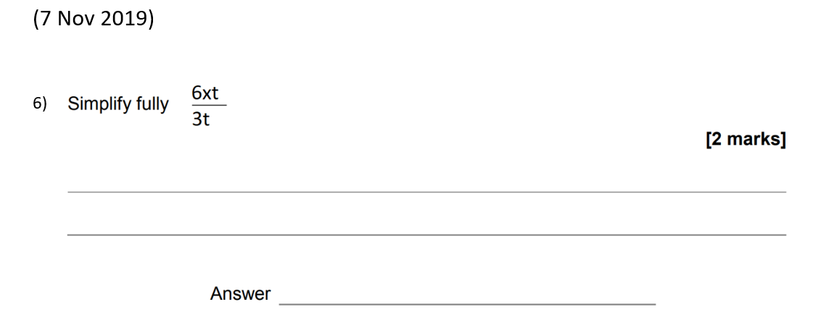

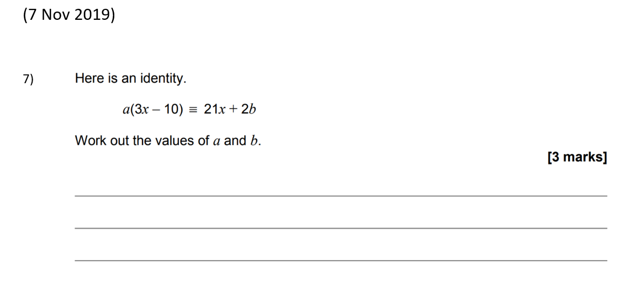
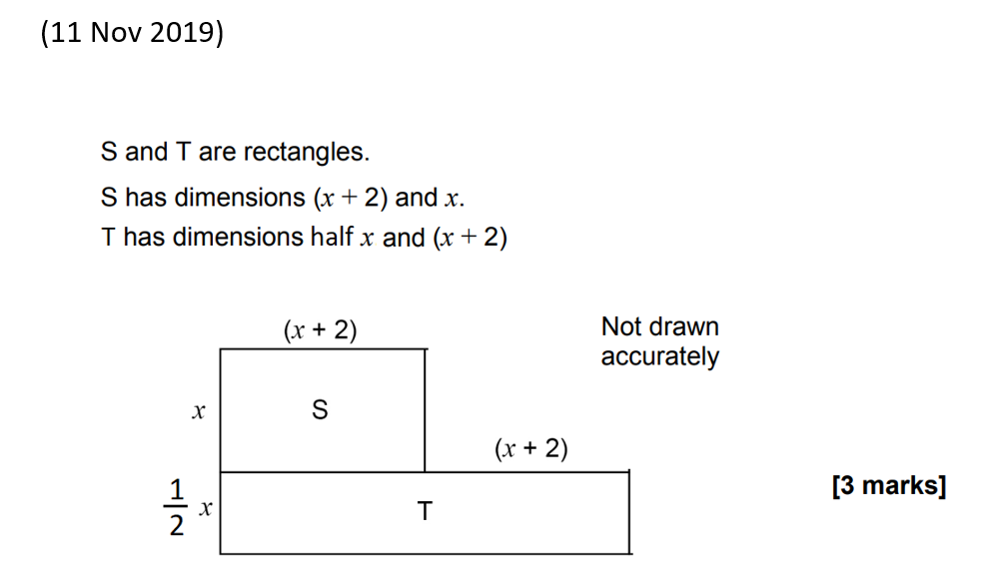
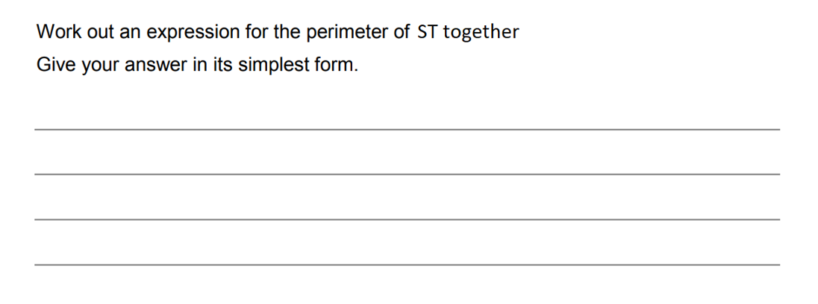

Grade 5

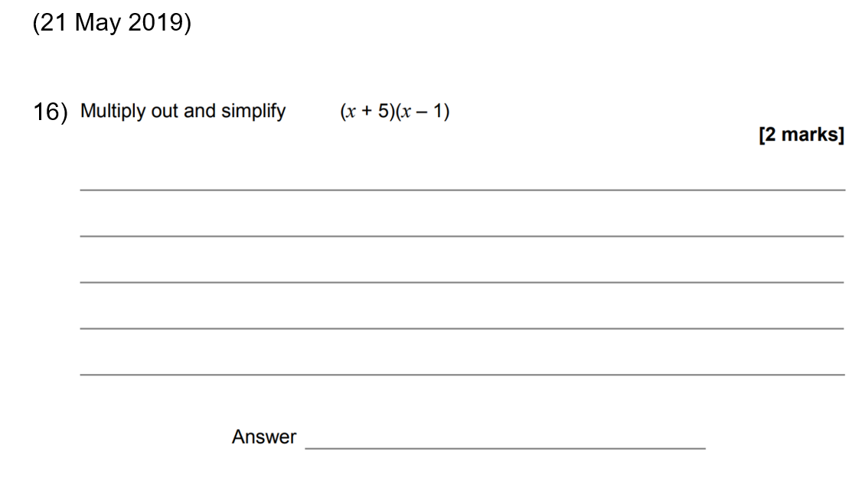

QR Links for Learning Resources and Extra Practice

Notes

___________________________________________________________________

___________________________________________________________________

___________________________________________________________________

___________________________________________________________________

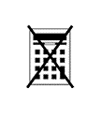
Substitution

Non-Calculator

Grade 3
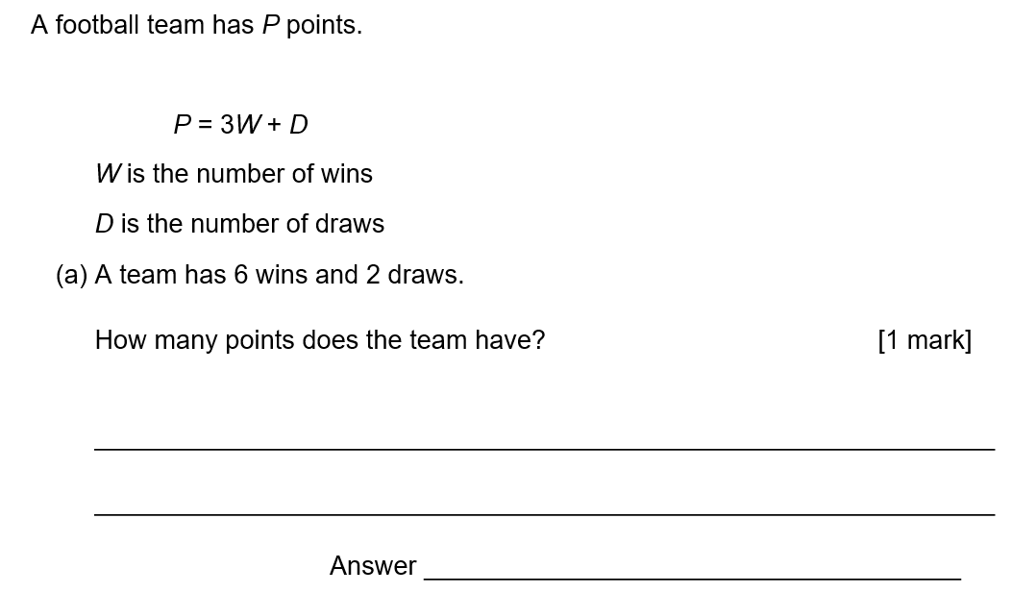
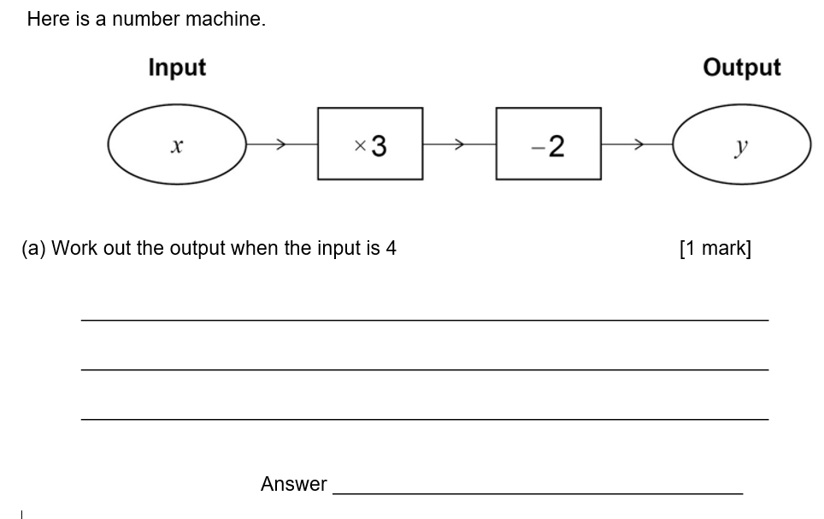
Grade 4

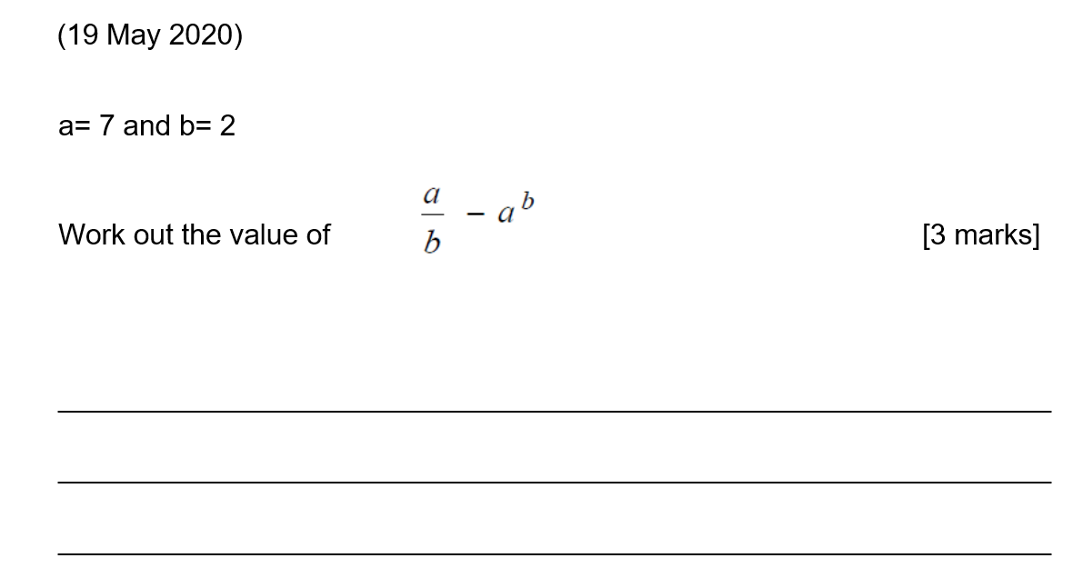

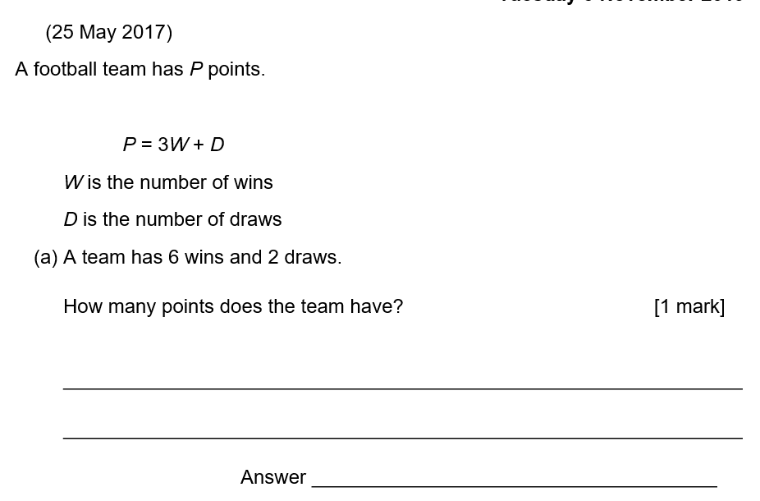

Substitution

Calculator

Grade 3

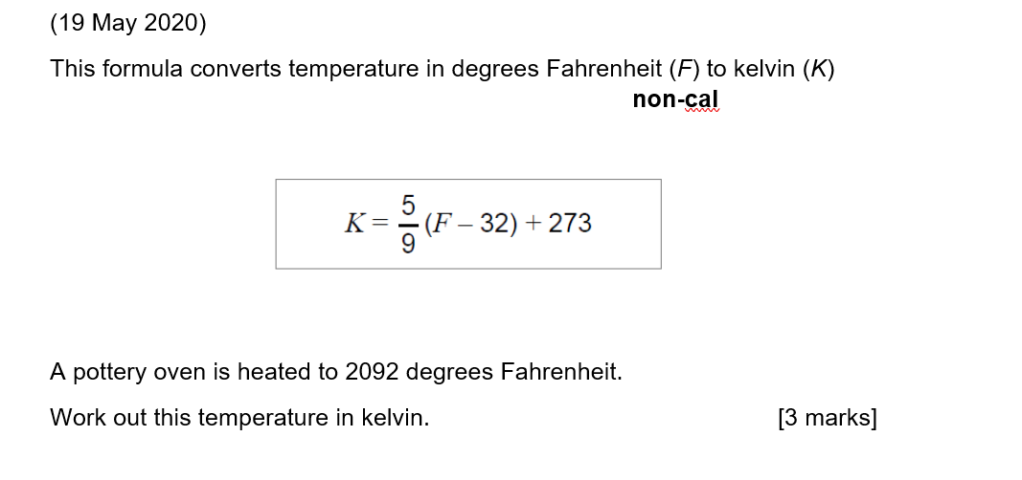

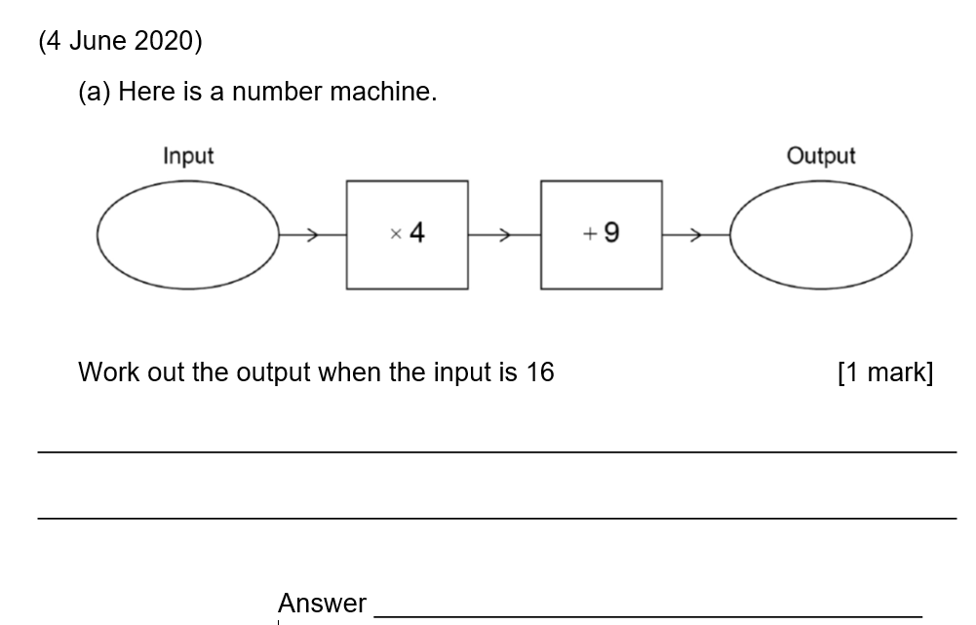
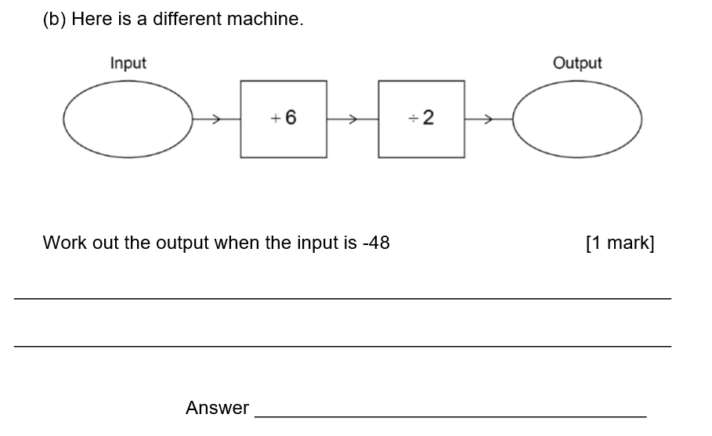

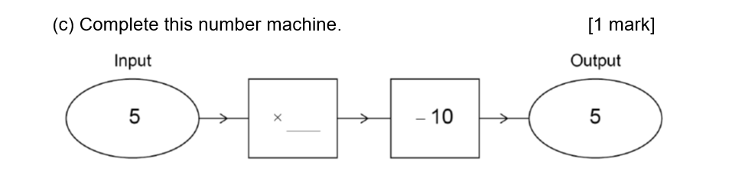

Grade 4

a)
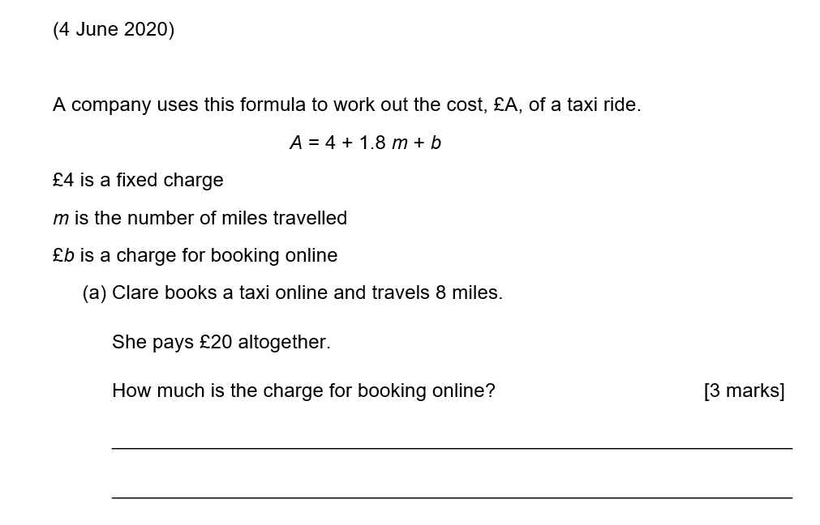

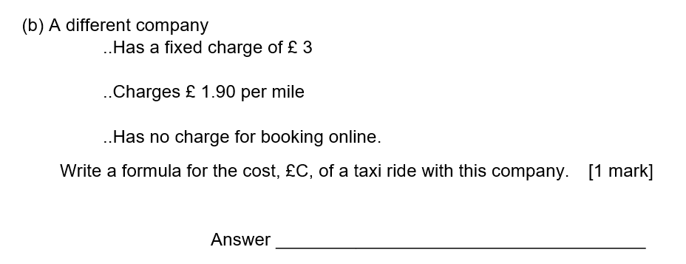

Grade 5
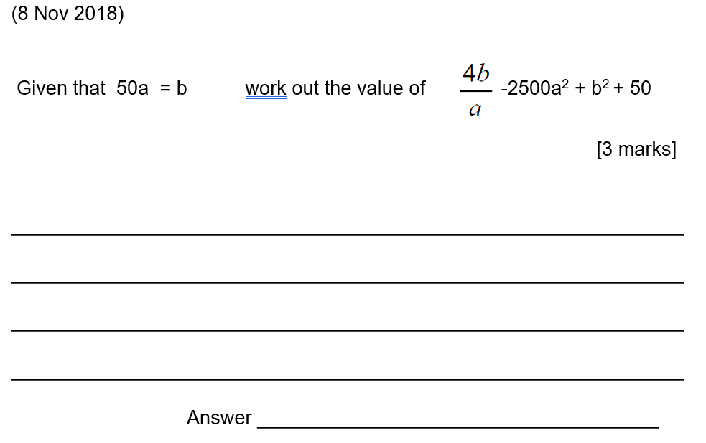

QR Links for Learning Resources and Extra Practice

Notes

___________________________________________________________________

___________________________________________________________________

___________________________________________________________________

___________________________________________________________________

Linear Equations and Inequalities

Non-Calculator

Grade 1-2

(2017 May )

Solve $x$ – 3 = 0

Circle your answer.
[1 mark]

$x= -3$ $x= 0$ $x= \frac{1}{3}$ $x= 3$

(2019 May )

Solve $4x$ = 8

Circle your answer [1 mark]

$x= 0.5$ $x= 2$ $x= 4$ $x= 3$2

(2017 November)
Solve $x-3=14$
[1 mark]

$x=$ __

Grade 3

(2017 November)

3a + b = 7 and $6x+8y=40$

Show that 9a + 3b has a greater value than $3x+4y$
[2 marks]

(2017 November)

Solve $7x+6>1+2x$ [2 marks]

Answer: ____________________________________________

Solve $5\left( x+3\right)<60$ [2 marks]

Answer:_________________________________________________

Grade 4
(2018 November)

Solve $3x-8=19$ [2 marks]

$x=$ __________________

(2019 November)

Solve $8x+7=2x+10$ [3 marks]
$x=$ __________________

(2020 November)

Solve $6x-11=13$ [2 marks]

$x=$ __________________

Linear Equations and Inequalities
Calculator

Grade 1 - 2

(2016 Practice Paper Set 4 - Paper 3)

Solve $20x$ = 4

Circle your answer.
[1 mark]

$x= \frac{1}{5}$ $x= -16$ $x= 5$ $x= 80$

(2016 Practice Paper Set 3 - Paper 2)

Write down the integer values of $x$ where 1 $≤x$ < 7
[2 marks]

Answer:

(2016 Practice Paper Set 3 - Paper 3)

Solve $3x$ = 13

Circle your answer.
[1 mark]

$x= 4$ $x= 9$ $x=15$ $x= 36$

Grade 3 – 4

(June 2017 - Paper 2)

Solve $4x-3=14$
[2 marks]
$x=$

(June 2017 – Paper 3)
How are the whole number solutions to A and B different?
A Solve 3 ≤ $3x$ < 18
B Solve 3 < $3x$ ≤ 18
[2 marks]

(November 2017- Paper 2)

Solve $4\left(3x-2\right)=2X-5$
[3 marks]

$x=$
(November 2017 - Paper 3)

Circle the equation which has the solution $x=6$
[1 mark]

$x-3= \frac{x}{2}$ $x= \frac{3+x}{2}$ 3$x= 36$ $\frac{x}{6}= 0$

(November 2017 - Paper 3)

$x$ is greater than 5 and less than or equal to 9.
Circle the inequality that shows this.
[1 mark]
5≤$x$<9 5>$x$≥9 5≤$x$>9 5<$x$≤9

(November 2018 - Paper 3)

Solve 8 > 3 - $\frac{1}{2}x$

[2 marks]

Answer:

QR Links for Learning Resources and Extra Practice

Notes

___________________________________________________________________

___________________________________________________________________

___________________________________________________________________

___________________________________________________________________

Circles

Non-Calculator

Grade 3

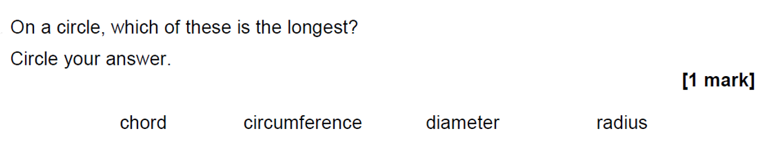

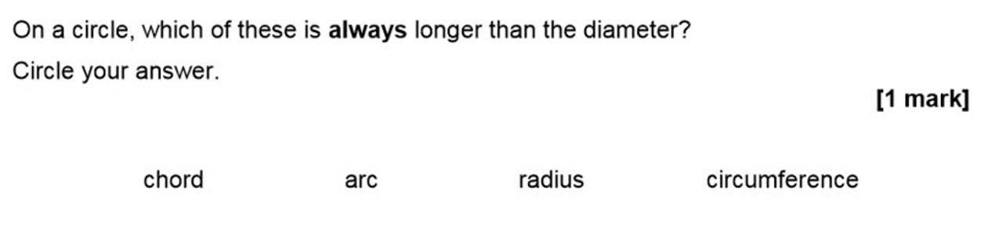

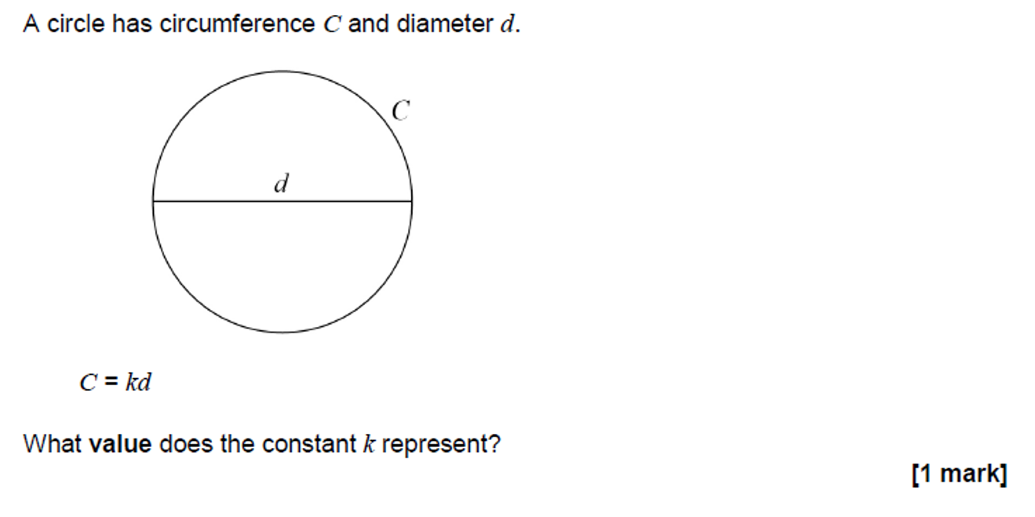

Grade 4
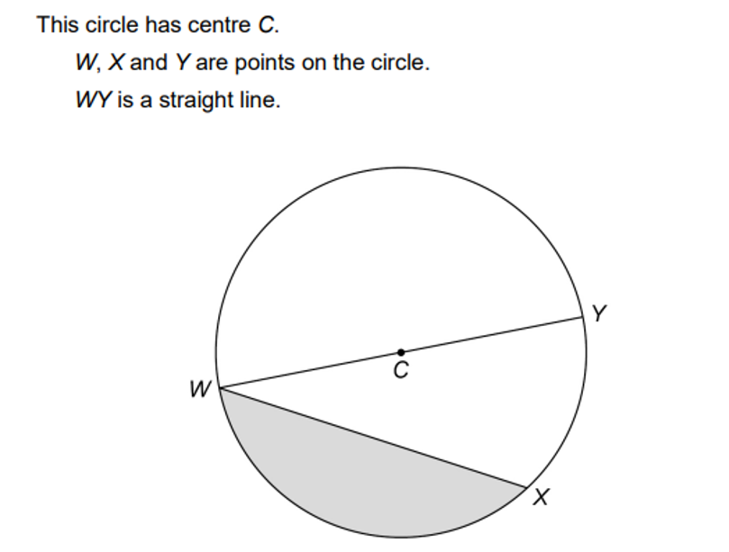
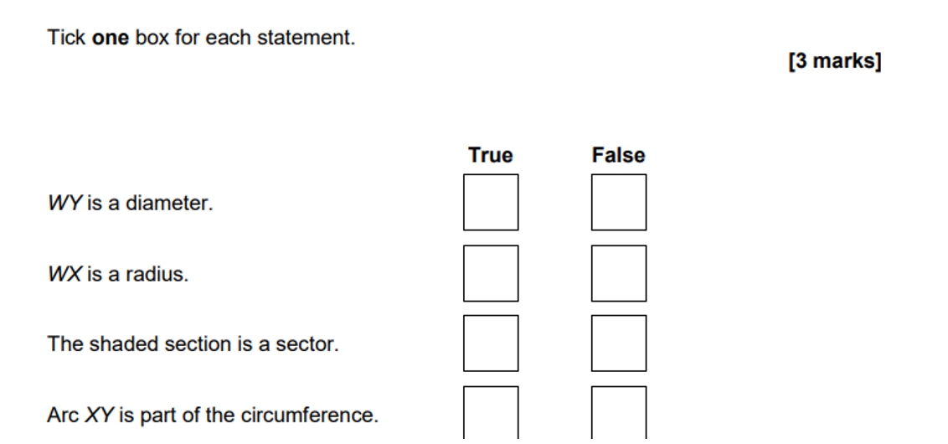

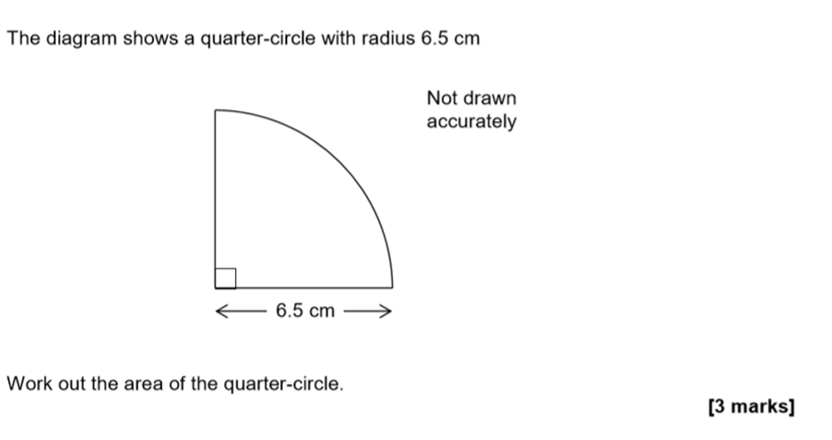

Give your answer to the nearest whole number.
___________________________________________________________________
___________________________________________________________________
___________________________________________________________________
Answer _________________________cm²

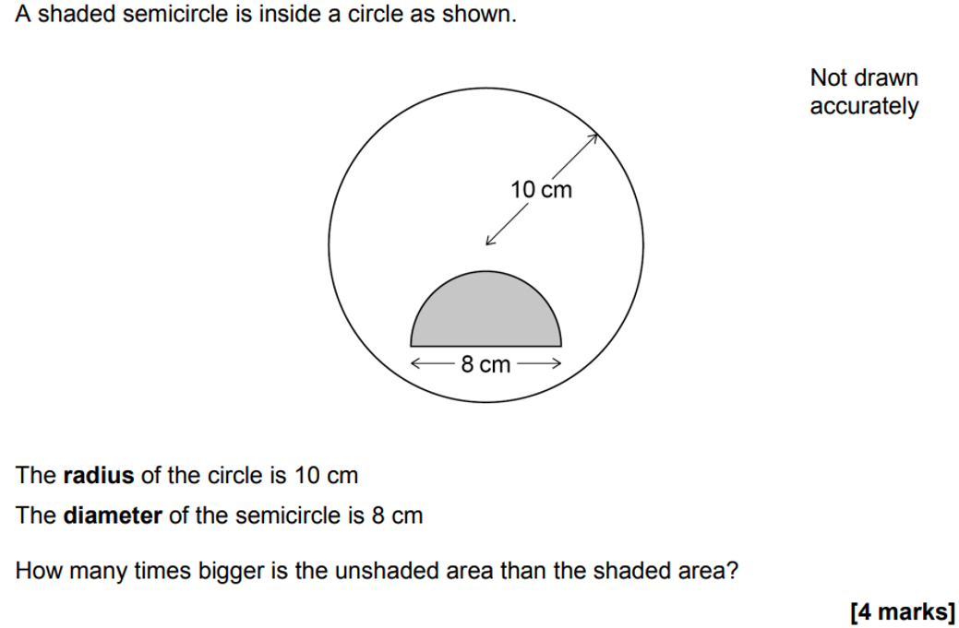

Circles

Calculator

Grade 3
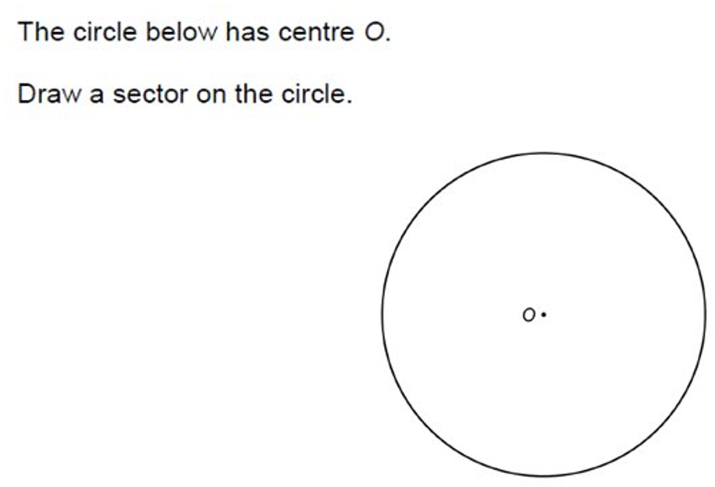

[1 mark]

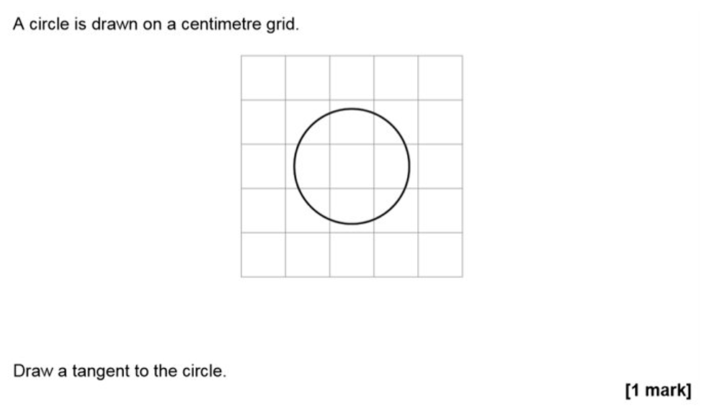

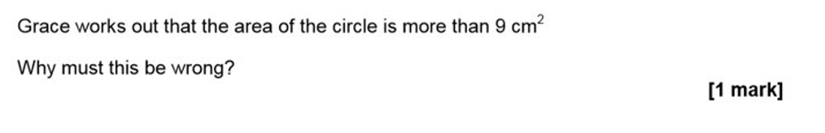

____________________________________________________________
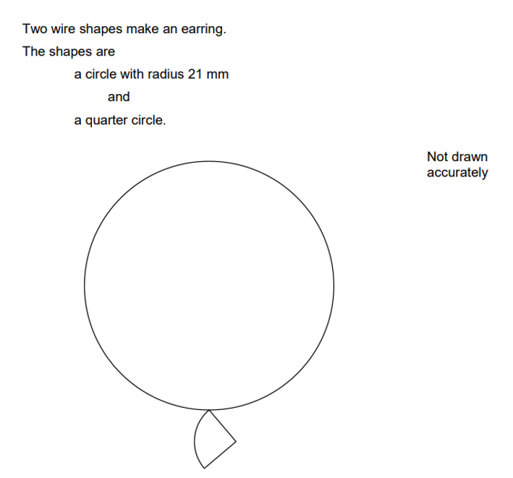
Grade 4

___________________________________________________________________
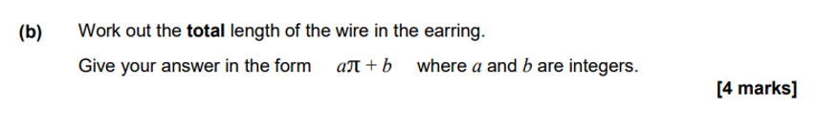

___________________________________________________________________
___________________________________________________________________
QR Links for Learning Resources and Extra Practice

Notes

___________________________________________________________________

___________________________________________________________________

___________________________________________________________________

___________________________________________________________________

