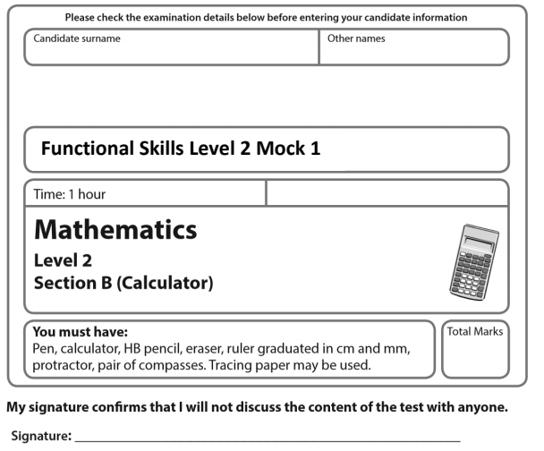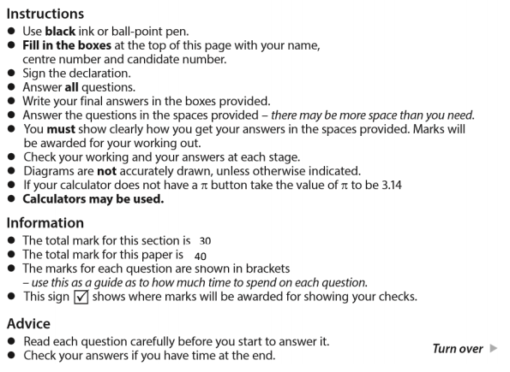

**April Mock**

40

30

What fraction of his total income last year came from his work at the gym?

Write the fraction in its simplest form. (4)

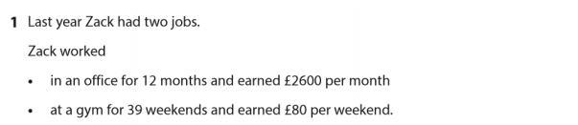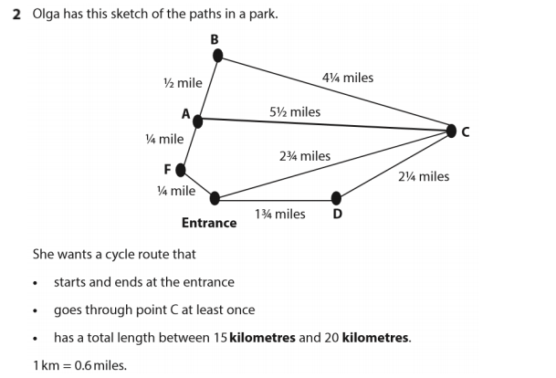

Plan a suitable route.

Work out the total distance of the route. (5)

Route

Total Distance

1. Has Megan changed the price correctly? (3)

🗸

b) Use estimation to show a check of your answer. (1)

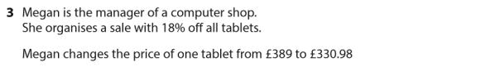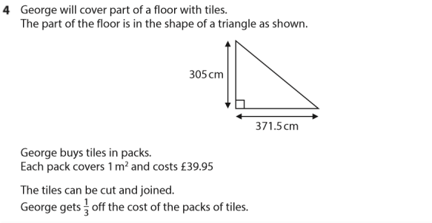

Work out the lowest cost of the tiles for George (5)

£

1. Work out the deposit that Gabi will have to pay. (3)

£

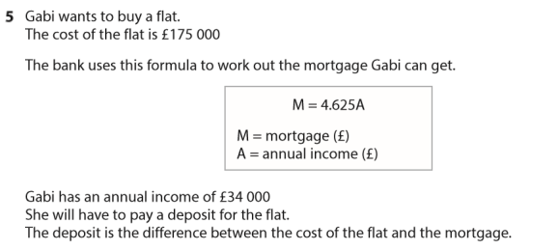





b) Work out the value of the investment at the end of 3 years. (3)

£

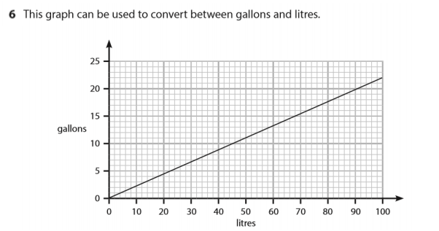

1. Convert 60 litres to gallons. (1)

gallons

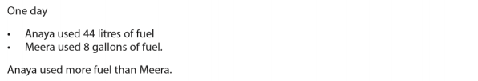

b) Use the graph to work out how much more.

Remember to give units with your answer. (2)

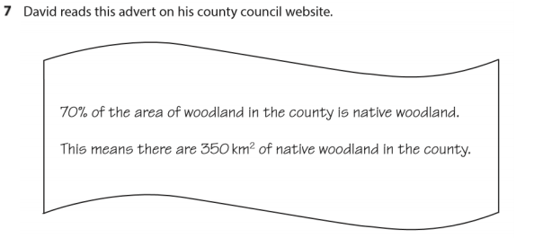

Work out the area of woodland in the county that is **not** native woodland.

(3)

Km2