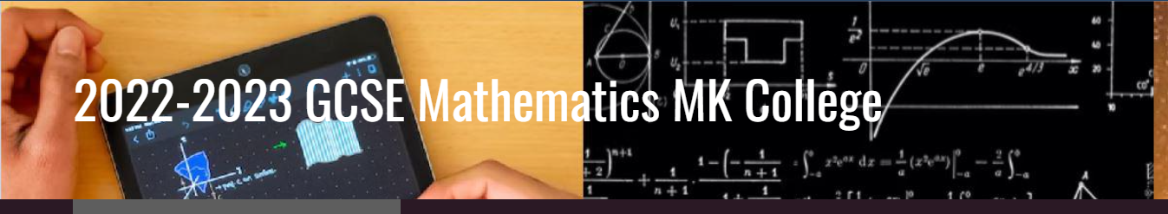

HY
Assessment Dates 2022-23 Adult GCSE maths
Course MC7 Friday Mornings

Dates Assessment Time Location

14th October ‘22 (week 5) Skills Check 3hrs F27 Chaffron Way
4th November ‘22 (week 7) End of term Assessment(1) 1.5hrs F27 Chaffron Way
6th January ’23 (week 14) End of term Assessment(2) 1.5hrs F27 Chaffron Way
24th February ’23 (week 20) End of term Assessment(3) 1.5hrs F27 Chaffron Way
17th March ’23 (week 23) Mock paper 1 non-calc 1.5hrs F27 Chaffron Way
24th March ’23 (Week 24) Mock paper 2 Calculator(1) 1.5hrs F27 Chaffron Way
31st March ’23 (Week 25) Mock paper 3 Calculator(2) 1.5hrs F27 Chaffron Way
May/June ’23 AQA Exams

