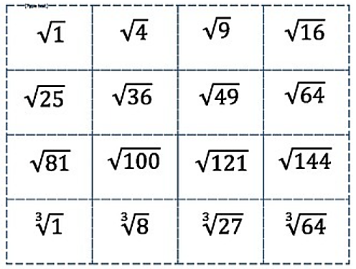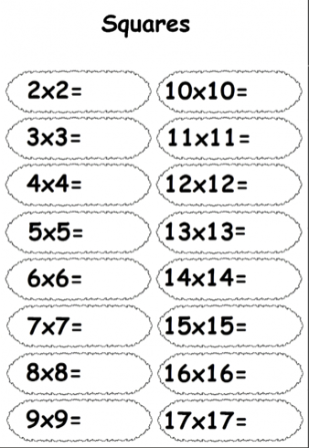 o

Squares and roots: practice

**write in each box the value of the square root of each number**

**complete each of these sums to find the square numbers**