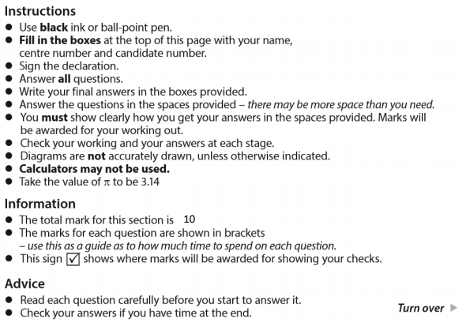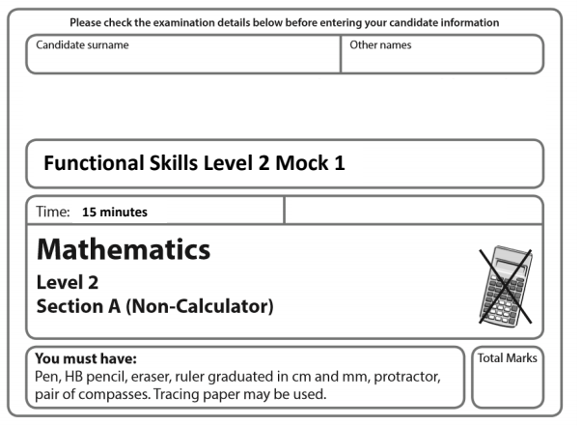

How much cement does he need to make the same type of mortar mix? (3)

Kg

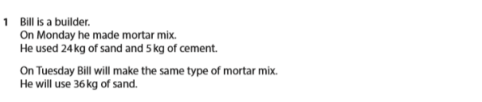



1. Write 2.71828 correct to 3 decimal places. (1)

b) Work out the value of p when t = 10. (2)

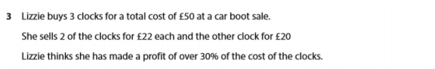

Is Lizzie correct?

Show why you think this. (4)