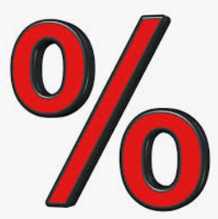
Percentage Formula

To find a Percent of a value

New value = 0. % x old value
The new number you are trying to find is found by multiplying the old value by zero point and then put the percentage value after the decimal. Eg: to find 15% of £300 = 0.15 x 300

To find an increase by a Percent

New value = 1. % x old value
The new number you are trying to find is found by multiplying the old value by one point and then add the percentage after the decimal. Eg: to find 35% increase of £200 = 1.35 x 200

To find a percentage decrease

New value = 0. (100 - %) x old value
The new value you are trying to find is found by multiplying the old value by zero point and then subtracting the percentage discount from 100 before multiplying by the old value.
Eg: to find a decrease of 26% on £400 = 0.(100-26) x 400 = 0.74 x 400

To find a reverse Percent

New value / old value = % change or New value / % change = old value

