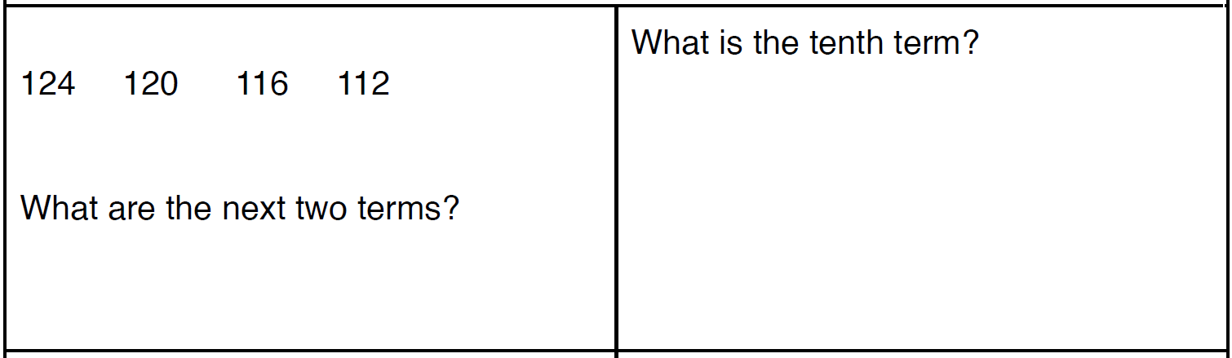

**ASSIGNMENT week 17**

**Sequences**

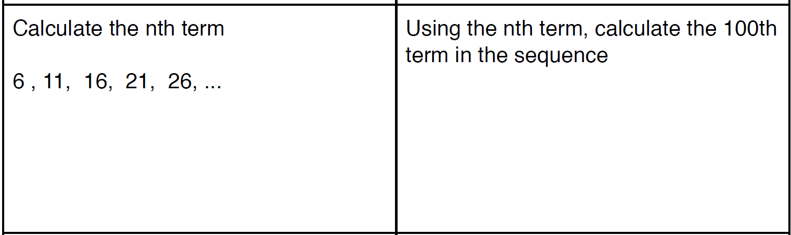

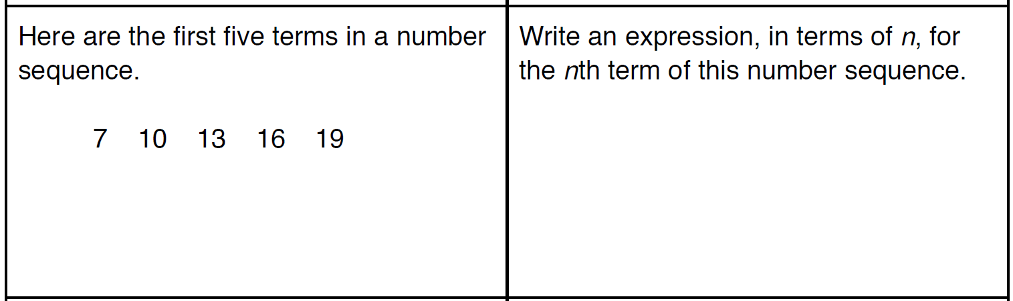

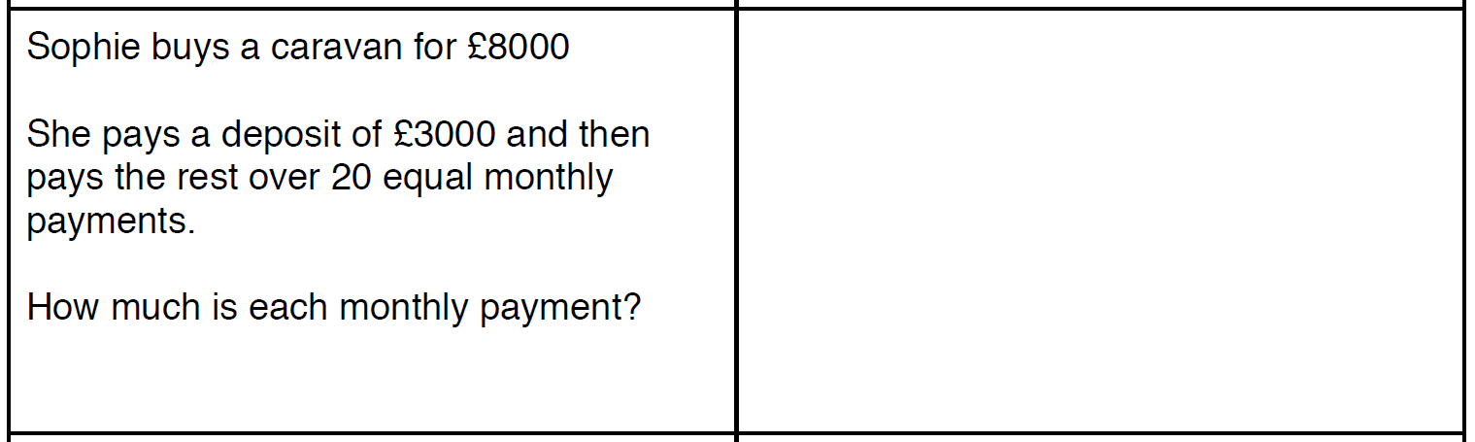

xn+1 = xn - 3



Write out the next four terms of this

sequence, starting with the first term

as 10



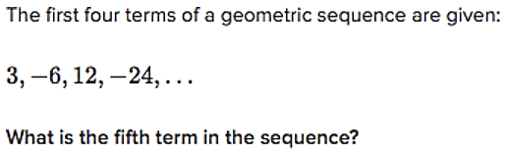



Using ‘a’ as the first term of the sequence and ‘r’ as the multiplier each time…. find the fourth term of the

sequence when ‘a=2’ and ‘r=3’

x n = a r n-1

