End of Term Assessment – Term 3 GCSE
Third half term

Full Name: _________________________________________________________

You must show all working. You may use a calculator for all questions.
Total marks 45 marks. Time allocated 75 minutes

Frequency trees and Tree Diagrams
Venn diagrams
Proportion
Percentage change
Rearranging formula
Compound Units
Charts and Graphs
Linear Graphs
Quadratics

1) 75 students either go to a football club or a rugby club at the weekend. Each student either goes to the club on Saturday or Sunday.
50 of the students go to a football club.
3/5 of the students that go to a football club go on Sunday. 46 students go to their club on Sunday.
Use this information to complete the frequency tree.

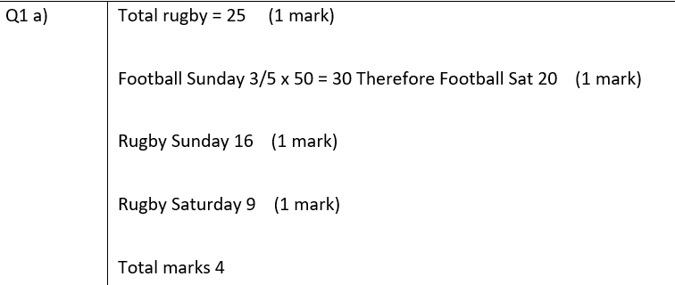
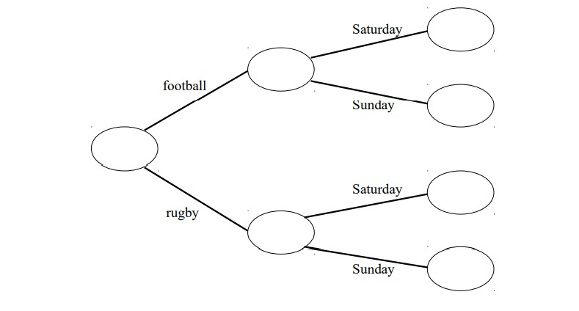

(4 marks)

2) Jo is going to play one tennis match and match of squash.
The probability she will win the tennis match is 4/5
The probability she will win the squash match is 7/10.

- Calculate the probability tree diagram

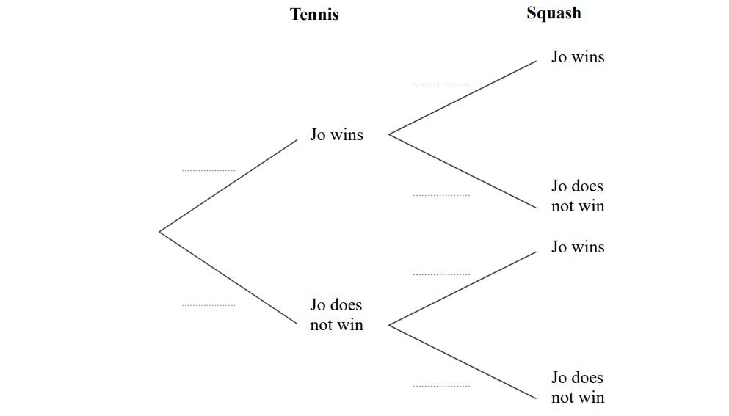

- Calculate the probability that Jo will win both matches.
(2 marks)

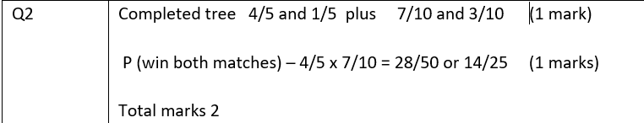

3) At a county park there is a house, a museum, and a garden.
The table shows the price per person to visit the park.
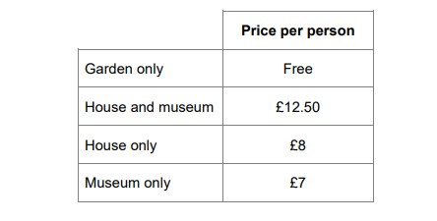
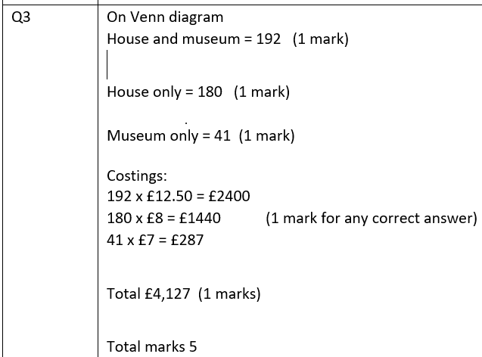
One day, 480 people visit the park.
67 people visit the garden only.
40% visit the house and the museum. visit the house only.
The rest visit the museum only.
In total, how much do the 480 people pay to visit the park?
You may use the Venn diagram to help you.
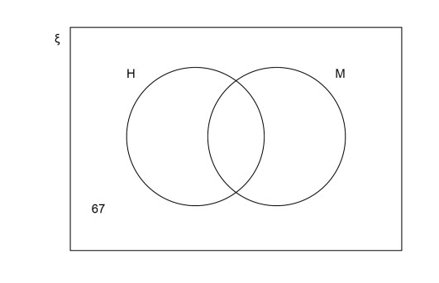

………………………………………………………………………………………………………………………………………………
……………………………………………………………………………………………………………………………………………… ……………………………………………………………………………………………………………………………………………… ………………………………………………………………………………………………………………………………………………
………………………………………………………………………………………………………………………………………………
………………………………………………………………………………………………………………………………………………
……………………………………………………………………………………………………………………………………………….
(5 marks)
Answer £______________________________________________________

4) 3 friends want to go for a hike.
They pack enough water to last for 6 hours.
3 more people join the hike.
How long will their water last now?
Give you answer in hours.

………………………………………………………………………………………………………………………………………………
………………………………………………………………………………………………………………………………………………
………………………………………………………………………………………………………………………………………………
……………………………………………………………………………………………………………………………………………….
……………………………………………………………………………………………………………………………………………..
(2 marks)
Answer ______________________________________________________

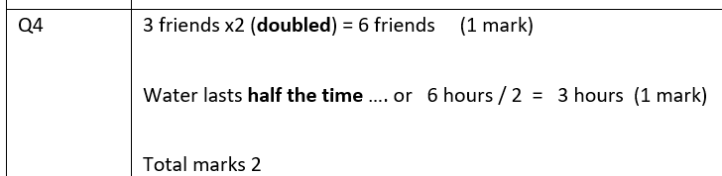

- Richard buys a car for £13,500.
He sells the car for £9,500.
Work out Richard’s percentage loss.
Give your answer correct to three significant figures.

………………………………………………………………………………………………………………………………………………
………………………………………………………………………………………………………………………………………………
………………………………………………………………………………………………………………………………………………
……………………………………………………………………………………………………………………………………………….
(3 marks)
Answer ______________________________________________________

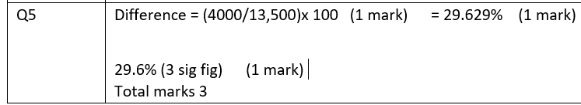

- A shop sells toilet rolls in small packs and big packs.
There are 4 toilet rolls in a smack pack.
There are 9 toilet rolls in a big pack.
The shop has s small pack and b big packs of toilet roll.
a) Write an expression for the total number of packs of toilet roll the shop has.
………………………………………………………………………………………………………………………………………………
………………………………………………………………………………………………………………………………………………
………………………………………………………………………………………………………………………………………………
……………………………………………………………………………………………………………………………………………….
- mark)
Answer ______________________________________________________

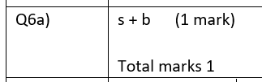

Write an expression for the total number of toilet rolls the shop has.
……………………………………………………………………………………………………………………………………………… ………………………………………………………………………………………………………………………………………………
……………………………………………………………………………………………………………………………………………….
Answer ______________________________________________________
- marks)

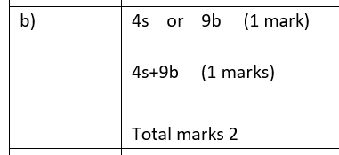

7) A rectangle has a length of (2x+3) and a width of (x+5 )cm.
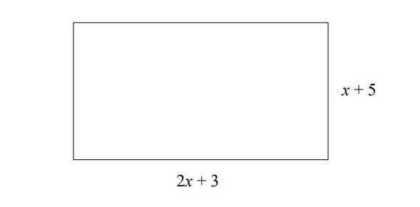
- Find an expression for the rectangle for the perimeter of the rectangle.
………………………………………………………………………………………………………………………………………………
……………………………………………………………………………………………………………………………………………… ………………………………………………………………………………………………………………………………………………
……………………………………………………………………………………………………………………………………………….
  - marks)
Answer ______________________________________________________
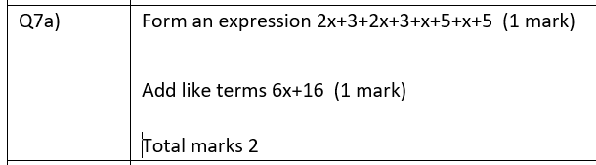

- Given the rectangle has a perimeter of 43 cm find the value of x.
………………………………………………………………………………………………………………………………………………
………………………………………………………………………………………………………………………………………………
……………………………………………………………………………………………………………………………………………….
  - marks)
Answer ______________________________________________________

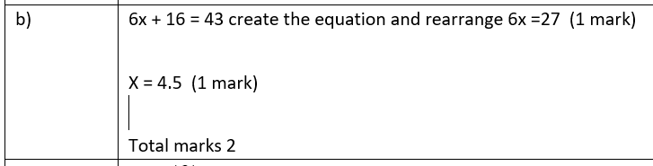

- Make t the subject of the formula.
U = 4t -21
………………………………………………………………………………………………………………………………………………
………………………………………………………………………………………………………………………………………………
……………………………………………………………………………………………………………………………………………….
(2 marks)
Answer ______________________________________________________

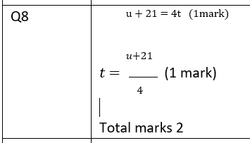

- A car journey is in two stages.
Stage 1 The car travels 110 miles in 2 hours.
Stage 2 The car travels 44 miles at the same average speed as stage 1.
Work out the time for Stage 2
Give your answer in minutes.
………………………………………………………………………………………………………………………………………………
………………………………………………………………………………………………………………………………………………
………………………………………………………………………………………………………………………………………………
……………………………………………………………………………………………………………………………………………….
(3 marks)
Answer ______________________________________________________

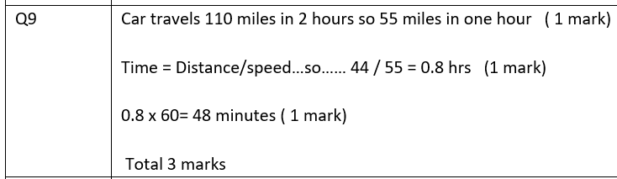

- A rock has a mass of 56 grams and a density of 3.5 grams/cm³.
Wok out the volume of the rock.
……………………………………………………………………………………………………………………………………………… ……………………………………………………………………………………………………………………………………………… ………………………………………………………………………………………………………………………………………………
……………………………………….
(2 marks) Answer ______________________________________________________

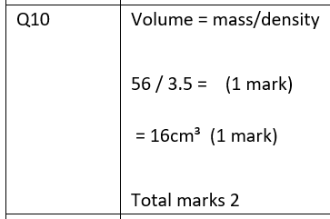

- The table shows the number of messages Sam received each day for 5 days.

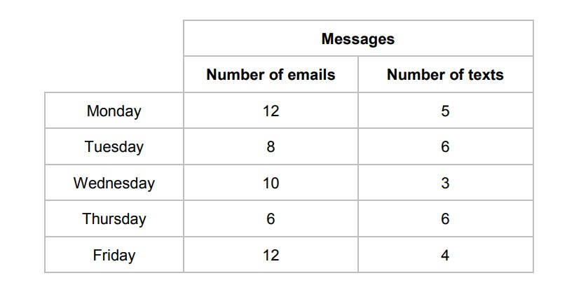
- Sam draws a composite bar chart to represent the data.
He has drawn the bar for Monday.
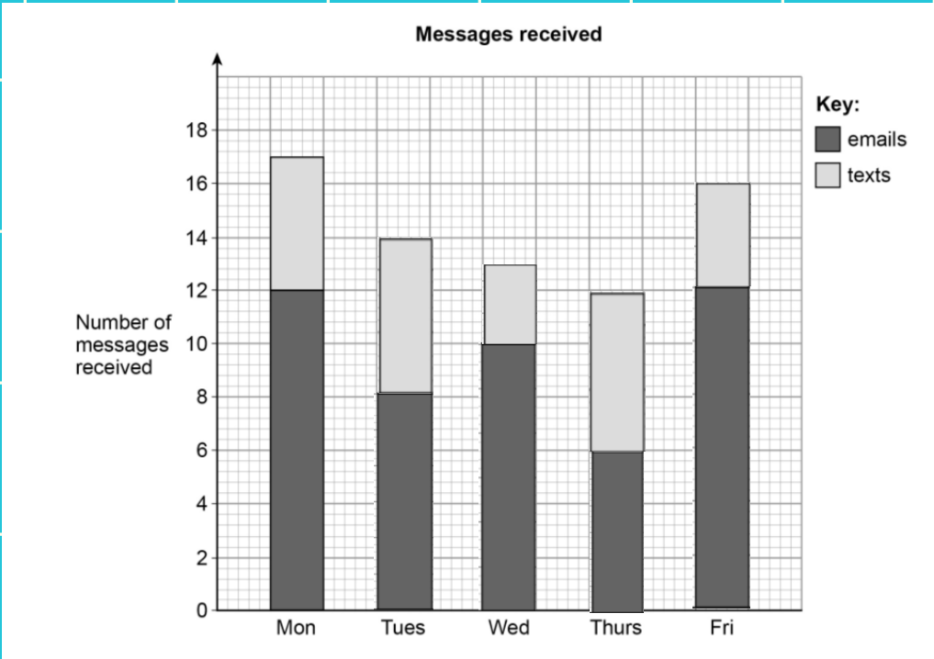

Complete the chart (2 marks)

- In total, what fraction of the messages were emails?
Give you answer in its simplest form.

……………………………………………………………………………………………………………………………………………………………
……………………………………………………………………………………………………………………………………………………………
……………………………………………………………………………………………………………………………………………………………
…………………………………………………………………………………………………………………………………………………………….
(3 marks)
Answer ______________________________________________________

- A straight line
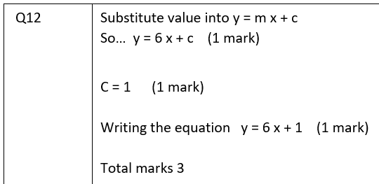
Has gradient 6
And
Passes through the point (3,19)
Work out the equation of the line.
Give your answer in the form y = mx+c

…………………………………………………………………………………………………………………………………………………………… ……………………………………………………………………………………………………………………………………………………………
……………………………………………………………………………………………………………………………………………………………
…………………………………………………………………………………………………………………………………………………………….
(3 marks)
Answer ______________________________________________________

- Complete the table of values for y = x²-2

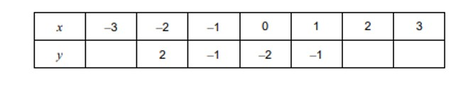 (1 mark)
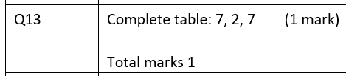

b) Draw the graph of y = x²-2 for values of x from -3 to 3

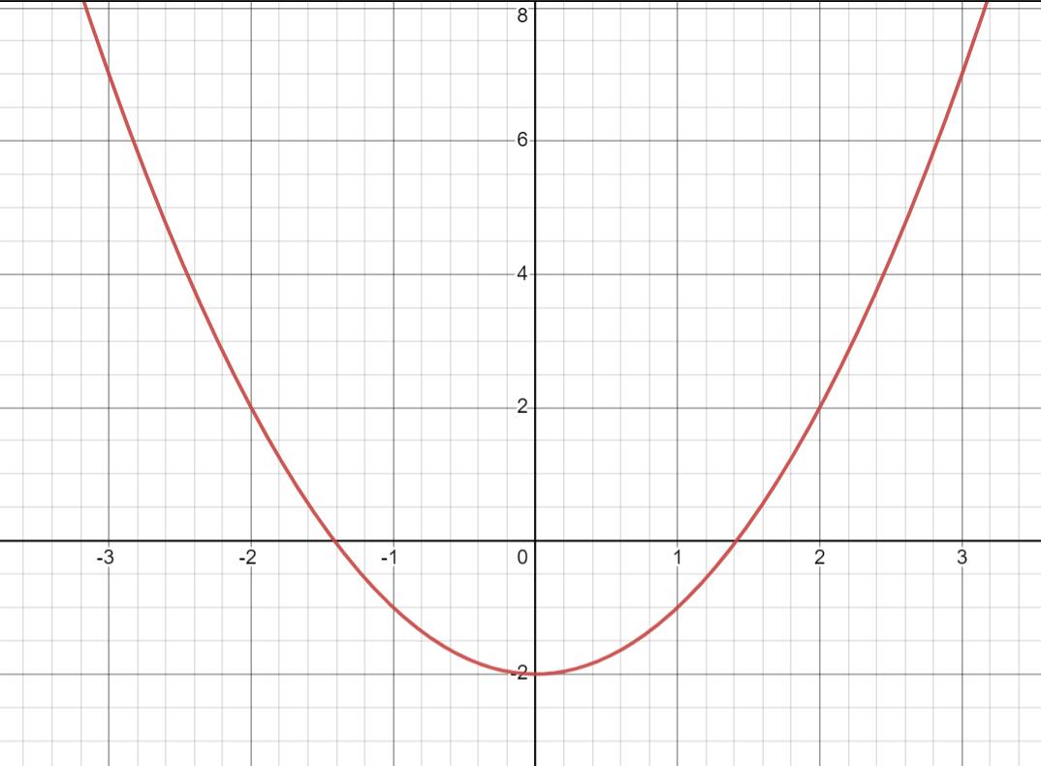

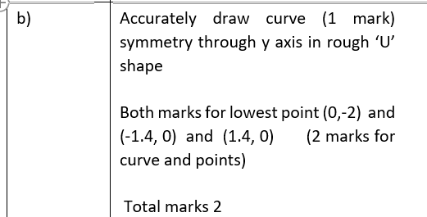

(2 marks)

14) Expand and simplify (2x-3)(x-5)

………………………………………………………………………………………………………………………………………………
………………………………………………………………………………………………………………………………………………
……………………………………………………………………………………………………………………………………………….
(2 marks)
Answer ______________________________________________________
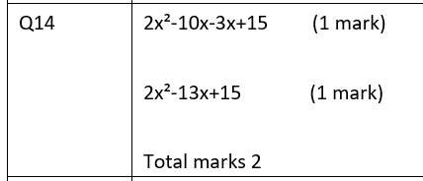

b) Factorise x² + 15x+ 36
………………………………………………………………………………………………………………………………………………
………………………………………………………………………………………………………………………………………………
……………………………………………………………………………………………………………………………………………….
(2 marks)
Answer ______________________________________________________

