Q1, Jane wants to buy a barbecue.
She sees this offer.
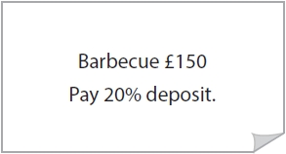
Work out 20% of £150 for Jane.
(2)
Use the space below to show clearly how you get your answer.

Q2, Michael wants to buy winter tyres for the car.
The normal price for the tyres is £400.
There is a discount of 15% off the normal price.
Michael thinks 15% of £400 is £50
Is 15% of £400 equal to £50? (2)

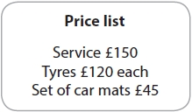
Q3, Jill buys a car.
She knows that in the first year she will need

- to service the car
- to buy 4 new tyres.
She also wants to buy a set of car mats.
Jill considers two offers.
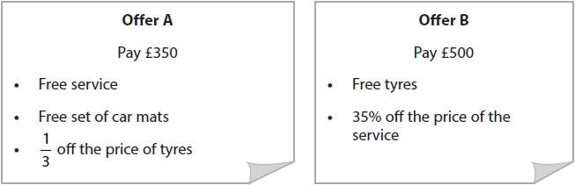
Which offer is the best value?
Show why you think this
(5)

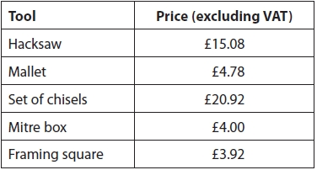
Q4, Josh is the manager of a carpentry company.
He needs to buy some new tools.
Josh wants 3 sets of chisels and a mitre box.

Josh needs to add 20% VAT to the total price of the tools.
He also has to pay £3.99 delivery charge.
How much does Josh pay for the tools and the delivery?
(4)

Q5, Katrin's monthly payment for electricity went down from £38.60 to £34.20

She thinks this means that her monthly payment has gone down by 20%
Is Katrin correct?
Show why you think this.
(3)

Q6, Laypin has this information about the number of sales the company made last month.
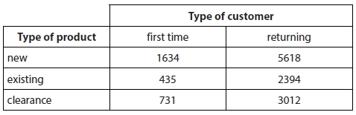
(a) What percentage of the products sold last month to first time customers were new products?
Give your answer correct to 1 decimal place.
(3)
Use the space below to show clearly how you get your answer.

