Onsite Dates 2022-23 Adult Level 2 Fskills maths
Course MC2 Monday Evenings HYBRID
Onsite Dates – You will be required to attend the college on the following dates for assessments of your learning.
H
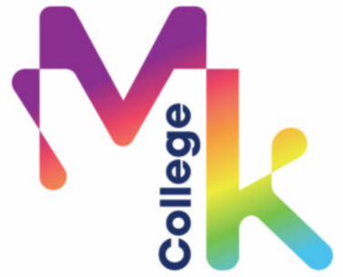
26th September ‘22 (week 2) 20th February ’23 (week 20)
31st October ‘22 (week 6) 17th April ’23 (week 26)
12th December ’22 (week 13) 22nd May ’23 (week 31)
9th January ’23 (week 15) 5th June ’23 (week 32)

3rd July ’23 (week 36) Final Exams

