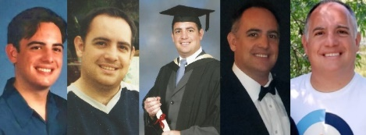
About your Tutor
Mr Malcolm R. Cooke 1974

Malcolm.cooke@mkcollege.ac.uk

Hi,

I am glad to be able to spend time with you this year as your tutor and I hope we can experience a positive and successful year together whilst learning maths.

I have always lived local to the MK and Bedford areas and took my first job in Cranfield University in an account’s role. After fifteen years of various admin and accounts roles and the decision to start a family, I began a career in teaching. It was hard work studying, working and looking after young children but I was looking forward to starting a more rewarding and creative career.

I studied at home, completing A-level maths then began my teacher training course with MK College and Oxford Brooks University. I then continued my studies of maths at the Open University to degree level. A job role was offered to me by MK College in 2002 and I took a teaching position with 15-16 year old students teaching maths, English and IT. After two years a position in the Adult English and Maths department became available. This role offered experience teaching in a variety of places such as Business, Community Centres, Bail hostel, prison, probation, Chadwick Lodge, and city centre offices teaching learners maths at Functional Skills level.

On a personal level I have had a love of maths and science since my childhood where my father would watch a tv series called Cosmos (Carl Sagan: 1980) with me. I was fascinated at school with seeing scientists with white boards full of algebra and wanting to know what it was that was written! I hope to pass on my enthusiasm for this subject and the knowledge you need to get through your course.
