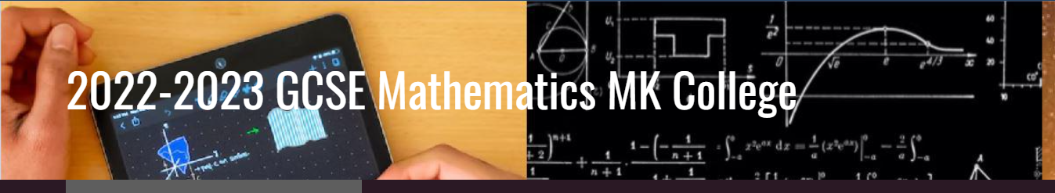

Assessment Dates 2022-23 Adult GCSE maths
Course MC3 Tuesday Mornings

Dates Assessment Time Location

11th October ‘22 (week 5) Skills Check 3hrs F27 Chaffron Way
1st November ‘22 (week 7) End of term Assessment(1) 1.5hrs F27 Chaffron Way
3rd January ’23 (week 14) End of term Assessment(2) 1.5hrs F27 Chaffron Way
21st February ’23 (week 20) End of term Assessment(3) 1.5hrs F27 Chaffron Way
14th March ’23 (week 23) Mock paper 1 non-calc 1.5hrs F27 Chaffron Way
21st March ’23 (Week 24) Mock paper 2 Calculator(1) 1.5hrs F27 Chaffron Way
28th March ’23 (Week 25) Mock paper 3 Calculator(2) 1.5hrs F27 Chaffron Way
May/June ’23 AQA Exams

