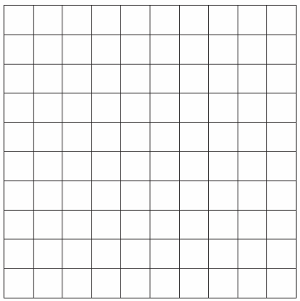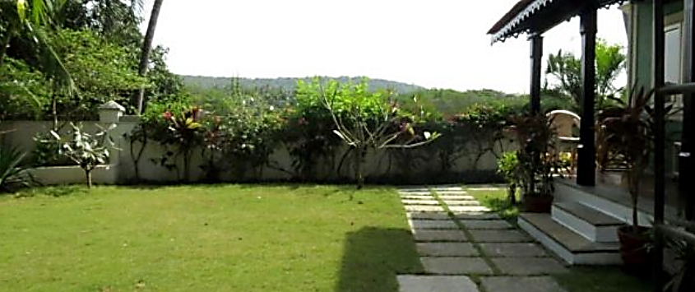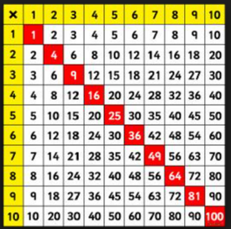

Draw a square on the above grid that contains 100 smaller squares.

How long is each side?

Draw a **square** on the above grid that contains 30 smaller squares.

How long is each side?

Draw a square on the above grid that contains 9 smaller squares.

How long is each side?

Draw a square on the above grid that contains 36 smaller squares.

How long is each side?

Draw a square on the above grid that contains 25 smaller squares.

How long is each side?

Draw a square on the above grid that contains 1 smaller squares.

How long is each side?

Draw a square on the above grid that contains 81 smaller squares.

How long is each side?

Draw a square on the above grid that contains 64 smaller squares.

How long is each side?

Draw a square on the above grid that contains 16 smaller squares.

How long is each side?

**Square Numbers**