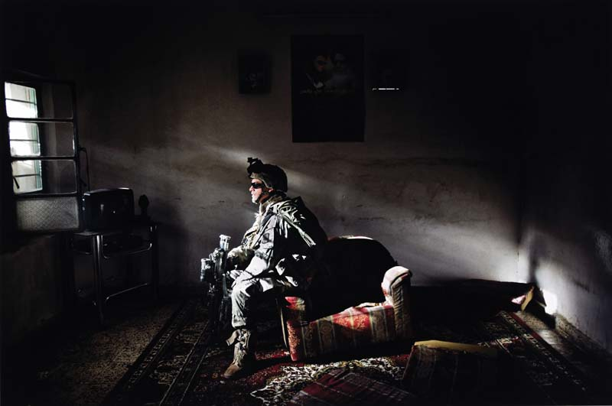
Yuri KOZYREV, Inside Irak 20/10/2006, 50 x 59,9 cm. FRAC Auvergne.

